# Option & Booking Request (Model | Mobile)

|  |  |
| --- | --- |
| **Target release** |  |
| **Epic** | [PM-403](https://forddigital.atlassian.net/browse/PM-403) - Manage Projects & Jobs. Option & Booking requests In Progress |
| **Document status** | APPROVED |
| **Document owner** | Sebastian Flores |
| **Designer** |  |
| **Developers** | Ramiel Galimov Marat Saytakov |
| **QA** |  |

### Description

Clients will now have the ability to Book a model. There are two ways to book a model:

1. Client sends Model an Option request first, then if model is available, Client can choose to Book model. Once Client books model the booking is confirmed.
2. Client sends Model a Direct Booking request. If model accepts then the booking is confirmed.

Process flow to illustrate the two scenarios above: <https://www.lucidchart.com/invitations/accept/ed759ff3-5006-4734-b76a-9bd51ec84891>

### Scenario 1

Model receives an Option request from Client, then once model accepts request, Client Books model.

Invision: <https://invis.io/A6DTTN9E9#/257029978_Screen_Shot_2017-10-05_At_10-58-21_PM>

UX Designs:

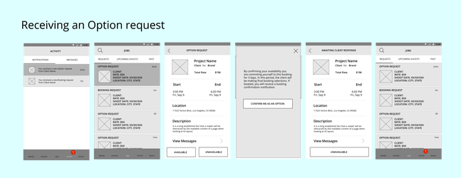

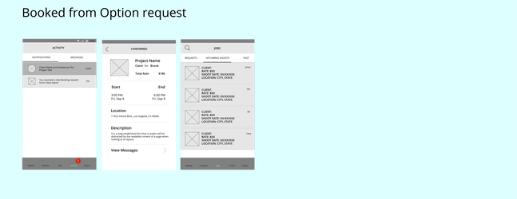

### Scenario 2

UX Designs:

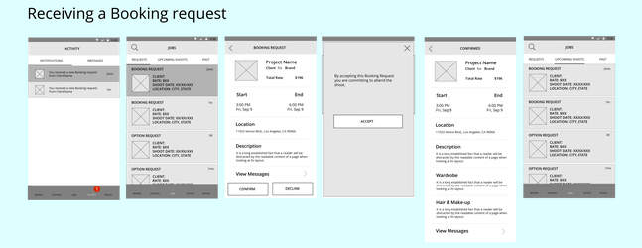

### Additional Booking UX Designs

If a Client updates a Booking, the model receives a notification:

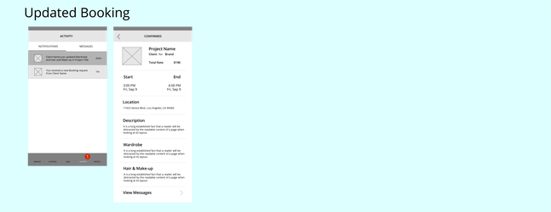

Once the shoot is complete, the model confirms her hours, and the client approves submitted hours, model is paid.

