# Model Profile

|  |  |
| --- | --- |
| **Target release** |  |
| **Epic** | [PM-394](https://forddigital.atlassian.net/browse/PM-394) - Model Profile with new data (mobile only) UPDATE Closed  [PM-414](https://forddigital.atlassian.net/browse/PM-414) - Edit model profile In Progress |
| **Document status** | APPROVED |
| **Document owner** | Sebastian Flores |
| **Designer** |  |
| **Developers** |  |
| **QA** |  |

## Description

Below is all of the information to be included on a model's profile. There are newly introduced fields, as well as fields to be removed. Some fields are not required to be filled out by the model upon account creation, and are therefore able to be filled out after their application has been submitted. These fields include (* denotes new field):

* Digitals
* Video*
* Instagram
* Tags/Other skills (options should be more relevant to modeling)
* I am currently in (location)
* Years of experience*
* Brands you’ve worked with*

## Model Info To Be Displayed

(* denotes new field)

### Name

Model Name displayed on top bar.

* First name, Last Initial (ex. Natalie L.)

### Portfolio

Display model portfolio photos.

### Digitals

Display model digital photos and date of last updated.

### Info

Fields to remove:

* About
* Representation

Fields to display:

* Rate*
  + Shoot Rate (hourly)
  + Shoot Rate (day)
* Experience*
  + Years of experience
  + Brands you’ve worked with
* Location
  + I am from
  + I am currently in
* Followers
* Tags
* Stats
  + Gender
  + Age Range
  + Ethnicity
  + Men (in order):
    - - Height
    - - Waist
    - - Suit
    - - Inseam*
    - - Shirt
    - - Shoe
    - - Hair
    - - Eyes
  + Women (in order):
    - - Height
    - - Bust
    - - Waist
    - - Hips
    - - Dress
    - - Shoe
    - - Eyes
    - - Hair
* Intro Video*

### Instagram

Display model Instagram photos.

## UX/UI Designs

<https://app.zeplin.io/project/59f0eabe176ce3b4a0252bb6/screen/5a0c2699f95b24e56a27b231>

## Notes

* Keep the ability to share / report profile where it currently lives.
* Keep the "Options" gear for editing account settings where it currently lives.
* To give an example of how adding years of experience and past brands you've worked with can function on mobile, this is how the Meriad desktop experience looked like:

1. Adding years of experience

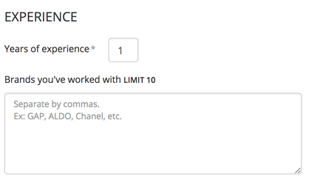

2. Adding Brands you've worked with

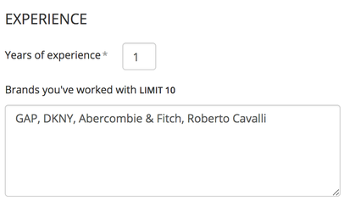

3. How it displays

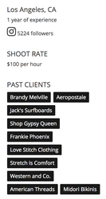

### All Input Values

HEIGHT = (60..84).to_a.map { |inch|

Unknown macro: { id}

}  
WAIST = (20..40).to_a.map { |inch|

Unknown macro: { id}

}  
HIPS = (20..40).to_a.map { |inch|

Unknown macro: { id}

}  
BUST = (24..40)  
BUST = "A", "B", "C", "D", "DD", "DDD", "G"

SUIT = 34, 36, 38, 40, 42, 44, 46  
SUIT = "S", "R", "L"  
INSEAM = 30,31,32,33,34

SHOES = 4,4.5,5,5.5,6,6.5,7,7.5,8,8.5,9,9.5,10,10.5,11,11.5,12,12.5,13,14,15,16  
DRESS = 0,2,4,6,8,10,12,14,16,18,20  
HAIR = "Black", "Brown", "Blonde", "Red", "Other"  
EYES = "Black", "Blue", "Brown", "Green", "Hazel", "Other"  
GENDER = "Male", "Female", "Non\-Binary"  
ETHNICITY = [Asian, Black/African American, Hispanic/Latino, Middle Eastern, White/Caucasian, Multiracial, Other]

## Questions

|  |  |
| --- | --- |
| **Question** | **Outcome** |
| What are the fields that should be displayed on the model's profile (for each gender type)? And what is the weight assigned to non-binary model attributes? | Women (10 stats displayed):  X -Gender  X -Age  X - Height  X - Waist  X - Hips  X - Bust  X - Shoes  X - Hair  X - Eye Color  X - Years of Experience  Male (10 stats displayed):  X - Gender  X -Age  X - Height  X - Waist  X - Shoes  X - Hair  X - Eyes  X - Suit  X - Inseam  X- Years of experience  Non-Binary (8 minimum, or 10 max with level of importance below):  X - Height*  X - Waist*  X - Shoes*  X - Hair*  X - Eye Color*  X -Gender  X -Age  X - Years of experience*  1 - Bust  2 - Hips  3 - Suit  4 - Inseam  5 - Dress  6 - Shirt |
| Model profile on iOS has abbreviated characteristics for hair and eye color. Can you provide a key for these abbreviations? | Hair:  Black = Blk  Brown = Brn  Blonde = Blnd  Red = Red  Other = Other  Eyes:  Black = Blk  Blue = Blu  Brown = Brn  Green = Grn  Hazel = Hzl  Other = Other |
|  |  |