Project Class Study.
Application Types

- Web Application
What is web application?
Web application structure.
Web application sub-Types:
    - Social networking?
Social networking is the grouping of individuals into specific groups, sharing common interests in hobbies, religion politics, to gather and share first-hand information and experiences and so on. E.g. MySpace, Yahoo! 360, Facebook, Twitter
    - E-commerce?
may be defined as the application of information and communication technologies to support business activities and consumer services.
- E-commerce applications allow the consumers buying and selling products or services. eBay
- E-commerce applications that conduct operations between the businesses are referred to as business-to-business or B2B, or commodity exchange.
- Online retailers are sometimes known as e-tailers:
Business entities: Bookshops, travel agencies, Publishers, Air Lines, Hotels, Car Rental, etc.
- Electronic commerce that is conducted between businesses and consumers is referred to as business-to-consumer or B2C where the buyer is directly online to the seller via the internet and there is no intermediary (agent) service.
Online shopping, such as Amazon.com or eBay.com, allows the sale and purchase transactions between three parties: vendors (sellers)-intermediary-consumers
Some common Web application components:
- Email
- Enterprise content management
- Instant messaging
- Newsgroups
- Online shopping and order tracking
- Online banking
- Online office suites
- Domestic and international payment systems
- Shopping cart software
- Teleconferencing
- Electronic tickets
- Hosting
- Search
- Content Sharing
- Integration with other (WEB) applications (OPEN ID Interface)
- Privacy, safety and security management
2. ERP: Enterprise Resource Planning
CRM (Customer Relation Management), Order Management, Financials, Manufacturing, Contract Management, HR, Corporate BI/WH (Business Intelligence and Analytics)
3. SaaS - Software as a Service vs. ERP
http://www.elementool.com/
4. Non Web Applications:
  - Shrink wrap: Of shelf – Games, Microsoft Office, Intuit
  - Firmware (HW embedded),
  - Technology applications (compilers, DB and Reporting agents)
  - Database (data warehouse – ETL)
5. Mobile
  - Native mobile application
  - Mobile WEB application
  - Hybrid mobile app
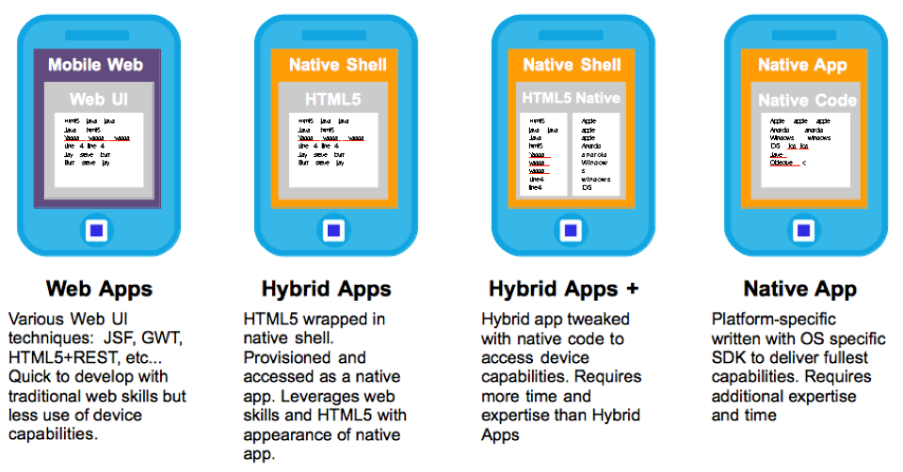

What is the difference between a native and a Mobile Web app?
A native mobile app is specifically designed and implemented to run on a device’s operating system and machine firmware, and typically needs to be adapted for different devices.
- xCode/Objective-C for iOS,
- Eclipse/Java for Android,
- Visual Studio/C# for Windows Phone.

A Mobile Web app, or browser application, is one in which all or some parts of the software are downloaded from the Web each time it is run. It can usually be accessed from all Web-capable mobile devices

- Eclips
- Visual Studio/C# for Windows Phone.
That means you must duplicate them using the appropriate programming language in order to target another mobile platform.
Nearly all games are native app.

