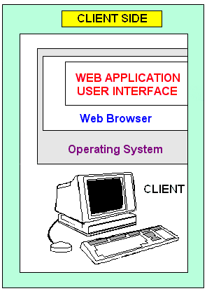
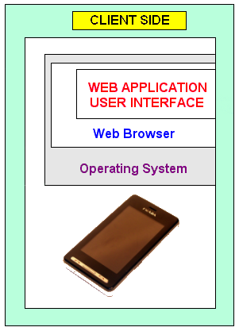
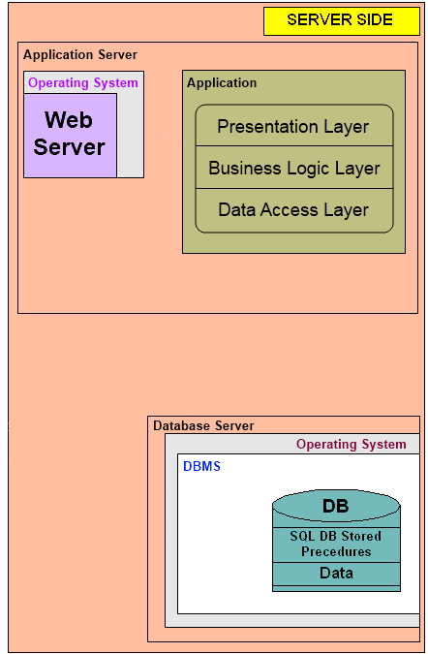
Web Server
IIS
Apache
GlassFish
GWS
lighttpd
Mobile Device
iPhone
iPad
Nokia
Motorola
Blackberry
OS
Symbian
Windows Mobile
Windows Phone
Android
iPhone OS
RIM

Browser
Opera Mini
Opera Mobile
Safari
Internet Explorer Mobile
Technologies
HTML
JavaScript
CSS
Flash
Ajax
ActiveX
OS
Windows XP/Vista/7
Ubuntu, Red Hat Linux, SUSE Linux
Mac OS X 10.2/10.3/10.4/10.5/10.6
Browser
Internet Explorer 7/8/9
Opera 10.0/10.1
Mozilla Firefox 3.5/3.6/4.0
Google Chrome
Safari
Protocol
HTTP, HTTPS, SMTP, POP3, SOAP, FTP
GET & POST requests
Operating System
Windows Server 2003/2008
Linux Red Hat, CentOS, Ubuntu Server
Unix SCO, Free BSD, Sun Solaris, AIX
Database Management System
Oracle
MS SQL
MySQL
PostgresSQL
Firebird
DB2
MS Access
DB API
DB API
PHP
ASP.NET (C#, VB.NET)
Python
JSP (Java)
Ruby on Rails
Perl

