Testing Applications of the WEB

Understanding Web Applications 2
Client/Server Architecture 2
Client Side 3
Dynamic UI Controls 4
Server Side 7
TOOLS 9
Internet Explorer Add-ons 9
Fiddler 9
Tamper IE 10
Firefox Browser Tools Menu 13
Firefox/Tools/Firebug 13
Other Tools – Browser Independent 13
Putty - A Free Telnet/SSH Client – Connect you to WebServers 14
How to test WebLogs 14
Lab Project 2 – in Excel 15
Agenda: Testing Process of buying new VIP services on www.live365.com 15
New Web Technologies 16
RIA - Rich Internet Applications 16
MVC with Service Oriented Architecture (SOA) 17
Agile software development 18
Open Source Web Test Tools 20
WATIR 21
OpenSTA – Load/Stress/Performance Open Source Tool 22

Understanding Web Applications
Testing plays a critical role in the development of the web site and its long-term maintenance. While smaller web sites—especially those with more limited budgets—may not need to follow the formal testing procedures that are required for large-scale, commercial web sites, every site needs to be thoroughly tested to ensure that it's error-free, user-friendly, accessible, and standards compliant.
Understanding what makes up the application and environment in which it operates

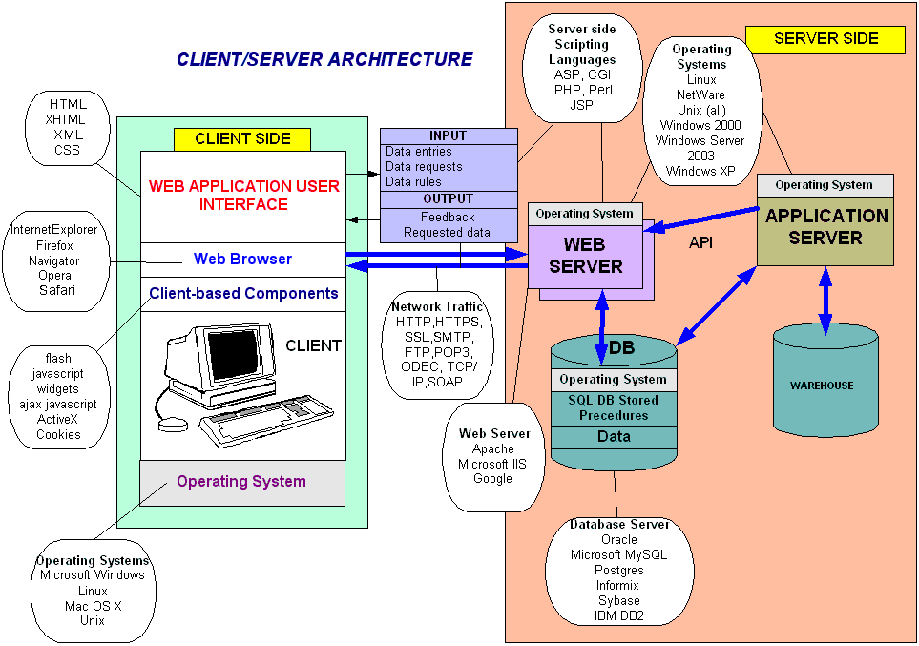
Example:
User begins running an application (browser) on their system to access WWW on the internet. The browser accepts commands in the location bar. For example (http://www.live365.com/index.html) tells browser to use HTTP protocol to contact live365.com and request index.html for that domain. A server system at live365.com providing the requested web page in the form of HTML commands. The user’s browser interprets the HTML, run appropriate scripts on a client.

Client/Server Architecture
Tester is responsible for identifying, analyzing and reproducing errors within different Web Environments with many different configurations and many variables. To do it you need to understand the environment your application runs in and have enough tools to work with each element. Here is an example of basic Web Application Infrastructure:

Web Based Client Server systems
Thick Client (http://www.flickr.com)
Thin Client (http://www.google.com)

Client Side
- Browser –is a software application running on a client system that interprets and displays information (text, images, videos, music) located on a Web page at a website on the World Wide Web .Text and images on a Web page can contain hyperlinks to other Web pages at the same or different website. Web browsers allow a user to quickly and easily access information provided on many Web pages at many websites by traversing these links. Web browsers format HTML information for display, so the appearance of a Web page may differ between browsers.
- Dynamic JavaScript – providing active displays in HTML, in many cases client-based components, like Ajax, Flash that allows short server messages to update display without refresh, or JavaScript to handle Client-based error handling.
- Data Presentation Scripting Languages - Languages describing what the browser should display and how (HTML, XHTML), to describe screen layout/ fonts (CSS), XML to describe the Contents
- Cookies
HTTP cookies, sometimes known as web cookies or just cookies, are parcels of text sent by a server to a web browser and then sent back unchanged by the browser each time it accesses that server. When a user accesses an application which needs to keep track of the actions and identity of that user across multiple requests, a cookie (or more than one) is generated by the server and sent to the client. The client will then send the cookie back to the server in all following connections until the cookie expires or is destroyed. The data stored in the cookie can provide to the server a large spectrum of information about who the user is, what actions he has performed so far, what his preferences are, etc
A typical example is provided by an online shopping cart. Throughout the session of a user, the application must keep track of his identity, his profile, the products that he has chosen to buy, the quantity, the individual prices, the discounts, etc. Cookies are an efficient way to store and pass this information back and forth (other methods are URL parameters and hidden fields).
Collecting information about cookies would be the first step in testing:
The first step required in order to manipulate the cookie is obviously to understand how the application creates and manages cookies. For this task, we have to try to answer the following questions:
- How many cookies are used by the application?
Surf the application. Note when cookies are created. Make a list of received cookies, the page that sets them (with the set-cookie directive), the domain for which they are valid, their value, and their characteristics.
- Which parts of the the application generate and/or modify the cookie?
Surfing the application, find which cookies remain constant and which get modified. What events modify the cookie?
- Which parts of the application require this cookie in order to be accessed and utilized?
Find out which parts of the application need a cookie. Access a page, then try again without the cookie, or with a modified value of it. Try to map which cookies are used where.
A spreadsheet mapping each cookie to the corresponding application parts and the related information can be a valuable output of this phase.
Analyzing the collected values, try to figure out all variables that could have influenced the cookie value and try to vary them one at the time. Passing to the server modified versions of the same cookie can be very helpful in understanding how the application reads and processes the cookie.
Examples of checks to be performed at this stage include:
- What character set is used in the cookie? Has the cookie a numeric value? Alphanumeric? Hexadecimal? What happens inserting in a cookie characters that do not belong to the expected charset?
- Is the cookie composed of different sub-parts carrying different pieces of information? How are the different parts separated? With which delimiters? Some parts of the cookie could have a higher variance, others might be constant, others could assume only a limited set of values. Breaking down the cookie to its base components is the first and fundamental step. An example of an easy-to-spot structured cookie is the following:
ID=5a0acfc7ffeb919:CR=1:TM=1120514521:LM=1120514521:S=j3am5KzC4v01ba3q
In this example we see 5 different fields, carrying different types of data:
ID – hexadecimal
CR – small integer
TM and LM – large integer. (And curiously they hold the same value. Worth to see what happens modifying one of them)
S – alphanumeric

While testing make sure to clear your cookies and temp files before new build/release. Also you need to know if user browser accepts cookies or not.

Dynamic UI Controls
Java Script, ActiveX, AJAX, CSS, XML
A Web 2.0 application can load several JavaScripts, Flash components, and widgets in the browser. These scripts and components utilize the XML/HTTPRequest object to communicate with the backend Web server.
XML – Extensible Markup Language
Not tied to any specific platform, language or system
(Example: http://www.w3schools.com/xml/simple.xml)
- It is data description language
- Works in conjunction with HTML
- XML tags are defined by you
- XML uses DTD (Document Type Definition) or XML schema to describe data
How to test XML document (use XML validators)
- Well-formed. A well-formed document conforms to all of XML's syntax rules. For example, if a start-tag appears without a corresponding end-tag, it is not well-formed. A document that is not well-formed is not considered to be XML; a conforming parser is not allowed to process it.
- Element names are case-sensitive. For example, the following is a well-formed matching pair: <Step> ... </Step>
- Valid. A valid document additionally conforms to some semantic rules. These rules are either user-defined or included as an XML schema or DTD. For example, if a document contains an undefined element, then it is not valid; a validating parser is not allowed to process it.
XML Validators: XMLSpy, www.stylusstudio.com, Validator 1.3(MAC).
When on testing environment use downloadable Validators as you will not be able to use private URL from your environment online.
CSS – cascading style sheets
- Style sheets provide a mechanism for supporting consistent style across Web Pages
- Style sheets work with properties of HTML elements such as text, font,color and with attributes like length, style and percentage
- Style sheets information is used t alter HTML elements
- Browsers have to be style sheet-capable
Javascript
1. Client-side script is often used for dynamically setting values of UI Controls, self-modifying the Web page content, data validation, error handling and more.
2. Script doesn’t need to be compiled, and can be included directly in the HTML pages.
3. They often can serve to do pre-validation of the form data and/or to prepare the form data to send to a server-side program.
3. Scripts can also be executed at server-side.
Ajax
With AJAX, your JavaScript can communicate directly with the server, using the JavaScript XMLHttpRequest object. With this object, your JavaScript can trade data with a web server, without reloading the page. The user will stay on the same page, and he or she will not notice that scripts request pages, or send data to a server in the background.
The XMLHttpRequest object is supported in Internet Explorer 5.0+, Safari 1.2, Mozilla 1.0 / Firefox, Opera 8+, and Netscape 7.
AJAX applications are browser and platform independent.
In the AJAX example below we will demonstrate how a web page can communicate with a web server online as a user enters data into a standard HTML form.
Example:
http://www.w3schools.com/ajax/tryit.asp?filename=tryajax_httpsuggest
example:
http://www.google.com/webhp?complete=1&hl=enXML – describing data

bad AJAX - http://usctrojans.cstv.com/ (do CTRL++)
Here are few problems you may find:
1. Too often the drop-down menus are unbalanced. You click on something to find a drop-down menu appearing to the left or the right of where you'd expect it. When you move the cursor to the menu, you take it off the trigger button and the menu goes away before you can get to it.
2. Mismanagement of highlights. This is a common problem with Javascript and mapping the screen for highlighting. You run the pointer over one thing and another thing—the wrong thing—lights up.
3. Screens do not scale. Most AJAX implementations will not scale when you change the font size from smaller to larger. A worse situation is when some fonts scale and others do not, making a mess on the screen.
4. The forward and backward functions of the browser are often rendered useless by changes on a page that never actually change the page, making it hard to find something you were just looking at unless you remember the exact menu sequence.
5. Menu overload. Some AJAX sites have far too many confusing drop-down and pop-up menus scattered all over the screen, making it a nightmare to find what you are looking for. Site maps, which normally cut to the chase on many Web sites, can be useless on AJAX sites.
6. Commercial viability for site monetization is difficult. The concept of page views does not work with AJAX since the person on the site rarely leaves the one master control page.
ActiveX
- is a Windows custom control run inside the browser. Supports events. Methods and Properties providing a solution for an event-based object to be executed in a browser.
Platform dependent (Windows), big in size, demand more memory to operate.

Beware of ActiveX. It is bad unless it is a site you know you can trust.

Navigation Methods
- Dictates how users are expected to navigate through the program.
Example: http://www.live365.com (navigation tabs)

Server Side
Servers – Computer Systems containing the web applications accessed by users, including files, web pages, databases, etc.

- Web Server - A computer that runs a computer program which is responsible for accepting HTTP requests from clients, which are known as web browsers, and serving them HTTP responses along with optional data contents, which usually are web pages such as HTML documents and linked objects (images, etc.). (How a Web Server Works - diagram)
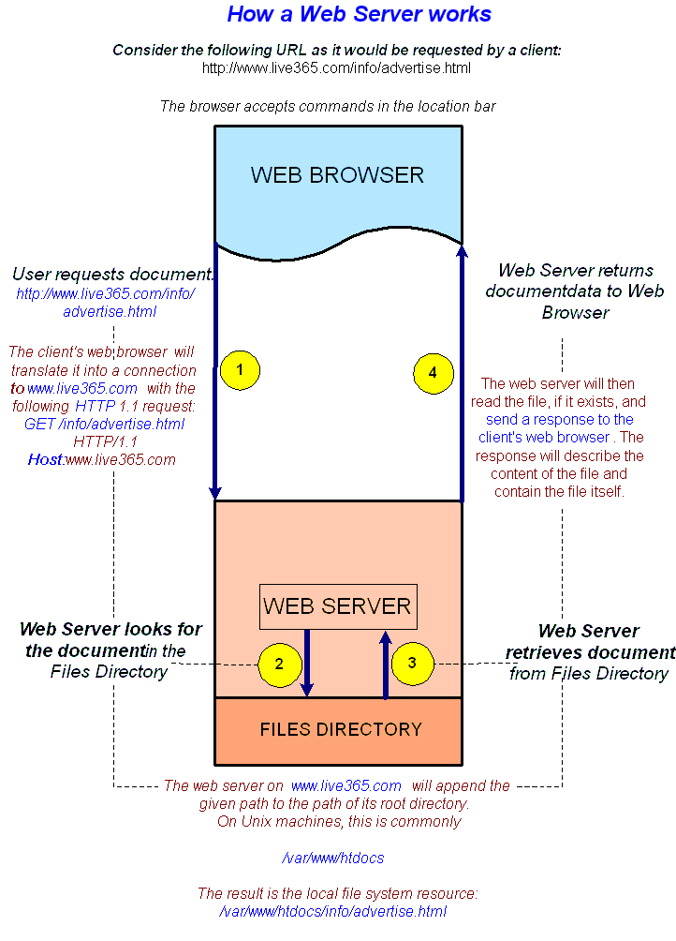

- Server Side Scripting languages - are the most common server-side programs used for web sites (CGI, JSP, ASP…)
A CGI (Common Gateway Interface) is a communications protocol used by Web servers to communicate with other applications. CGI allow web users to access Databases. CGI applications usually written in Perl.
- An Application Server is a software engine that delivers applications to client computers or devices, typically through the Internet and using the HTTP. Application servers are distinguished from web servers by the extensive use of server-side dynamic content and frequent integration with database engines.

Some application servers also provide an API, making them operating system independent.
(Diagram)
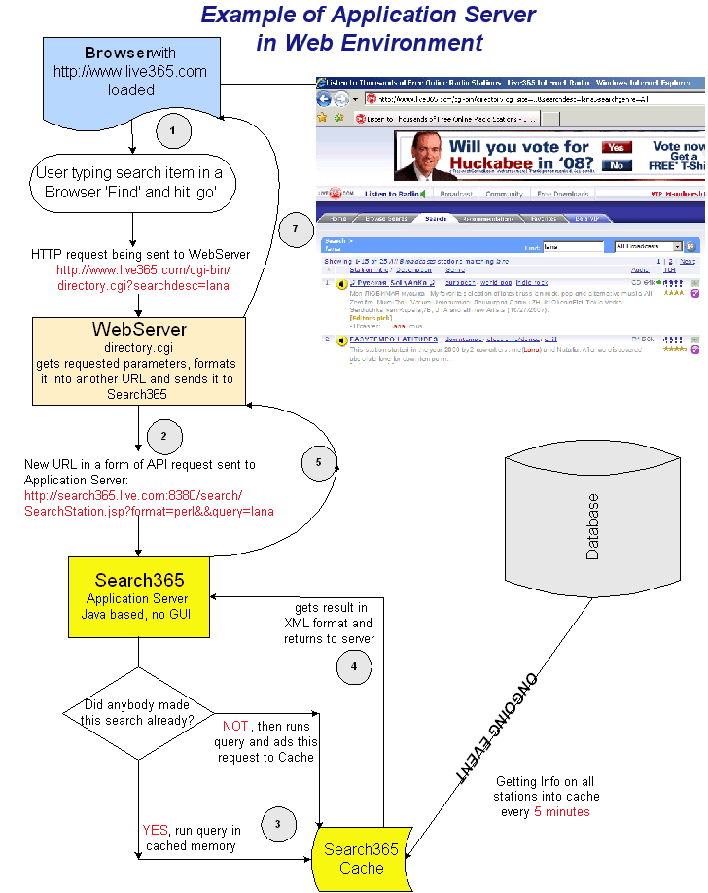

API (Application Program Interface) - Flickr has an open Application Programming Interface (API for short). This means that anyone can write their own program to present public Flickr data (like photos, tags, profiles or groups) in new and different ways. There's a long list of API methods available.
(Example: show it with Fiddler: http://www.airtightinteractive.com/projects/flickr_postcard_browser/app/)

- Database
Database plays an important role in Web-application technology;they house the content that Web application manage-fulfilling user requests for data storage and record queries.
- Relational Database – is a collection of data items organized as a set of tables from which data can be accessed or reassembled in many different ways without having to reorganize the database tables (Oracle, Microsoft SQL, Sybase)
- Data Warehouses – are large databases that aggregate information from several “operational” databases. In the process the raw data transformed through the filtering/cleansing process and stored in a form that fits the designer’s informational needs. (Give an example of our warehouse which stores statistics for broadcasters from logs – it filters entries like this below into readable values for DB)

Communication:
- Internet – a network of connected systems communication via IP
- World Wide Web – An internet based collection of interconnected documents linked by hyperlinks and URLs
- SOAP(Simple Object Access Protocol) to transport data (is a protocol for exchanging XML-based messages over computer networks, normally using HTTP/HTTPS
- HTTPS allowing secure (encrypted) connections to the server on the standard port 443 instead of usual port 80.
- HTTP: HyperText Transfer Protocol is used for transferring World Wide Web pages across the internet
- FTP: File Transfer ProtocolThe FTP helps you copy files between two computers. It downloads files from remote computer and uploads files onto the remote computer or server.
- SMTP: Simple Mail Transfer Protocol
Transfers e-mail messages between computers. It is the mail transfer protocol for the internet. When you send e-mail through an operating system other then UNIX, a special SMTP gateway must be established.

TOOLS

Internet Explorer Add-ons

Fiddler



Fiddler is a Web Debugging Proxy which logs all HTTP(S) traffic between your computer and the Internet. Fiddler allows you to inspect all HTTP(S) traffic, set breakpoints, and "fiddle" with incoming or outgoing data.

Info and Download: http://www.fiddler2.com/fiddler2/

You can debug:
HTTP Requests/Responses
Broken Links, Images
Forms values
Hidden Server-side scripts URLs
HTTP Response Codes

HTTP Response Codes:
http://en.wikipedia.org/wiki/List_of_HTTP_status_codes
http://www.w3.org/Protocols/rfc2616/rfc2616-sec10.html

Example 1 – Verify Proper values being sent to server side scripts from application
Show Radio365 application api calls
Note: Do not click ‘play’ icon (Fiddler doesn’t support it). Use Packetyzer to test play parameters.

Example 2 - Server Side scripts testing - Testing Rewards.cgi properly passing parameter tag for rewarded station:
- Launch : http://www.live365.com/stations/easytempo not logged in
- Launch Fiddler
- Click ‘Support This Station’ button
- Look into WebSessions in Fiddler :
  - Verify Rewards.cgi properly captured tag and product parameter(tag presents a station name with will be rewarded)
- Download Radio365 application http://www.live365.com/downloads/radio365-win/
- Launch Fiddler
- Run application, login as (username :djrussian, password :test)
- Click on ‘Be A VIP’ button
- Look into WebSessions in Fiddler
  - Verify Rewards.cgi properly captured tag and product parameter(tag presents a station name with will be rewarded)
- Submit bug report

Example 3 - Editing Request with Fiddler
Show how to edit api requests with Fiddler for http POST and GET

Tamper IE
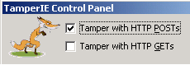

- An IE plugin that allows intercepting POSTs and GETs before they occur and give you a chance to tweak it (change/add POST data).
- You can also do a blind SQL Injections
- Bypass JavaScript error handling and submit invalid data to a form
- Hidden form field manipulations
WARNING: This tool makes it simple to do very bad things to poorly written code. Malicious use of this tool against third-parties is a violation of federal, state, and local laws. Be smart.
TamperIE is a useful tool for security testing your web applications, in order to ensure you don't make foolish assumptions about the data sent by client browsers. Since the tool exposes and allows tampering with otherwise inconvenient input, many user-input security flaws immediately become apparent.
SSL? TamperIE works inside IE itself, before data is placed on the wire; this means that it works fine even against SSL secured sites.
Start the TamperIE Control Panel referenced in the IE toolbar. (If the icon isn't visible, right-click the IE toolbar, and choose Customize).
Example1 – Testing Registration form Client and Server Side Error Handling Verification
a)What are proper Client Side Error Handling Cases?
- Mistyped ‘Re-type Password’ parameter
- Invalid email address
- Username less than 5 characters
- Password less than 4 characters
- Age and Gender not selected
- Username using special characters like ‘!@#$%’
- Password having space
- Username longer than 18 char
- Password longer than 18 char
b)What are proper visible Server Side Error Handling Cases?
- Membername already exists
- For Login form (Invalid password)
- For Login form (Membername doesn’t exist)

NOW BYPASS ALL JAVASCRIPT ERROR HANDLING WITH TAMPER IE
Try all cases from a and b, they all should be properly handled by ServerSide scripts

Example 3 – Try editing fields with bad data
To do so you can make a template call it:hackstrings.txt and save in the same directory where your Temper IE installed, usually: C:\Program Files\TamperIE\
Add these values below to the list:
*' or '1'='1
‘;drop tablename;
“’<script>alert(‘XSS hole #n’);</script>
Name123’
Name123;
Verylongusernamelongerthan56664b4!@#$%^&*(*^%%fndjvndjvddjdjvbvbhd

Example 2 – Bypass required fields
1. Launch http://www.live365.com/registration/index.live
Fill in all required info
When TamperIE activated observe Raw POST, Click ‘PrettyPOST’
Remove values for required fields, for example ‘email’ if user doesn’t want to give his email address
Click button ‘Send Altered data’
Observe response
Fill in all required info
When TamperIE activated observe Raw POST, Click ‘PrettyPOST’
Try removing ‘gender’ and ‘age’
Click button ‘Send Altered data’
Observe Response, Submit Bug Report

Example 2 – SQL Injection into hidden fields
1. Launch http://www.live365.com/registration/index.live
Fill in all required info
When TamperIE activated observe Raw POST, Click ‘PrettyPOST’
Change value of hidden fields, for example radiofree to *' or '1'='1
Click button ‘Send Altered data’
Observe ErrorMessage:

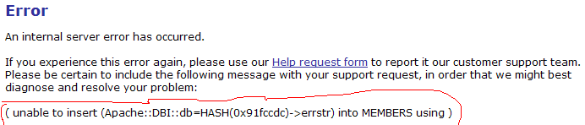

This is pretty nasty error, it means there is no validation for valid data type for field ‘radiofree’ when only ‘Y/N’ should be accepted.
Submit Bug Report
Example 2 – Changing price of an ordered item
Launch http://www.bayden.com/sandbox/shop/
When TamperIE activated observe Raw POST, Click ‘PrettyPOST’
Change price to lower or 0, observe response

Internet Explorer Developer Toolbar
Download: http://www.microsoft.com/downloads/details.aspx?familyid=e59c3964-672d-4511-bb3e-2d5e1db91038&displaylang=en
The Microsoft Internet Explorer Developer Toolbar provides a variety of tools for quickly creating, understanding, and troubleshooting Web pages.

You can:
- Selectively clear the browser cache and saved cookies.
- View DOM Source for Page and single Element
- View Source
- Locate and select specific elements on a Web page through a variety of techniques
- View Link Paths, Links Report
- Outline tables, table cells, images, or selected tags.
- Display image dimensions, file sizes, path information, and alternate (ALT) text.
- View Images Reports
- Tools – Immediately resize the browser window to a new resolution.
- Validate HTML, CSS, WAI, and RSS Web feed links
- Validate: Accessibility (Selectively disable Internet Explorer settings)

Firefox Add-ons

Link Checker
Highlights failed links

FireShot
screenshot with ability to add comments and pointers
https://addons.mozilla.org/en-US/firefox/addon/5648

Tamper Data
Similar to Tamper IE – but even better!!!
https://addons.mozilla.org/en-US/firefox/addon/966
Use tamperdata to view and modify HTTP/HTTPS headers and post parameters.
Trace and time http response/requests.
Security test web applications by modifying POST parameters.

Add N Edit Cookies
https://addons.mozilla.org/en-US/firefox/addon/573

Firefox Browser Tools Menu
Tools/Error Console
Displaying Errors, Warnings

Tools/Page Info
General:
Displaying Format: HTML, XHTML
Size of the Page
Meta Tags
Forms: (this is great for COOKIE values – show example)
Names of all Forms
Methods (Post/Get)
Form Actions (which CGI or other script called on Submit)
Field Name, Type and Current Value
Links:
Links Report
Media:
Images
Plugins
Security:
Validation of Certificate if HTTPS page

Firefox/Tools/Firebug
View DOM Objects, HTML, CSS

Other Tools – Browser Independent
Packetyzer
http://sourceforge.net/projects/packetyzer/
Packetyzer is a network protocol analyzer for Windows, also known as a packet sniffer. It is based on the Ethereal project, but provides a native Windows GUI. Packetyzer can capture from virtually any network adapter and supports many advanced features.
Example: Play url differences for VIP and Expired Free Trial listening sessions
Show how to use it.

Putty - A Free Telnet/SSH Client – Connect you to WebServers
http://www.chiark.greenend.org.uk/~sgtatham/putty/

How to test WebLogs
Web Logs (Commands: more, ls, grep)
On Unix Server WebLogs will be located:
/var/www/logs
There are usually 2 types of logs: access logs – where all requests are captured and error logs where you can see errors
Use these basic commands to find errors:
- Ask your Manager or IT person how you can login to a web server? (assuming it is Unix environment)
- Ask - where web (access and error) logs are located?
- Once logged in navigate to the directory which can look like this:
www@stgweb03:/live/apache_live/logs$
‘live/apache_live ‘– this part is different for different companies
- Do command to list all logs: ls. Example for list:
www@stgweb03:/live/apache_live/logs$ ls
access_log error_log
access_log-fat error_log-fat
- If looking for errors, do following:
www@stgweb03:/live/apache_live/logs$ more error_log | grep error
Here is possible output:
[Thu Oct 19 16:25:19 2006] [error] [client 216.235.80.254] File does not exist: /live/apache_live/htdocs/downloads/images/screenshot-studio365loader-win-full-s2.gif, referer: http://www.live365.com/popup/studio365loader-win.html
- What does it mean? It means when user who came from this IP(client 216.235.80.254) launched this page: http://www.live365.com/popup/studio365loader-win.html and one of images was missing (screenshot-studio365loader-win-full-s2.gif)
- For tester there can be 3 options for bug report: Image doesn’t exist on a server or url to the image is incorrect and the location or name should be different or permissions on image file restricted to the public.
- To check first (when image doesn’t exist) do following:
ls /live/apache_live/htdocs/downloads/images/screenshot-studio365loader-win-full-s2.gif
- Issue 2:If image is there check how web page actually calls it? (use Web Debugging tools for exact URL) , Look for request like:
http://www.live365.com/downloads/images/screenshot-studio365loader-win-full-s2.gif
If it is different for example http://www.live365.com/sideloads/downloads/images/screenshot-studio365loader-win-full-s2.gif (then it will not find the file)
- Issue 3: File Permissions, to check permissions on the file do the following:
ls -la /live/apache_live/htdocs/downloads/images/screenshot-studio365loader-win-full-s2.gif
Output:
-rwxr-xr-x 1 www www 26639 2006-10-24 09:59 /live/apache_live/htdocs/downloads/images/screenshot-studio365loader-win-full-s2.gif
Understanding how to read this output is useful to all unix users, but especially people using group access permissions. (-rwxr-xr-x 1 www www 26639 2006-10-24 09:))
Field 1: a set of ten permission flags.
Field 2: link count (don't worry about this)
Field 3: owner of the file
Field 4: associated group for the file
Field 5: size in bytes
Field 6-8: date of last modification (format varies, but always 3 fields)
Field 9: name of file (possibly with path, depending on how ls was called)
The permission flags are read as follows (left to right)
position | Meaning
1 | directory flag, 'd' if a directory, '-' if a normal file, something else occasionally may appear here for special devices.
2,3,4 | read, write, execute permission for User (Owner) of file
5,6,7 | read, write, execute permission for Group
8,9,10 | read, write, execute permission for Other
value | Meaning
- | in any position means that flag is not set
r | file is readable by owner, group or other
w | file is writeable. On a directory, write access means you can add or delete files
x | file is executable (only for programs and shell scripts - not useful for data files). Execute permission on a directory means you can list the files in that directory
s | in the place where 'x' would normally go is called the set-UID or set-groupID flag.

- Find all errors that may happen at a time you were testing:
For example you were testing at 13:20 pm.
Issue following command:
more error_log | grep 'Thu Oct 19 13:20' | grep 'error'
Output:
[Thu Oct 19 16:25:19 2006] [error] [client 216.235.80.254] File does not exist:/live/apache_live/htdocs/downloads/images/screenshots/tudio365loader-win-full-s2.gif, referer: http://stage.nanocosm.com/popup/studio365loader -win.html

Lab Project 2 – in Excel
http://weblecturelab.blogspot.com/

Agenda: Testing Process of buying new VIP services on www.live365.com
Gray-box testing is essential to successful web application testing.
Gray box testing presents human users and hidden users (O/S and Browser users, Application service user).
A few simple rules:
- Input/output data in a Web transaction is sent/received through several interface layers.
- Errors may happen at one or more interface layers which will cause a transaction to fail.
- Not all interfaces are visible to end users.
- For example for Forced-error testing you should look for various input/output interfaces and force failures by injecting erroneous input data.
Draw the picture of Interface Layers

New Web Technologies

RIA - Rich Internet Applications
These sorts of Web applications, which consume one or more remote services, are often referred to as Mash-ups. There are different types of gadgets targeting different platforms. A web-based gadget is a portable web-application that can be deployed on any gadget hosting site such as, for example, live.com or start.com. A web-based gadget consists of the following:
- An Xml Manifest: containing information on the gadget itself (title, description, publisher, build information, etc.) and links to the gadget components (.jss and .css files). The following is a sample manifest for a fictitious gadget (widget):
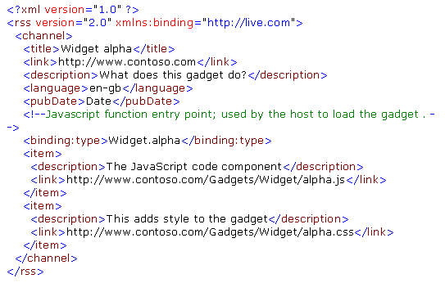
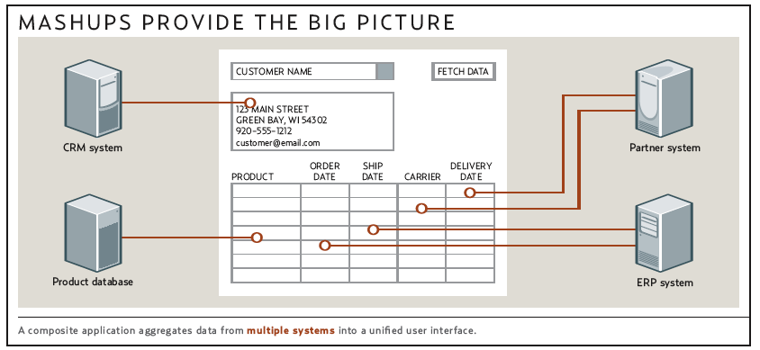

MVC with Service Oriented Architecture (SOA)
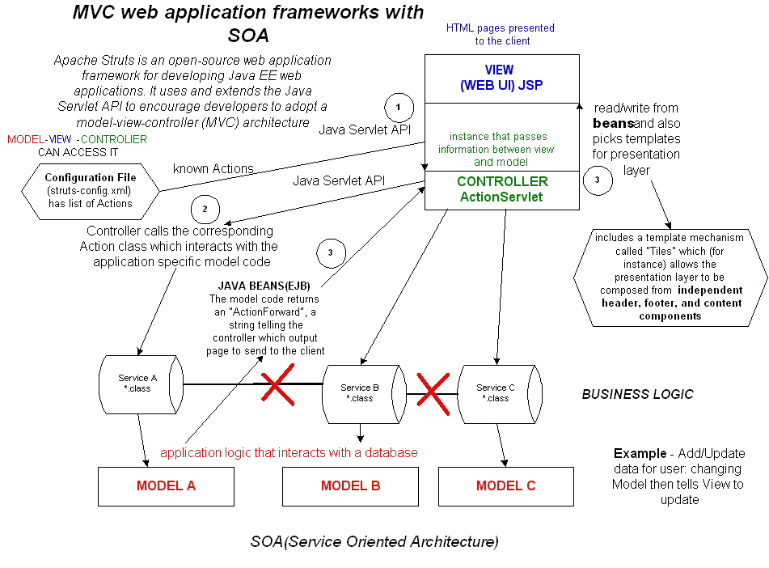

Model-view-controller (MVC) is an architectural pattern, which at the same time is also a Multitier architecture, used in software engineering. In complex computer applications that present a large amount of data to the user, a developer often wishes to separate data (model) and user interface (view) concerns, so that changes to the user interface will not affect data handling, and that the data can be reorganized without changing the user interface. The model-view-controller solves this problem by decoupling data access and business logic from data presentation and user interaction, by introducing an intermediate component: the controller.

SOA - is a style of IT architecture that delivers enterprise agility and Boundaryless Information FlowTM.
Service-Oriented Architecture (SOA) is an architectural style that supports service orientation. Service orientation is a way of thinking in terms of services and service-based development and the outcomes of services.
A service:
- Is a logical representation of a repeatable business activity that has a specified outcome (e.g., check customer credit; provide weather data, consolidate drilling reports)
- Is self-contained
- May be composed of other services
- Is a “black box” to consumers of the service

SOA style It is based on the design of the services – which mirror real-world business activities.
SOA separates functions into distinct units (services), which can be distributed over a network and can be combined and reused to create business applications.

Now when we divided our services we can talk about Agile and other Development styles:

Software development process
Activities and steps
Requirements | Architecture | Design | Implementation | Testing | Deployment
Models
Agile | Cleanroom | Iterative | RAD | RUP | Spiral | Waterfall | XP | Scrum
Supporting disciplines
Configuration management | Documentation | Software quality assurance (SQA) | Project management | User experience design

Info on Software Development Process:
http://en.wikipedia.org/wiki/Software_development_process

Agile software development
- is a conceptual framework for software engineering that promotes development iterations throughout the life-cycle of the project.
Agile Unified Process
TFD (Test-First Design)
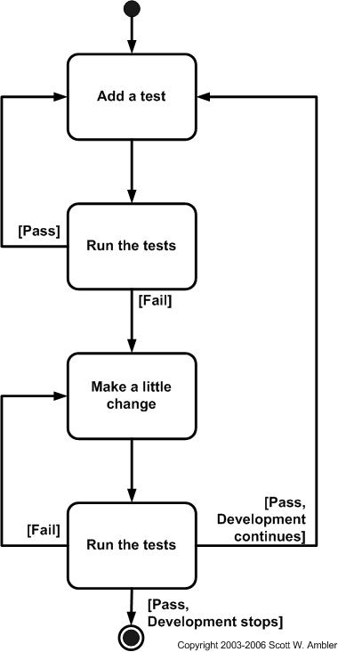
The Agile UP is based on the following philosophies:
1. Your staff knows what they're doing. People are not going to read detailed process documentation, but they will want some high-level guidance and/or training from time to time. The AUP product provides links to many of the details, if you are interested, but doesn't force them upon you.
2. Simplicity. Everything is described concisely using a handful of pages, not thousands of them.
3. Agility. The Agile UP conforms to the values and principles of the agile software development and the Agile Alliance.
4. Focus on high-value activities. The focus is on the activities which actually count, not every possible thing that could happen to you on a project.
5. Tool independence. You can use any toolset that you want with the Agile UP. The recommendation is that you use the tools which are best suited for the job, which are often simple tools (like many of open source solutions).
6. You'll want to tailor the AUP to meet your own needs.
Some of the principles behind the Agile Manifesto^{[4]} are:
- Customer satisfaction by rapid, continuous delivery of useful software
- Working software is delivered frequently (weeks rather than months)
- Working software is the principal measure of progress
- Even late changes in requirements are welcomed
- Close, daily cooperation between business people and developers
- Face-to-face conversation is the best form of communication
- Projects are built around motivated individuals, who should be trusted
- Continuous attention to technical excellence and good design
- Simplicity
- Self-organizing teams
- Regular adaptation to changing circumstances
Team of 20-40

Live365.com Release /Bug Tracking Unified System
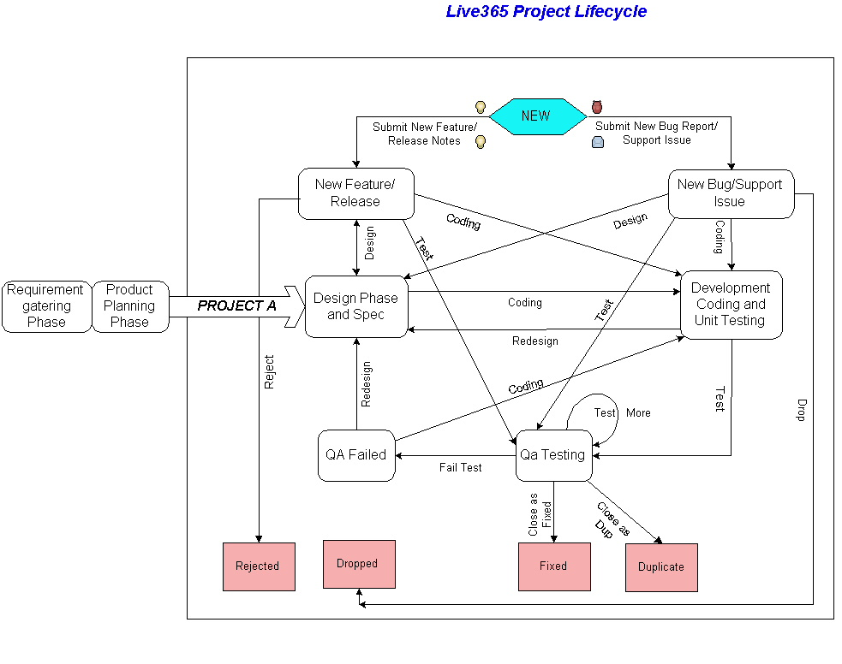

Open Source Web Test Tools

WATIR
Example: C:\ruby\lana>ruby search365.rb (Getting data from Excel, entering it into Search field, verifying results)
Watir is a simple open-source library for automating web browsers. It allows you to write tests that are easy to read and easy to maintain. It is optimized for simplicity and flexibility.
Watir drives browsers the same way people do. It clicks links, fills in forms, presses buttons. Watir also checks results, such as whether expected text appears on the page.
Watir is a Ruby library that works with Internet Explorer on Windows. Watir is currently being ported to support Firefox and Safari.
Like other programming languages, Ruby gives you the power to connect to databases, read data files, export XML and structure your code into reusable libraries. Unlike other programming languages, Ruby is concise and often a joy to read.
Watir stands for “Web Application Testing in Ruby”. It is pronounced water.

http://wiki.openqa.org/display/WTR/Tutorial

http://wtr.rubyforge.org/

http://pine.fm/LearnToProgram/ - Programming Language for Testers

SHOW EXAMPLE:
Run in Command Prompt: ruby filename.rb

Code Example:
# set a variable
test_site = http://www.google.com

# open the IE browser
ie = Watir::IE.new
# print some comments
puts "Beginning of test: Google search."

puts " Step 1: go to the test site: " + test_site
ie.goto test_site

puts " Step 2: enter 'pickaxe' in the search text field."
ie.text_field(:name, "q").set "pickaxe" # "q" is the name of the search field

puts " Step 3: click the 'Google Search' button."
ie.button(:name, "btnG").click # "btnG" is the name of the Search button

puts " Actual Result:"
if ie.text.include? "Programming Ruby"
puts " Test Passed. Found the test string: 'Programming Ruby'. Actual Results match Expected Results."
else
puts " Test Failed! Could not find: 'Programming Ruby'."
end

OpenSTA – Load/Stress/Performance Open Source Tool

http://opensta.org/download.html
The applications that make up the current OpenSTA toolset were designed to be used by performance testing consultants or other technically proficient individuals.
This means testing is performed using the record and replay metaphor common in most other similar commercially available toolsets.

Recordings are made in the tester's own browser producing simple scripts that can be edited and controlled with a special high level scripting language.

These scripted sessions can then be played back to simulate many users by a high performance load generation engine.

Using this methodology a user can generate realistic heavy loads simulating the activity of hundreds to thousands of virtual users.

Basic Instructions for OpenSTA:
1. Install OpenSTA from www.opensta.org
2. Make sure Open STA Name Server is running (task bar on the right)
3. Launch OpenSTA Commander
4. Create-New-Script (HTTP)
5. Record your actions
6. Long UserAgent wouldn't compile - cut it to be: "User-Agent: Mozilla/4.0 (compatible; MSIE 6.0; Windows NT 5.1)"
7. Compile and Save
8. Add variables under with '+' button
9. To lock login and other sessions use Mutex:
ACQUIRE MUTEX "LOGIN"
NEXT USERNAME
NEXT PASSWORD
SET MY_USERNAME = USERNAME
SET MY_PASSWORD = PASSWORD
RELEASE MUTEX "LOGIN"
10. also make sure to declare local variables:
CHARACTER*512 MY_USERNAME, LOCAL
CHARACTER*512 MY_PASSWORD, LOCAL
11. Compile and run
12. Check for response codes - 200, 304 - good, 500 - error
13. Create new test
14. Drag your script into one of tasks and set VU (virtual users)
15. Compile and run script
16. In results also observe response codes and errors

Help pages:
http://opensta.org/docs/gsg/index.htm

