There are almost twice as many mobile phones in the world than there are computers. With that phenomenal thought in mind you can understand why developing mobile apps is so lucrative, its a huge market with its users demanding ever more powerful and functional applications bridging the gap between mobiles and computers.

Keeping up with demand and trends is only half the battle for mobile app developers. They face the huge challenge of testing there application across a multitude of different handsets and OSes. Each handset is slightly different and each has its own little quirks that can not be ignored, and that is before you even contemplate the huge differences from the mobile operating systems.

In this article we have compiled a list of free tools for testing your application across the most popular mobile operating systems, including iPhone, Blackberry, Android, Symbian and Palm. Some of the tools have been officially released (with the exception of the iPhone) and are available to download with there respective SDKs, Other tools, which maybe a little bit basic, can be used as a reliable testing environment.

There are also tools below for checking your web sites “mobile-friendliness”. Some will allow for visual views, others will give you detailed reports and grade your site on its mobile effectiveness.

[**Google Android Emulator**](http://www.addictivetips.com/windows-tips/download-google-android-emulator/)

[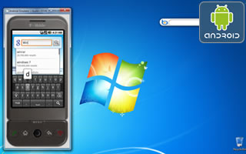](http://www.addictivetips.com/windows-tips/download-google-android-emulator/) For those of you who want to test drive Android you can use this Android Emulator which is patched to run on a Windows PC as a standalone app without having to download and install the complete and complex Android SDK, and you can even install and test Android compatible apps on it.  
[Google Android Emulator Download Package »](http://www.addictivetips.com/windows-tips/download-google-android-emulator/)

[**Official Android SDK Emulator**](http://developer.android.com/guide/developing/tools/emulator.html)

[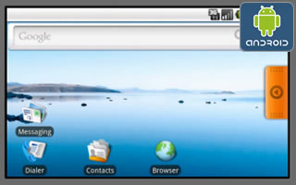](http://developer.android.com/guide/developing/tools/emulator.html)The Android SDK includes a mobile device emulator which mimics all of the hardware and software features of a typical mobile device (although, without the calls). It provides a variety of navigation and control keys, which you can "press" using your mouse or keyboard to generate events for your application. It also provides a screen in which your application is displayed, together with any other Android applications running.  
[Official Android SDK Emulator »](http://developer.android.com/guide/developing/tools/emulator.html)  
[How to Install Applications on the Android Emulator »](http://developer.android.com/guide/developing/tools/emulator.html#apps)

[**MobiOne**](http://www.genuitec.com/mobile/)

[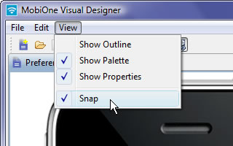](http://www.genuitec.com/mobile/)MobiOne Developer is a mobile Web IDE for Windows that helps developers to code, test, debug, package and deploy mobile Web applications to devices such as iPhone, Blackberry, Android, and the Palm Pre.  
Recently updated with its seventh version, it now includes a new drag-n-drop mobile Web visual designer for mockups, mobile HTML code generation, convenient mobile design templates, updated OSS components, screen capture, multi-touch and gesture support.  
[MobiOne Homepage & Downloads »](http://www.genuitec.com/mobile/)

[**TestiPhone.com – iPhone Application Web Based Simulator**](http://www.testiphone.com/)

[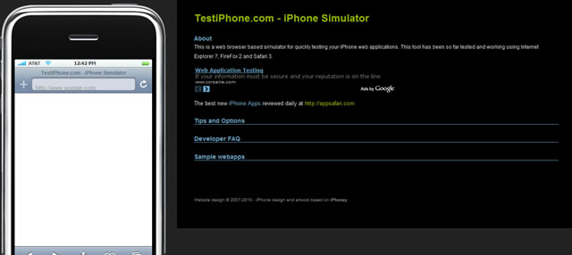](http://www.testiphone.com/)TestiPhone is a web browser based simulator for quickly testing your iPhone web applications. This tool has been tested and works using Internet Explorer 7, FireFox 2 and Safari 3.  
[TestiPhone.com – iPhone Application Web Based Simulator »](http://www.testiphone.com/)

[**iPhoney**](http://www.marketcircle.com/iphoney/)

[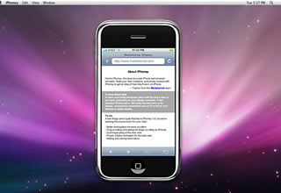](http://www.marketcircle.com/iphoney/)iPhoney gives you a pixel-accurate web browsing environment – powered by Safari – that you can use when developing web sites for the iPhone. It's the perfect 320 by 480-pixel canvas for your iPhone development.  
iPhoney is not an iPhone simulator but instead is designed for web developers who want to create 320 by 480 (or 480 by 320) websites for use with iPhone. It gives you a canvas on which to test the visual quality of your designs.  
iPhoney will only run on Mac OS X 10.4.7 or later.  
[iPhoney Homepage and Downloads »](http://www.marketcircle.com/iphoney/)

[**iBBDemo – Blackbaud iPhone Browser Simulator**](http://labs.blackbaud.com/NetCommunity/article?artid=662)

[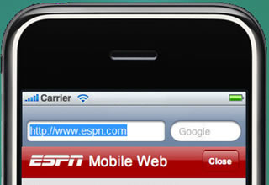](http://labs.blackbaud.com/NetCommunity/article?artid=662)iBBDemo correctly renders Webkit targeted html including the custom -webkit CSS extenstions, effectively giving you a compelling demo/test platform for iPhone Web content from the comfort of a Windows desktop (who said it could not be done?).  
[iBBDemo – Blackbaud iPhone Browser Simulator »](http://labs.blackbaud.com/NetCommunity/article?artid=662)  
[iPhone Browser Simulator for Windows Screencast »](http://labs.blackbaud.com/ibbdemo/ibbdemo.html)

[**Emulator – Palm Developer Center**](http://developer.palm.com/index.php?option=com_content&view=article&id=1744&Itemid=21)

[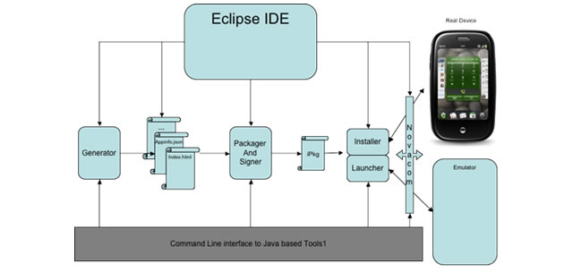](http://developer.palm.com/index.php?option=com_content&view=article&id=1744&Itemid=21)This official Palm emulator emulates the Palm webOS device on a Linux, Mac and or Windows. If you already the SDK installed, you will already have the emulator on your computer.  
[Pre Emulator – Palm Developer Center »](http://developer.palm.com/index.php?option=com_content&view=article&id=1744&Itemid=21)  
[Download the Palm Pre SDK (Mac, Linux and Windows) »](http://developer.palm.com/index.php?option=com_content&view=article&id=1788&Itemid=55)

[**BlackBerry Simulator**](http://www.blackberry.com/developers/downloads/simulators/index.shtml)

[](http://www.blackberry.com/developers/downloads/simulators/index.shtml)There are a variety of official BlackBerry simulators available to emulate the functionality of actual BlackBerry products. With any of the BlackBerry device simulators, you can demonstrate and test how the BlackBerry device software, screen, keyboard and trackwheel will work with your application. These simulators will also simulate behavior in various wireless network conditions.  
[BlackBerry Simulator »](http://www.blackberry.com/developers/downloads/simulators/index.shtml)  
[Software Downloads for Blackberry Device Simulators »](https://www.blackberry.com/Downloads/entry.do?code=060AD92489947D410D897474079C1477)

[**Nokia Platform and Device SDKs**](http://www.forum.nokia.com/Tools_Docs_and_Code/Tools/Platforms/S60_Platform_SDKs/)

[](http://www.forum.nokia.com/Tools_Docs_and_Code/Tools/Platforms/S60_Platform_SDKs/)When coupled with your favourite development tool, the S60 platform and device SDKs provide all the features required to quickly and efficiently build and test Symbian applications on a PC.  
[Nokia Platform and Device SDKs »](http://www.forum.nokia.com/Tools_Docs_and_Code/Tools/Platforms/S60_Platform_SDKs/)  
[Nokia Device Specifications »](http://www.forum.nokia.com/devices/matrix_s60_1.html)  
[Nokia Mobile Browser Simulator 4.0 »](http://www.forum.nokia.com/info/sw.nokia.com/id/db2c69a2-4066-46ff-81c4-caac8872a7c5/NMB40_install.zip.html)  
NMB 4.0 is a mobile Internet browser SDK that can browse mobile Internet content from your local computer. This resource has been archived because it is not considered relevant for developers creating commercial solutions today, but it was still fun playing about with it.

[**WinWAP Smartphone Browser Emulator**](http://www.winwap.com/desktop_applications/browser_emulator)

[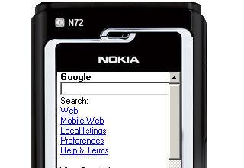](http://www.winwap.com/desktop_applications/browser_emulator)WinWAP Smartphone Browser Emulator let's you use WAP services on your Windows PC. The browser is a mobile Internet browser that emulates the way you would use the mobile Internet services on the built-in browser of a smartphone.  
This Smartphone Browser Emulator is more about providing an experience that mimics the one you would have on a real smartphone. It looks like a smartphone on the desktop of your PC, you can click with the mouse on the buttons of the phone to scroll the screen and select links, and use the keyboard of your PC to enter text.  
[WinWAP Smartphone Browser Emulator »](http://www.winwap.com/desktop_applications/browser_emulator)  
[WinWAP Smartphone Browser Emulator Downloads »](http://www.winwap.com/downloads/downloads)  
[WinWAP Smartphone Browser Emulator Skins »](http://www.winwap.com/desktop_applications/browser_emulator_skins)

[**Windows Mobile 6.1.4 Emulator Images**](http://www.microsoft.com/downloads/details.aspx?FamilyID=1A7A6B52-F89E-4354-84CE-5D19C204498A&displaylang=en)

[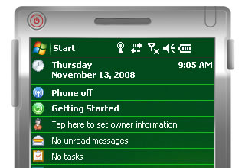](http://www.microsoft.com/downloads/details.aspx?FamilyID=1A7A6B52-F89E-4354-84CE-5D19C204498A&displaylang=en)This official Windows Mobile 6.1.4 Emulator Images package adds emulator images to Visual Studio 2005 or Visual Studio 2008 that allows you to test applications for Windows Mobile 6.1.4, including Internet Explorer Mobile 6. The emulator images CAN also be used as standalone application without Visual Studio.  
[Windows Mobile 6.1.4 Emulator Images »](http://www.microsoft.com/downloads/details.aspx?FamilyID=1A7A6B52-F89E-4354-84CE-5D19C204498A&displaylang=en)

[**MicroEmulator**](http://www.microemu.org/)

[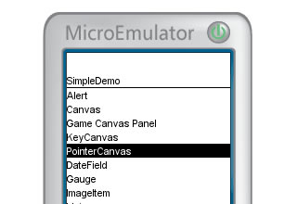](http://www.microemu.org/)The MicroEmulator is a versatile and expandable CLDC/MIDP 1.0 mobile device emulator. It can be used as a standalone application on any Java enabled workstation. It will allow you to demonstrate MIDlet based applications in a web browser applet and can be run as standalone java application.  
[MicroEmulator Home »](http://www.microemu.org/)  
[Skinning the MicroEmulator »](http://www.petitpub.com/labs/j2me/me/tutorial/)  
In this tutorial the developer describes how to skin the MicroEmulator to look like his favorite mobile platform, the SonyEricsson T610, using the Applet presentation layer.

[**Perfecto Mobile -Test Mobile Applications on Real Devices**](http://www.perfectomobile.com/portal/cms/index.html)

[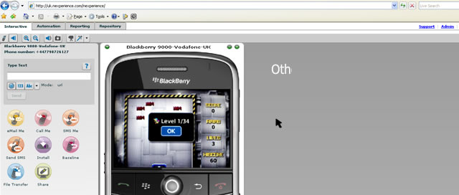](http://www.perfectomobile.com/portal/cms/index.html)The Perfecto Mobile Handset Cloud service will allow you to test your mobile applications, websites or services on a multitude (over 450 hand-sets) of REAL handsets. It will allow you to access real mobile devices via the web and control them as if you were holding them in your hands.  
This service is not free, you can choose from either paying $16 per hour or buy a subscription from $12 per hour.  
[Perfecto Mobile -Test Mobile Applications on Real Devices »](http://www.perfectomobile.com/portal/cms/index.html)  
[Perfecto Mobile Demo »](http://www.perfectomobile.com/portal/cms/demo/)

[**mobiReady – dotMobi Compliance & mobileOK Checker**](http://mobiready.com/launch.jsp?locale=en_EN)

[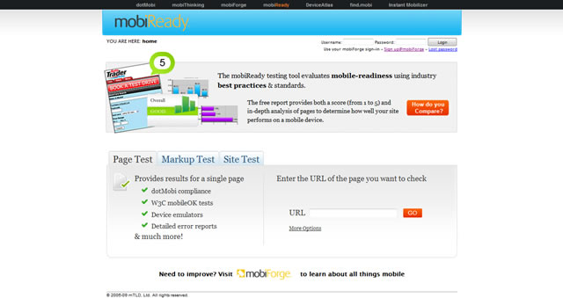](http://mobiready.com/launch.jsp?locale=en_EN)The mobiReady testing tool evaluates your websites mobile-readiness using industry best practices ands standards.  
The free report provides both a score (from 1 to 5) and an in-depth analysis of pages to determine how well your site will perform on a mobile device.  
You can either test individual page (by URL input), test the markup or you can choose to Site Test, which will give you detailed reports for an entire site.  
[mobiReady – dotMobi Compliance & mobileOK Checker »](http://mobiready.com/launch.jsp?locale=en_EN)

[**W3C mobileOK Checker**](http://validator.w3.org/mobile/)

The W3C mobileOK Checker is a free service from the W3C that helps check the level of mobile-friendliness of Web documents, and in particular assert whether a Web document is mobileOK.  
[W3C mobileOK Checker »](http://validator.w3.org/mobile/)  
[W3C Mobile Web Best Practices »](http://www.w3.org/TR/mobile-bp/)

[**iPad Peek**](http://ipadpeek.com/)

[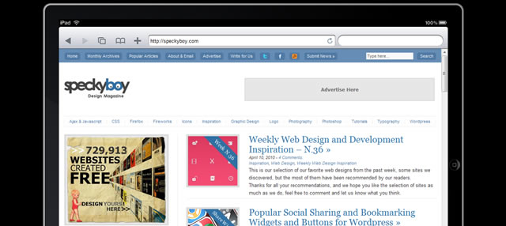](http://ipadpeek.com/)iPad Peek is a nifty tool that lets you see how any website will be rendered on the iPad. Click on the top border to switch from landscape to portrait mode. The virtual keyboard and the buttons on the iPad browser are just for show, but the reload button works.  
[iPad Peek »](http://ipadpeek.com/)  
[iPad Peek: See How Your Website Looks on the iPad »](http://mashable.com/2010/04/05/ipad-peek/) article via Mashable.

[**Opera Mini Simulator**](http://www.opera.com/mobile/demo/)

[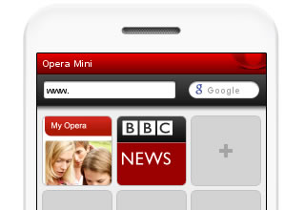](http://www.opera.com/mobile/demo/)This MicroEmulator (see above) powered live demo of the world’s most popular mobile Web browser, Opera Mini 5. It functions exactly as it would when installed on a handset.  
[Opera Mini Simulator »](http://www.opera.com/mobile/demo/)

Basically links to all the emulators of the devices that are in jquery mobile's mgbs:  
<http://jquerymobile.com/gbs/>

Looks like PPK has basically done this with his recent ALA post:   
<http://www.alistapart.com/articles/smartphone-browser-landscape/>

don't have all the browsers listed on the jQuery Mobile site, but I wrote a blog post on my exploits getting devices last month and the cost:  
<http://thomasjbradley.ca/blog/mobile-testing-suite>

<http://www.mobilexweb.com/emulators> super handy.

and also <http://www.456bereastreet.com/archive/201102/opera_mobile_emulator_and_opera_mini_simulator/>

and running the three emulators quickly:  
<https://gist.github.com/844458>

asked Brad to document his setup! <http://bradfrostweb.com/blog/mobile/test-on-real-mobile-devices-without-breaking-the-bank/> good stuff

EDIT: and a post on selecting devices from stephanie: <http://stephanierieger.com/strategies-for-choosing-test-devices/>

Posted some resources I've used and come across that may be useful. <http://www.thecssninja.com/mobile/testing-devices>

<http://adactio.com/journal/5433/>  
They seem to have a collect everything possible approach   
and it is crowdsourced <http://adactio.com/journal/5446/>.

also, <http://cole007.net/blog/111/setting-up-a-mobile-testing-suite>

very related: cataloging all people's mobile device test setups here: <http://mytestsuite.tumblr.com/>

awesome: <http://adactio.com/journal/5661/>

the Open Device Lab way: <http://mobile.smashingmagazine.com/2012/09/24/establishing-an-open-device-lab/>

I put together the details of how we [set-up our device lab](http://www.dmolsen.com/mobile-in-higher-ed/2012/06/26/how-to-build-a-device-lab-part-1/) at West Virginia University. We've also open sourced a tool, [Throttle](https://github.com/dmolsen/Throttle), that we're using to test how well our sites perform at less than optimal network speeds/connections. I'm hoping to do a follow-up post that focuses on the software-side of a device lab showing how we're using [Adobe Shadow](http://labs.adobe.com/technologies/shadow/) & [shim](https://github.com/marstall/shim) too: <http://www.dmolsen.com/mobile-in-higher-ed/2012/06/26/how-to-build-a-device-lab-part-1/>

<https://github.com/dmolsen/Throttle>

<http://html.adobe.com/edge/inspect/>

<https://github.com/marstall/shim>

Mobile Devices rentals and device services:

<https://bagcheck.com/bag/7264-yiibu-s-tools-of-the-trade>

<https://bagcheck.com/blog/22-mobile-device-testing-the-gear>

Ultimate Guide for Emulators:

<http://www.mobilexweb.com/emulators>