***Session 4    ***

***Dear Students,***

1. ***Session 4 Presentation Slides have been uploaded to :***

[***https://drive.google.com/drive/folders/0B__Jza6ZnWYYc0Y4Sl9rR3BTbDg***](https://drive.google.com/drive/folders/0B__Jza6ZnWYYc0Y4Sl9rR3BTbDg)

***2. It’s time to get familiar with our Bugzilla Bug Tracking Database.***

***Link to Bugzilla , Lomotif Project  (  DO NOT FILE ANY BUGS)***

[***http://bugzilla.portnov.com/***](http://bugzilla.portnov.com/)

***login: lomotif_jan3@portnov.com    ( case sensitive)***

***password: welcome010317    ( case sensitive)***

***(  DO NOT FILE ANY BUGS until we go through all of them. Each session I will be adding more from our Main Database)***

***READ this First :***

***In a previous session you have recorded a Media Files.***

***We don’t need them any more, especially the ones that FAIL.***

***Remove it from your phone and copy it to YOUR GOOGLE DRIVE folder ( not mine )***

***I will ask you for an access to this folder later.***

***Please Read the Bug Description and step to reproduce and then go find a corresponding column in our table and enter the following :***

1. ***For Bugs, that you are able to reproduce - enter “Open”***
2. ***For Bugs, that you are UNABLE to reproduce - enter “U/R”***
3. ***For features that is not supported by your device while going through entries , “N/A”***

***Check entries : #5611,#5610,#5609,#5608,#5607,#5606,#5605,#5603,#5602 and #5601***

***iOS and Android users - use your Tabs***

***Again, DO NOT ENTER ANY BUGS !!!***

***See you on Thursday, Feb 16***

***Regards,***

***Natalia***

***Session 3 Homework*** 

***2/10/2017***

***Dear Students,***

***Let’s continue to roll with our Mobile APP Testing***

***New Folder was created in our Google Drive: Interview Questions.***

***Please review it and answer to yourself ( no need to send anything out)***

***Questions that are highlighted in yellow are mandatory to know***

[***https://drive.google.com/drive/folders/0B__Jza6ZnWYYOGZRaEpVWlNTSTA***](https://drive.google.com/drive/folders/0B__Jza6ZnWYYOGZRaEpVWlNTSTA)

***Lomotif :***

1. ***Download MSQRD app from Google Play Store or APP Store***
2. ***Create 1 Image File***
3. ***Create 1 Video File***

***Play around with stickers , other available options ( have fun with it :)***

***4. Save and playback***

***5. If everything ( 1-5 ) looks good , then playback these Image and Video Files through Lomotif.***

***6. Enter Pass or Fail Results into our Main Table ( columns are added)***

***Help me a little please by copy/paste already colored cells with info***

***Green for Pass, Red for Fail, yellow for N/A ( thanks a lot)***

***Battery Consumption Test :***

1. ***Lomotif***

***a)Uninstall Lomotif App***

***b)Connect charger and wait until your device is fully charged***

***c) Install Lomotif***

***d) Play with Lomotif App for 15 min (no stress testing)***

***e) Check % of Power consumed***

***f) Enter your result in an appropriate column in Reference Table.***

***(The number should indicate % of Power consumed, not the remaining life)***

***Preparing for the Project Testing : Link below ( read first)***

***Please Download a specific Media subfolders to your Devices .***

***This Media is sent to us by Lomotif).***

***Get familiar with content. ( no need to report anything yet)***

***Android Users : Audio Media, Special Media, Position_me.jpg and test_media_5x***

***( use iTunes or other tool ) iOS Users : Audio Media, Special Media, Position_me.jpg and test_media_6S***

***Note for iOS Users: on some devices it is possible that not ALL test_media_6S files would be downloaded to your device, because of unsupported formats. Please use your own media files and those that were able to download from Media Files Folder.***

***Should be no issues with Android OS.***

***Wait for more instructions …..***

[***https://drive.google.com/drive/folders/0B__Jza6ZnWYYVkV3NThQeDA5Nkk?usp=sharing***](https://drive.google.com/drive/folders/0B__Jza6ZnWYYVkV3NThQeDA5Nkk?usp=sharing)

***See you on Monday, Feb 13th***

***Have a nice weekend,***

***-Natalia***

***Session 2*** 

***Dear Students,***

***UPDATE 2/7/2017 : Columns for PANORAMA photo were updated :***

***Please submit your results :***

1. PANORAMA Portrait mode photo : 1
2. PANORAMA Landscape mode photo : 1

***Please READ Carefully entire instructions before proceeding with testing.***

***In Homework 1 you have created Media Files, that we will use now, doing our Homework after Session 2.***

***USE YOUR DEVICE (Mobile Phone)***

***1. Open Gallery or Albums where you Files are stored***

***2. Check Preview (Thumbnail), verify it’s not empty and the picture (frame) is stored.***

***3. Tap to Playback ( your default Media Player)***

***4. Playback few Files that you have recorded. Verify that there are no black screens instead of Video or Pictures.***

***LOMOTIF …….is our Project !***

***What is Lomotif? Please watch this Video to get familiar with our app. You will include it in your resume!***

[***https://www.youtube.com/watch?v=ifOEKai5Gn0&feature=youtu.be***](https://www.youtube.com/watch?v=ifOEKai5Gn0&feature=youtu.be)

***LOMOTIF is a Native APP, used by 5.5 million users all over the world.***

***Lomotif is the simplest way to add music to your moments. You can create hyper-short, super shareable music videos in 3 simple steps. The app allows users to cherry-pick from over a billion songs to instantly and automatically create visual mash-ups.***

***It’s developed for both iOS and Android. Current version for iOS is 2.1.5 and for OS ( Android) is 2.0.4 (updates for versions are rolling on frequently, it can change any day)***

***It’s a live Project and we have a continuing feedback from the development team, live Bug Tracking Database and Test Suits, which were created by Lomotif QA team.***

***5. Go to Google Play or App Store. Find LOMOTIF app (do not install) and READ # 6 and further***

***6. Read carefully the description, reviews, find version number, description of fixes.***

***7. Observe GUI , does it look good on your Device Screen?***

***8.******Install LOMOTIF APP (check your GUI at all times, verify LOGO is not corrupted and Download/Install Buttons are correctly marked)***

***9.******After installation , Open LOMOTIF , tap START at HOME SCREEN.***

***10.******The MEDIA that you have created should be picked by APP and placed in a FOLDER at “ADD PHOTOS AND VIDEOS” ( depending on Device this screen with Albums may look a little different. Anyway it’s going to be a second screen(page) after HOME PAGE.***

***11.******Playback ALL the Media Files THROUGH LOMOTIF .***

***(Select , press next ( > on the top) , do not select Music, proceed to next screen.***

***YOUR test results ONLY apply if you playback created MEdia Files through LOMOTIF.***

***Enter Pass or Fail Results into an appropriate columns in our Main Table.***

***Fill out Columns : F-U ( before greyed out area)***

***Enter N/A ( not applicable ) for Options that is not supported by your device.***

***FYI : you will find plenty of Bugs while working on Lomotif. Although I understand an urge and excitement in finding them , we do have a Bug Tracking Database where all previous finding are documented.***

***We will need to perform a regression test on these first ( access to Bugzilla will be given later) and then we will be filing a new ones.***

***See you Thursday, Feb 9th @6pm***

***Regards,***

***Natalia***



Dear Students,

It’s been a pleasure to begin our Mobile App Testing Sessions with you.

Our Homework from each session is going to be included in this doc and latest ones are always going to be on top.

1. I would need 6 people to be a Team Leaders : 3 – for Android Devices and 3 – for Apple Devices
2. You ( as a group ) should select volunteers that are willing to contribute some extra time to answer questions in a chat room, deliver information from me , know how to manage Google Sheets , supervise data entry , collect problem media and overall have be a nice and helpful people who is patient and courteous.

From our side – volunteer’s activity would be reflected in a resume as extra points.

1. Team Leaders: create a separate Group on Skype , name it “Leaders_Jan03” and invite me and **Kristina Dzyuba** ( your Program Supervisor).
2. Copy of incompatible Devices that wouldn’t be able to participate in our project. Please get another device.

<https://drive.google.com/drive/folders/0B__Jza6ZnWYYMkhJc05rc1pIdXM>

**My message to all :** Please READ all instructions CAREFULLY and FOLLOW them.

Our course is very structured and if for some reason you don’t know what to do next, this means you haven’t been guided yet to make a next step or did not proceed with given instructions.

Ask your Team leaders and group members first and “hard” cases will be forwarded to me.

I will not be participating in a Chat Room because of my schedule in a classrooms however I could be reached via Skype ( natalia.stefanioutine ) or email [sqamobilemgr@gmail.com](mailto:sqamobilemgr@gmail.com)

Link to our INFO doc <https://drive.google.com/drive/folders/0B__Jza6ZnWYYMkhJc05rc1pIdXM>

Let’s ROLL with our first task and prepare a **Testing Multimedia Files** for our future Project that will be included in your Resume.

No need to send it in or do anything else at this point. Just Record Videos, take pictures and rename it accordingly. (You might want to connect your Device to PC/Laptop to rename files)

**NOTE 1:** To take upside-down picture/or video you will need just to rotate your phone to the position where camera “window” is down.

**NOTE2:** some Camera and Video Settings might not be available for your particular Device (Phone). Also, Settings do vary from Device to Device.

**NOTE3:** Rotating your Phone to the right or left will give you a Landscape Mode (16:9)

Otherwise it’s in 4:3 (Portrait)

If this is a case, please prepare Files that are only applicable for your Device (Phone). Instructions and Screenshots are below.

See you on Monday, February 6th @6pm .

Natalia S.

***Record Video Files :***

Rename files ( best to use PC or MAC) . Example : you have recorded a video from front camera, portrait 4:3 layout, in 720p ( from task 1)

Rename a file to : **fc_prt_720p.\***

(for landscape 16:9 layout the file name is fc_**lsp**_720p.*)

1. FRONT CAMERA – Portrait layout : Record 1 ( 1-2 min) videos in 720P mode .
2. FRONT CAMERA – Portrait layout : Record 1 ( 1-2 min) videos in 1080P mode .
3. BACK CAMERA- Portrait layout : Record 1 (1-2 min) videos in any mode ( 720p or 1080p)
4. BACK CAMERA – Landscape 16:9 layout : Record 2 (1-2 min) videos in any mode ( 720p or 1080p)
5. BACK CAMERA – UpsideDown– Portrait layout : Record 2 (1-2 min) videos in any mode ( 720p or 1080p)
6. BACK CAMERA – UpsideDown– Landscape 16:9 layout: Record 2 (1-2 min) videos in any mode ( 720p or 1080p)
7. FRONT CAMERA – any layout- Record 1 ( 1 min) videos in 720P mode .
8. FRONT CAMERA – any layout- Record 1 ( 1 min) videos in 1080P mode .

***Please take some pictures :***

1. FRONT CAMERA – Portrait 4:3 layout : 5
2. FRONT CAMERA – Landscape 16:9 layout : 5
3. BACK CAMERA – Portrait 4:3 layout : 5
4. BACK CAMERA – Landscape 16:9 layout : 5
5. PANORAMA Portrait mode photo : 1
6. PANORAMA Landscape mode photo : 1

xxxxxxxxxxxxxxxxxxxxxxxxxxxxxxxxxxxxxxxxxxxxxxxxxxxxxxxxxxxxxxxxxxxxxxxxxxxxxxxxxxxxxxxxxxxx

Android Samsung

1. Tap on Camera Icon

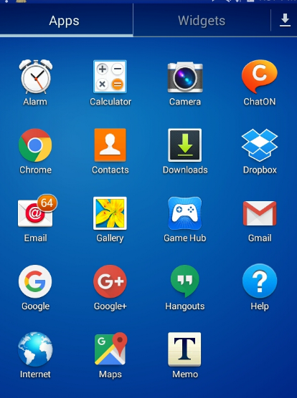

1. Tap a Setting Wheel, Select Photo Icon and Select desired option. Complete required task ( below)

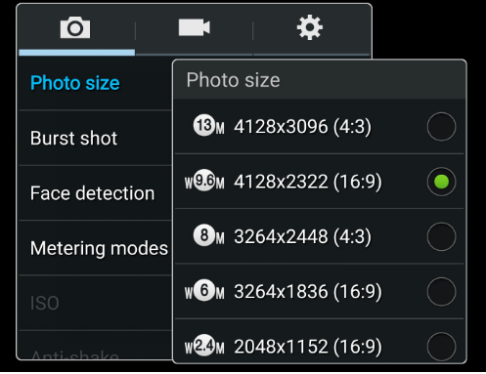

1. Repeat #2 for Video.

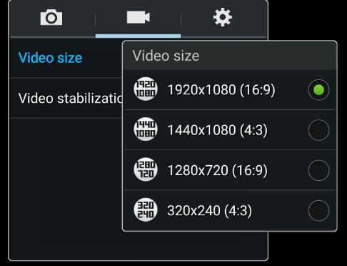

For IPhone : Go to Settings

