***https://docs.google.com/drawings/u/1/d/shKfMFl1CphAQ8Tm21gkGyQ/image?w=210&h=44&rev=4&ac=1       ( ready to use )***

***2/27/2018***

***Still having a Problem with Android Studio ? Check :***

1. ***Did you read ALL Instructions?***
2. ***Did you contact Team Leaders or Team Members?***
3. ***Did you install ALL Updates that were prompted by links?***

***If you answered NO to any of these three questions , please do not contact me . Thank you for your consideration?***

***Otherwise : Send me a note with your email address to*** [***natalias@portnov.com***](mailto:natalias@portnov.com)

***ONLY IF THIS IS Absolutely last option.***

***xxxxxxxxxxxxxxxxxxxxxxxxxxxxxxxxxxxxxxxxxxxxxxxxxxxxxxxxxxxxxxxxxxxxxxxxxxxxxxxxxxxxxxxxxxxxxxxxxxxxxxxxx***

1. ***Final QA Interview Questions Document was updated with a correct Question about the difference in testing approaches between WEB and Mobile APP . Thank you , guys for letting me know there was a mistake in there .  Question # 1***

[***https://drive.google.com/drive/u/1/folders/1mnAgnqWC8CmcI-tn-mnOMjcCgTBbCMfv***](https://drive.google.com/drive/u/1/folders/1mnAgnqWC8CmcI-tn-mnOMjcCgTBbCMfv)

***2.   Session 6  ( 2 sets - because we are done with Part 1 and started Part 2 )  Presentation is now posted in*** https://drive.google.com/drive/u/1/folders/183DhG115u7O20uSwqNxlg01_hB54bbTI

1. ***Please go through Interview Questions and answer # 38-57*** [***https://drive.google.com/drive/u/1/folders/1mnAgnqWC8CmcI-tn-mnOMjcCgTBbCMfv***](https://drive.google.com/drive/u/1/folders/1mnAgnqWC8CmcI-tn-mnOMjcCgTBbCMfv)

***3.  Check Java  version on your PC/Laptop  .***

***For Windows :***

***Control Panel -->Programs and Features→ Scroll to Java version***

***If you have Java 9 installed on your system , please uninstall it***

***Then Go to*** [***https://java.com/en/download/***](https://java.com/en/download/) ***and install this version 8 update 161***

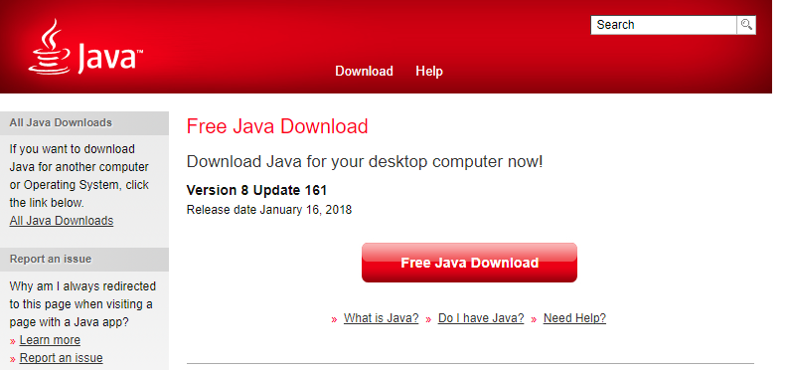

***This is the most stable update and if do not downgrade your Java version from 9 to 8u161 , you might be having problems with AVD and Android Monitor when we start working on it.***

***4.   Android Device  ( WINDOWS users ONLY. MAC users will not experience this potential problem )***

***Take your Android Device, insert USB Cable and connect it to your PC/Laptop***

***4.1  If it’s the first time, you will be receiving a notification “ Installing Software from this device”.....Wait until you receive a message “ Software is successfully installed”***

***Go Device Manager and check Portable Devices .***

***Your Device should be shown without any visual indications that something is wrong ( i.e yellow icons near device )***

***4.2 In case you have received a notification “ Software for your device is NOT successfully installed “***

***Take your Device-->Open Settings-->find Model Number***

***Write it down***

***Google Search : USB driver for Model #***

***Download Driver to your PC/Laptop ( if .exe is available double click it and allow installation -->update driver***

***Done***

***if only package available:***

***Go back to Device Manager -->Portable Devices-->Right click-->Remove , then again Right click -->Install , prompt where driver is located when asked.***

***Check Device Manager if your Device is now recognized.***

***xxxxxxxxxxxxxxxxxxxxxxxxxxxxxxxxxxxxxxxxxxxxxxxxxxxxxxxxxxxxxxxxxxxxxxxxxxxxxxxxxxxxxxxxxxxxxxxxxxxx***

***5. LOMOTIF  ( not loCOmotif, not LomotifF or other please ), it’s lomOtif  :) :)***

***Test Scenario Matrix  ( most of you already created your own copy in the same directory)***

***For someone who didn’t →  DOWNLOAD YOUR OWN COPY of Testers Regression Testing Checklist***

***( originally it was made for iOS, but you may adjust some options to fit your device settings)***

<https://drive.google.com/drive/u/1/folders/1_WZAnhV2zDH2brX8AgrbfU3jp1VQnqbF>

***Using the Media that you have downloaded from Media Folder , select few files ( not all of them ) and start testing Scenarios 12-18***

***6. Please go through entries - # 7862- #7852  ( ignore the bugs that are in grey columns #  in our main table)***

***Enter your results into our Main Table :*** [***https://docs.google.com/spreadsheets/u/1/d/1KUzHf1IFYowzrWQ_0FML1iDf37IsRgOrSRDp2D69GBw/edit?usp=drive_web&ouid=107325977683124671283***](https://docs.google.com/spreadsheets/u/1/d/1KUzHf1IFYowzrWQ_0FML1iDf37IsRgOrSRDp2D69GBw/edit?usp=drive_web&ouid=107325977683124671283)

***Open - if you are able to reproduce it***

***U/R - if you are unable to reproduce it***

***N/A- if you are unable to follow exact steps to reproduce this bug***

***As a reminder:***

***Link to Bugzilla , Lomotif Project  (  DO NOT FILE ANY BUGS)***

[***http://bugzilla.portnov.com/***](http://bugzilla.portnov.com/)

***login: lomotif_jan3@portnov.com    ( case sensitive)***

***password: welcome010317    ( case sensitive)***

***( AGAIN :  DO NOT FILE ANY BUGS  UNTIL WE ARE DONE WITH REGRESSION TEST)***

***See you on Thursday, March 1***

***-Natalia***