***SESSION 1 Homework  ***

***2/06/2018***

Dear Students,

It’s been a pleasure to begin our Mobile App Testing Sessions with you.

**Please get an older ANdroid ( OS 4.4 and higher ) to participate in Android Studio IDE and learn how to use ADB commands when we start .**

xxxxxxxxxxxxxxxxxxxxxxxxxxxxxxxxxxxxxxxxxxxxxxxxxxxxxxxxxxxxxxxxxxxxxxxxxxxxxxxxxxxxxxxxxxxxxxxxxxxxxxxxxxxxxxxxxxxxxxxxxxxxxxxx

Our Slides Homework as well as Presentations from each session is going to be included in this doc and latest ones are always going to be on top.

<https://drive.google.com/drive/u/1/folders/183DhG115u7O20uSwqNxlg01_hB54bbTI>

xxxxxxxxxxxxxxxxxxxxxxxxxxxxxxxxxxxxxxxxxxxxxxxxxxxxxxxxxxxxxxxxxxxxxxxxxxxxxxxxxxxxxxxxxxxxxxxxxxxxxxxxxxxxxxxxxxxxxxxxxxxxxxxx

I will be asking you to answer Interview Questions after each Session.

<https://drive.google.com/drive/u/1/folders/1mnAgnqWC8CmcI-tn-mnOMjcCgTBbCMfv>

**Your task for Thursday : PLEASE ANSWER QUESTION # 1**

**IMPORTANT and HIGHLY APPRECIATED :**

**Please do not modify any of my documents and do not leave yours in my Google Folder unless I ask you.**

**You, at all time, should download, create your own copy on your own computer/device .**

xxxxxxxxxxxxxxxxxxxxxxxxxxxxxxxxxxxxxxxxxxxxxxxxxxxxxxxxxxxxxxxxxxxxxxxxxxxxxxxxxxxxxxxxxxxxxxxxxxxxxxxxxxxxxxxxxxxxxx

Our Main Table is here. This document will be showing Project Progress.

<https://drive.google.com/drive/u/1/folders/1jzW2ZpzYrEpqD9ptOWTVOvqm4gGVYZNw>

Looks like you guys are so good in finding team leaders , great job :) Thank you

1. I would need 6 people who are willing to spend extra time to answer questions in a chat room, deliver information from me , know how to manage Google Sheets , supervise data entry , collect problem media and overall have be a nice and helpful people who is patient and courteous.

From our side – volunteer’s activity would be reflected in a resume as extra points that is approved by Mikhael and Kristina will be adding it into resumes of those who are involved.

1. Team Leaders: create a separate Group on Skype , name it “Leaders_Jan4th_2018” and invite me and **Kristina Dzyuba** ( your Program Supervisor).
2. Copy of incompatible Devices that wouldn’t be able to participate in our project : AZUS... Please get another device.

Please add your device name and info here : PLEASE NOTE there is a separate TABS for iOS ( APPLE) devices and Android Devices

<https://docs.google.com/spreadsheets/u/1/d/1KUzHf1IFYowzrWQ_0FML1iDf37IsRgOrSRDp2D69GBw/edit?usp=drive_web&ouid=107325977683124671283>

**My message to all :** Please READ all instructions CAREFULLY and FOLLOW them.

Our course is very structured and if for some reason you don’t know what to do next, this means you haven’t been guided yet to make a next step or did not proceed with given instructions.

Ask your Team leaders and group members first and “hard” cases will be forwarded to me.

I will not be participating in a Chat Room because of my schedule in a classrooms however I could be reached via Skype ( **nstefanioutine@gmail.com** ) or email [sqamobilemgr@gmail.com](mailto:sqamobilemgr@gmail.com)

Link to our INFO doc :

<https://drive.google.com/drive/u/1/folders/1JM6rSrx-kGRMnv5odKI6rkgZJ-ziJyJQ>

Let’s ROLL with our first task and prepare a **Testing Multimedia Files** for our future Project that will be included in your Resume.

No need to send it in or do anything else at this point. Just Record Videos, take pictures and rename it accordingly. (You might want to connect your Device to PC/Laptop to rename files).

When asked to create upside pictures and videos all I care is that your camera is down. The picture would rotate, but it’s not important .

**NOTE 1:** To take upside-down picture/or video you will need just to rotate your phone to the position where camera “window” is down.

**NOTE2:** some Camera and Video Settings might not be available for your particular Device (Phone). Also, Settings do vary from Device to Device.

If this is a case, please prepare Files that are only applicable for your Device (Phone). Instructions and Screenshots are below.

**NOTE3:** Rotating your Phone to the right or left will give you a Landscape Mode (16:9)

=Otherwise it’s in 4:3 (Portrait)

***Record Video Files :***

Rename files ( best to use PC or MAC) . Example : you have recorded a video from front camera, portrait 4:3 layout, in 720p ( from task 1)

Rename a file to : **fc_prt_720p.\***

(for landscape 16:9 layout the file name is fc_**lsp**_720p.*

1. PANORAMA photo : 2

xxxxxxxxxxxxxxxxxxxxxxxxxxxxxxxxxxxxxxxxxxxxxxxxxxxxxxxxxxxxxxxxxxxxxxxxxxxxxxxxxxxxxxxxxxxx

Android SamsungTap on Camera Icon 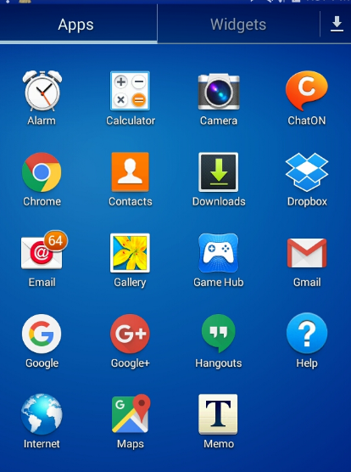

1. Tap a Setting Wheel, Select Photo Icon and Select desired option. Complete required task ( below)

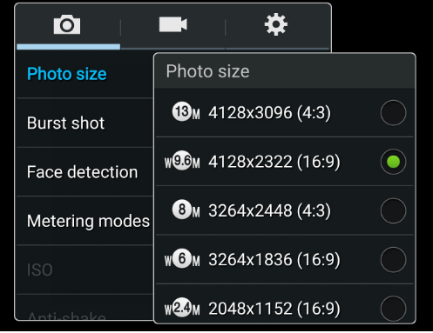

1. Repeat #2 for Video.

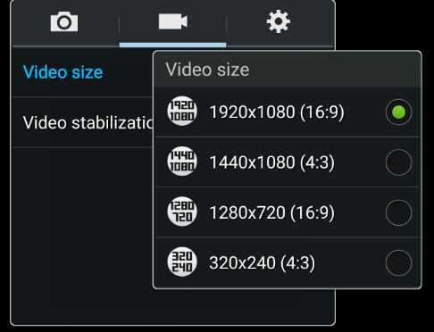

For IPhone : Go to Settings



