***https://docs.google.com/drawings/d/s3AultVsECcOWt2pHhalSPQ/image?w=210&h=44&rev=2&ac=1     (ready to use )***

1. ***Session 3 Presentation is now posted in***[***https://drive.google.com/drive/u/0/folders/1UNeo4XHUcjvhUnVYQTQ8wAzxUbEBv1GR***](https://drive.google.com/drive/u/0/folders/1UNeo4XHUcjvhUnVYQTQ8wAzxUbEBv1GR)

***2. Please go through Interview Questions  Session 2 and answer questions: ## 14-26***

[***https://drive.google.com/drive/u/0/folders/1KRjt0oE7IfypwwTjbEtpYZr44yQLgZ8l***](https://drive.google.com/drive/u/0/folders/1KRjt0oE7IfypwwTjbEtpYZr44yQLgZ8l)

***DO NOT EDIT my original documents. Please download your own copy and keep it on your PC/MAC . No need to send or post your document.***

***xxxxxxxxxxxxxxxxxxxxxxxxxxxxxxxxxxxxxxxxxxxxxxxxxxxxxxxxxxxxxxxxxxxxxxxxxxxxxxxxxxxxxxxxxxxxxxxxxxxxxxxxxxxxxxxxxxx***

***Message to Team Leaders :***

***I will be working on a Excel Spread Sheet to include all data, that you guys will be collecting for each brand to make a single and comprehensive document about Secret Codes and Keys for Android Devices.***

***You need to distribute the devices by Brand ( i.e Samsung, HTC, OnePlus ) among you and fill out the Table that I will  provide later this week. Filling up this table will be an ongoing task - nothing urgent , would be good to have it completed by the end of our Program ( Session 15 )***

***I need a separate Skype Group with you. Please include me. My skype name is natalia.stefanioutine***

***We will communicate in there.***

***xxxxxxxxxxxxxxxxxxxxxxxxxxxxxxxxxxxxxxxxxxxxxxxxxxxxxxxxxxxxxxxxxxxxxxxxxxxxxxxxxxxxxxxxxxxxxxxxxxxxxxxxxxxxxxxxxxxxxx***

***DUE MONDAY,  June 18 ( other homework due on Thursday - scroll down )***

***JAVA : last stable version is 8u171 . Works without problem with latest ANdroid Studio.***

***Remove JAVA 9 if you have it installed and download this :***

[***https://java.com/en/download/***](https://java.com/en/download/)

***ANDROID STUDIO  ( only to be installed on your PC/MAC/Laptop, not on your mobile device )***

***This could go for a few days, as Android Studio installation and setup can take some time. Before we start I want to be sure that all of you have it.***

1. ***Download Android Studio for windows 64bit  from*** [***https://developer.android.com/studio/***](https://developer.android.com/studio/)
2. ***If you have 32bit Windows : Download Android Studio from the same link as #1 . Once installation is complete do not click icon to open it. INSTEAD go to your Explorer ( follow instructions from a document where to find SDK directory , open it and in BIN-->run studio.exe , not studio64.exe***
3. ***Download Android Studio for MAC ( use Google Search, I can’t give you a link because I’m using Windows)***

***Watch YouTube or use search if you are having problem.***

1. ***When downloading , ALSO select SDK TOOLS ( adb , which is Andoid Debug Bridge resides in these TOOLS )***

***MANDATORY : ENABLE ALL HIDDEN FILES AND FOLDERS in FOLDER “VIEW OPTIONS” in WIndows.***

***You will not find your SDK otherwise ( READ INSTRUCTIONS )***

1. ***Follow instructions a_READ_FIRST*.docs for MAC and WINDOWS in this folder***

[***https://drive.google.com/drive/u/0/folders/1HZ_LcbrfinaBiBTWZjg0F-hxPZu26MKE***](https://drive.google.com/drive/u/0/folders/1HZ_LcbrfinaBiBTWZjg0F-hxPZu26MKE)

***Install Android Studio . Open it.  Follow prompts by pressing NEXT without changing anything ( leave in defaults)***

***GO TO Terminal ( click the tab at the bottom )***

***You will have to install every update that Android Studio suggests in pop up window. Check the links for updates that Andriod Studio is providing.  After that ;***

***Go to SDK Manager ( top bar inside Android Studio . Icon .) and make sure you check and install the following .***

***By now you might also have an updated API’s like 8.1***

***MAC USERS : READ INSTALLATION instructions CAREFULLY. It’s more complicated than in WINDOWS.***

***If you are having Problems , refer to GOOGLE SEARCH “ running adb on MAC” or watch YouTube videos .***

***JUST INSTALL ANDROID STUDIO. No further actions needed at this time.***

***DO NOT CONTACT ME in case you are jumping ahead and trying to connect your device.***

***#1***

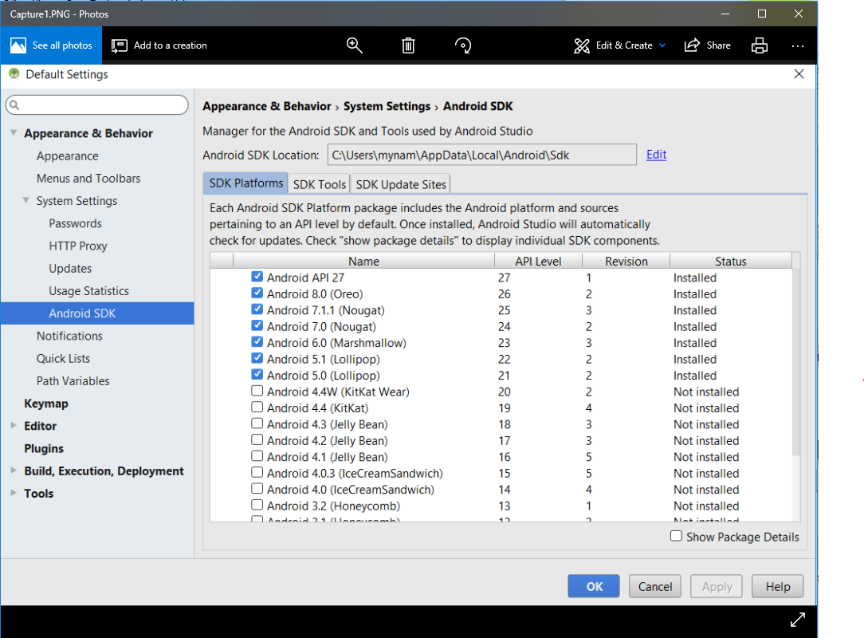

***#2  ( On this slide please also check “CMAKE”, “LLDB”  )- not shown***

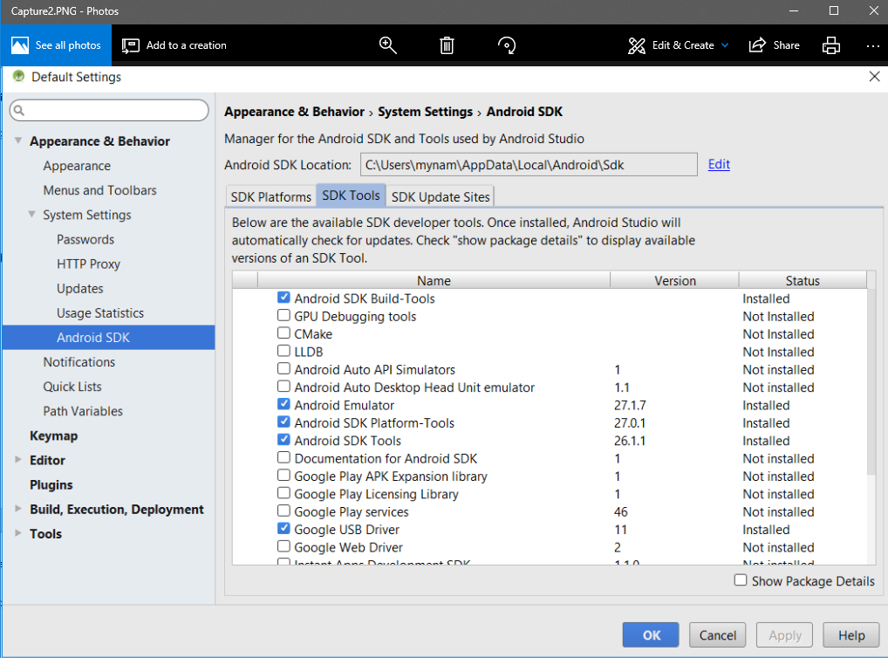

***#3***

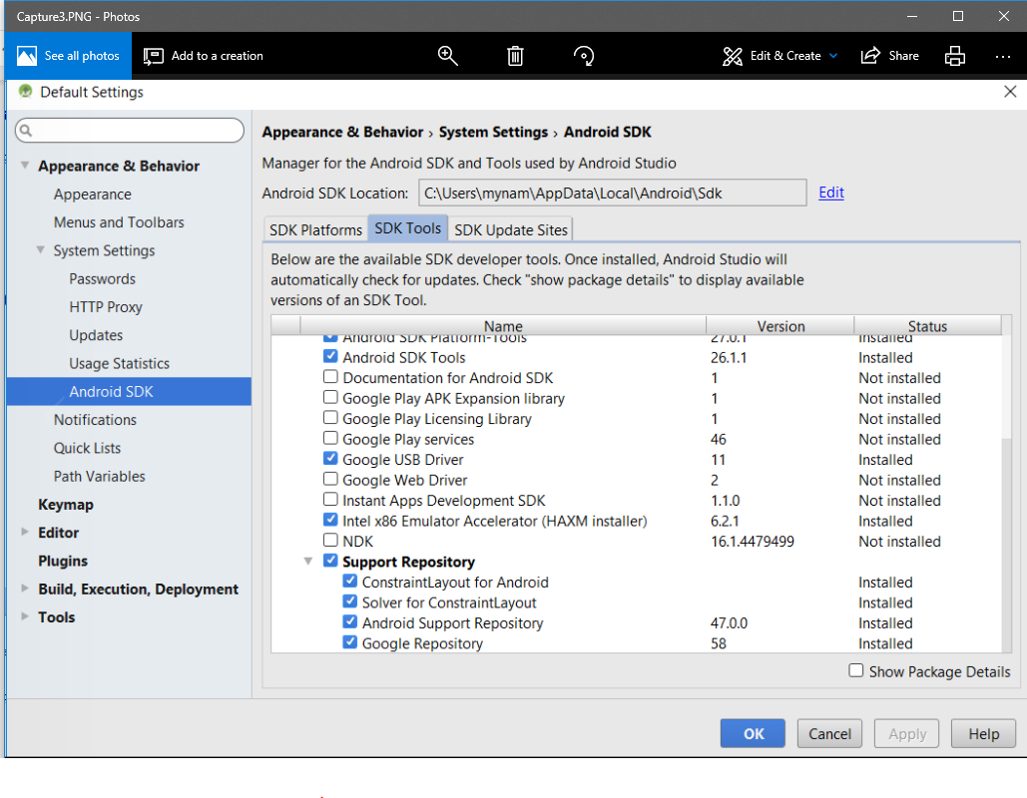

***Again, please follow Android Studio instructions for upgrades ( click the blue links if available )***

***DUE THURSDAY,  June 14***

***Let’s continue to roll with our Mobile APP Testing***

***Preparing for the Project Testing :  Link below ( read first)***

[***https://drive.google.com/drive/u/0/folders/1UBXLGPWStEkhmC_Yk15nVtJNZSP6QJ96***](https://drive.google.com/drive/u/0/folders/1UBXLGPWStEkhmC_Yk15nVtJNZSP6QJ96)

***Please Download a specific Media subfolders to your Devices .***

***This Media is sent to us by Lomotif).***

***Get familiar with content. ( no need to report anything yet or test anything)***

***Android Users : Audio Media, Special Media, Position_me.jpg and test_media_5x***

***( use iTunes or other tool ) iOS Users : Audio Media, Special Media, Position_me.jpg and test_media_6S***

***Note for iOS Users: on some devices it is possible that not ALL test_media_6S files would be downloaded to your device, because of unsupported formats. Please use your own media files and those that were  able to download from Media Files Folder.***

***Should be no issues with Android OS.***

***Our Lomotif Project is very structured and do have Test Plan with Test Cases;***

***Get familiar ( play around with it, but do not fill out yet ). We would need to go through this document and test with special Media.***

***This Table is created for iOS devices. If you have an android , please apply logical approach. If you are able to complete the task using a different steps ( like OS doesn’t have an “hamburger” icon ) then it passes.***

***Download your own copy:***

[***https://drive.google.com/drive/u/0/folders/1OzG3SjJ7JqX0G2tnI89zjhxWRgxkgTm3***](https://drive.google.com/drive/u/0/folders/1OzG3SjJ7JqX0G2tnI89zjhxWRgxkgTm3)

***No further instructions for now. Just  create your own copy in the same directory where this matrix is posted.***

***Your skype name first for renaming document. Make sure you are not renaming my original copy.***

***See you soon ☺***