***Session 12                           Homework ( ready to use )***

***7/20/2018***

***Hello guys,***

***I created a folder where you will have an uncut presentations for your convenience:***

***I will upload Presentation 3 after we go through it by the end of Session 15.***

[***https://drive.google.com/drive/u/0/folders/1xXStOEP1MTYXANKgSDLc5d7xOzbvVQtL***](https://drive.google.com/drive/u/0/folders/1xXStOEP1MTYXANKgSDLc5d7xOzbvVQtL)

1. ***Session 12 Presentation Slides***[*https://drive.google.com/drive/u/0/folders/1UNeo4XHUcjvhUnVYQTQ8wAzxUbEBv1GR*](https://drive.google.com/drive/u/0/folders/1UNeo4XHUcjvhUnVYQTQ8wAzxUbEBv1GR)

***2. Please go through Interview Questions  Session 12 and answer questions: ##163 - 168 + Answer questions we took care during our Session.***

***3. Games APP ( any ): Fill out this document with your test results. Name it yourname.games.\****

***You may select your favorite game and take a look at it from a Tester’s Angle :) Have fun!***

***https://drive.google.com/drive/u/0/folders/11r5sDOORIGjzygIomGc_JyiYIvLzPrG4***

***4. Banking APP :***

***Task1 : Mobile Deposit Screen . Create 10 test cases for it and post it as yourname.banking.mobiledeposit.\****

[***https://drive.google.com/drive/u/0/folders/1j3Kx0VTcqXZcAPsQ3PJO6gU8bWUbEjta***](https://drive.google.com/drive/u/0/folders/1j3Kx0VTcqXZcAPsQ3PJO6gU8bWUbEjta)

***Your task is on the right side ( Quick Deposit and Check Images). Please note, execution of the screen and all errors and notifications appear ONLY after you tap “NEXT”***

***I’m interested in NEGATIVE TEST CASES ONLY***

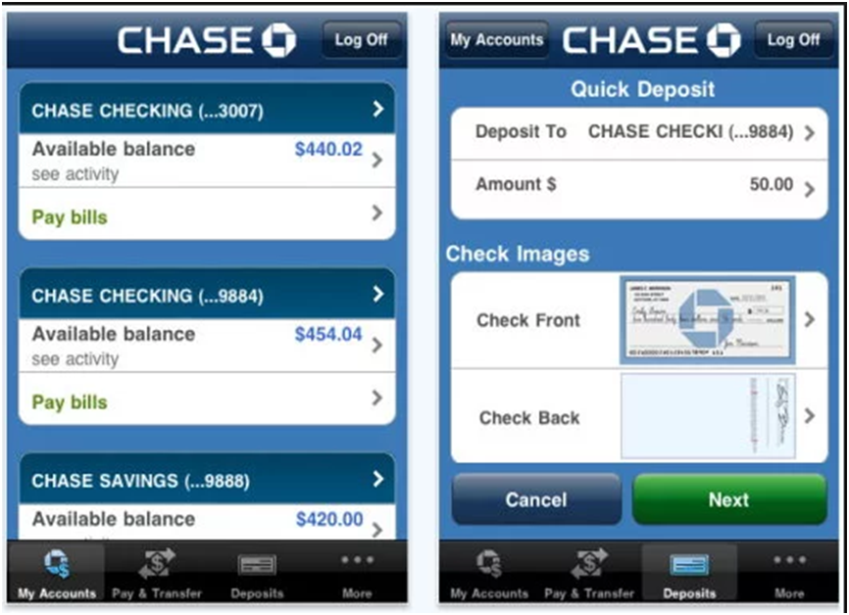

***Task2 : Open your favorite Banking APP or any Financial APP where money are processing ( Amazon, PayPal, etc )***

***Select a component ( example : Money Transfer, Bill Pay, etc ) Create 10 test cases for it and post it as yourname.banking.mobilecomponent.\****

[***https://drive.google.com/drive/u/0/folders/1j3Kx0VTcqXZcAPsQ3PJO6gU8bWUbEjta***](https://drive.google.com/drive/u/0/folders/1j3Kx0VTcqXZcAPsQ3PJO6gU8bWUbEjta)

***MANDATORY : Project is Dabbl ( scroll to the end for more tasks )***



***Request came from QA Manager: Please verify***

As a Dabbl App User,

I want better Profile Screen,

so that It would be easier to update my personal information in the app

**1. Rename Account tab to Profile**  
**2. Profile structure**  
**2.1**Profile picture: Ratio: 1:1 Circle

Adding Profile picture Flow:

1. User clicks on empty profile picture (Maybe Dabbl smiley face?)
2. User selects picture from file: **Size/extension restrictions: Resize up to 800KB, Validate loading of big files, error "Please select file less than 10MB" if file is more than 10MB, extension limited to png, jpeg**
3. **User crops image**
4. **User saves image**

**Editing profile picture:**

1. **User clicks on profile picture**
2. **Present message on maximized image: Resize up to 800KB, error "Please select file less than 10MB" if file is more than 10MB, extension limited to png, jpeg**
3. User selects picture from file
4. **User crops image**
5. **User saves image**

**[PUT DESIGN HERE]**

Note: Final decision that DOB is not editable, so there should be no Edit button  
 **2.2. User Name: Currently First Name, in Future Username**

for existing user: take from backend  
for new users: empty, but grey default text FIRST NAME, until filled in personal info

**2.3. MY DABBL**

**2.3.1. Personal Info**

2.3.1.1 First Name (editable), for existing users filled from backend, for new users empty

2.3.1.2 Last Name (editable), for existing users filled from backend, for new users empty

2.3.1.3 Phone Number (not editable), pre-filled from user ID/phone number

2.3.1.4 Email (editable), for existing users filled from backend, for new users empty

2.3.1.5 Birthday (not editable), pre-filled from user registration info

**2.3.2. Preferences**

2.3.2.1 Notifications: Allow Notifications toggle

2.3.2.1 Location: Share Location toggle (after implementation of story 5191)

**2.3.3 Legal**

2.3.3.1 Terms of Use

2.3.3.2 Privacy Policy

**2.3.4 Help**

**2.4 LOG OUT button**

**2.5 REFER A FRIEND button**

**3. Gift Card ordering flow using profile information:**

* user selects new gift card
* information is profiled from profile screen
* if user changes information for the gift card order, profile information is not updated and remains the same

***Bugzilla Dabbl - Production***

***Please submit more information : Bug # 10893 and Bug # 10895 ( they are unable to reproduce it )***

***Please verify that Bug # 10910 still open. The owner of this bug should monitor the status at all times.***

***All other bugs : see explanation why they closed it.***

***Have a great weekend and we will see each other on Monday, July 23***

***-Natalia***