How to set up your testing environment:

Clickberry Interactive Video Editor is a part of Clickberry Platform. It is a Windows based application, which supports the following Windows operating systems:
- Windows Vista SP 2, x64
- Windows Vista SP 3, x 86
- Windows XP SP 2, x64
- Windows XP SP 3, x 86
- Windows 7 SP 1, x64
- Windows 7 SP 1, x 86

NetFrame 3.5 and NetFrame 4.0 are required components and need to be installed prior to Clickcberry Editor installation.

Installation

- Download current build of Clickberry Editor:

Copy link: http://files.clickberry.tv/ActioEditor/QA/024fc14c-22d2-49eb-8ccf-a90a74f97a52/ClickBerryEditor_306_us.exe and Paste into your Browser URL and hit Enter.
Follow Installer’s prompts to install Clickberry Editor. In Clickberry Editor Setup: “Choose Components” select optional but mandatory components to be installed.
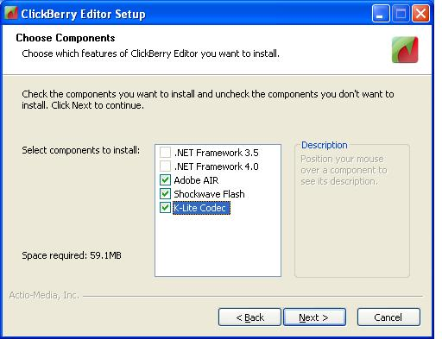

Select option “Run Editor” upon completing installation; click “Finish”

- Launch Editor by double click on Editor’s icon locating on your Desktop if auto run option wasn’t check during installation.
Registration Wizard will start automatically. Provide your valid email information and password in “Account Registration step 1 of 2”
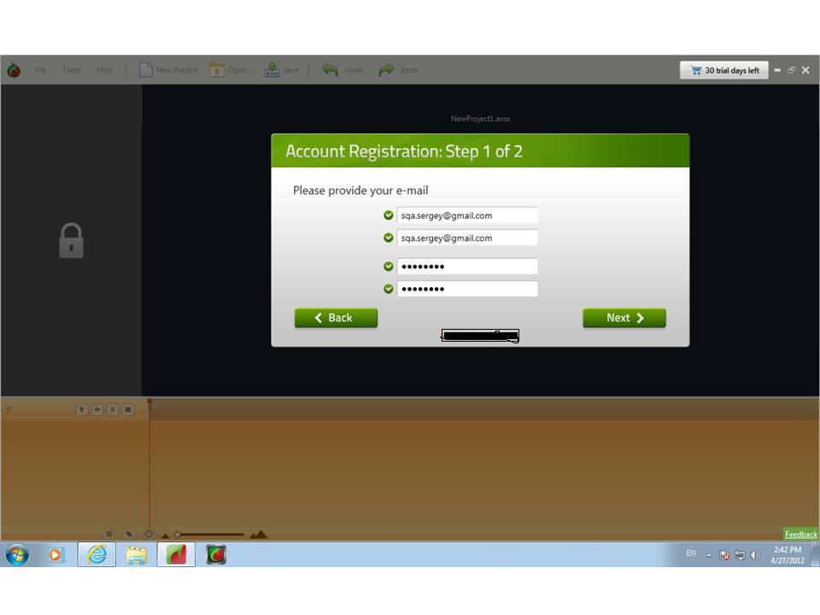
- Finished your account registration in Account registration step 2 of 2.

Verification and Activation of your account

- Login to your Email and look for “Thank you” email from Clickberry support

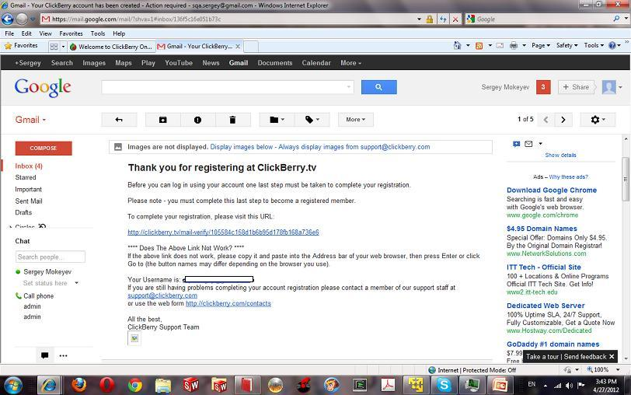

- DO NOT CLICK ON ACTIVATION LINK
- Copy the activation link that should look like this: http://clickberry.tv/mail-verify/b37fe45c5243c97ee8f27befc2536a68 into Notepad and modify to
http://kolesov.clickberry.tv/mail-verify/b37fe45c5243c97ee8f27befc2536a68
- Copy modified link into Browser URL:
http://kolesov.clickberry.tv/mail-verify/b37fe45c5243c97ee8f27befc2536a68 and hit Enter
8. Go back to the Clickberry Editor and login.

