# Option & Booking Request (Client | Desktop)

|  |  |
| --- | --- |
| **Target release** |  |
| **Epic** | [PM-403](https://forddigital.atlassian.net/browse/PM-403) - Manage Projects & Jobs. Option & Booking requests In Progress |
| **Document status** | APPROVED |
| **Document owner** | Sebastian Flores |
| **Designer** |  |
| **Developers** | Ramiel Galimov Aleksandr Ishchenko |
| **QA** |  |

Lucidchart: <https://www.lucidchart.com/documents/edit/c11f8ae3-9909-421a-acbc-3c3ed69f7a83>

# ****Description****

Client will have the ability to send a model a (1) Booking Request, (2) Option Request, (3) Casting Invitation. All three request processes begin the same way, with a client clicking on "send request" button on the model's profile.

The actual request form is identical for both the Booking and Option Requests, only thing that changes is the title of the request (i.e. Booking Request; Option Request).

**Option Request**

When a client sends an Option Request, they mainly want to know a model's availability, and they may send an Option Request to multiple models. Once a model receives the request, she chooses whether or not to accept or decline the request. If she accepts, then she is committing herself to attend the job. The client will receive a notification that the model has accepted or declined. If model accepted, then the client will have 3 days to Book the model. The client can Book the model directly from the Option Request page by clicking the "Book Model" button. Once the client clicks this button the booking is confirmed and the model receives a notification that she was booked. This request now turns into a Booking and is no longer an Option.

**Booking Request**

When a client sends a Direct Booking Request, they know exactly that they want to book a model. If a model accepts the request, the booking is confirmed - both model and client are committed.

In order to send a Direct Booking Request, they click on the "send request" button on the model's profile and fills out the request form, then sends request. The client is now committed to the job if the model accepts. Model receives a notification that she has a new booking request. Model can accept or decline the request. If accepts she is committed to the job.

**Notes**

* If this is the first Booking Request (or first time the client is clicking Book Model button from the Options Request page) the client will need to input a Payment Method. The system will prompt them to enter their payment method (credit or debit card).
* The client can choose an existing project using the Project Title dropdown to pre-populate the request with information from that specific project.
* Alternatively, the client can also create a new project from this field and will then input all information manually. In this case, once the request is sent, this information should automatically create a new project in the client's project dashboard.
* There are circles on the top of the request pages that signify the progress of the request. A client can hover over the circles and view the next step in the process.

# ****UX/UI Design - Booking / Option Request Mock****

Sketch file: <https://newbook.box.com/s/9uv7u00l5ligof7aduruigxsq3b10t6r>

Invision flow: <https://invis.io/F4ECN4K2P#/262666816_Model_Profile_Ss>

## Step 1 of the Send Booking Request flow

# Request Type

## Step 2

# Request inactive

## Step 3

# Request Active

## Step 4

# Add Payment

## Step 5

# Request Sent

# Option Request

Invision: <https://invis.io/F4ECN4K2P#/262665783_S_3DFAB76C890900DB6460325D553C6E2EAC25ADBBEE2F9AD2DBBCAD7BA91F75F6_1510016903001_Option_Request>

# Step 1

## Option Request

## Option request (Hover State)

Option Request - Unavailable

## Option Request-Unavailable (hover state)

# Step 2

## Option Request-Available

## Option Request-Available (Hover State)

# Booking Request

# Step 1

## Booking Request

## Booking Request (hover state)

## Booking Request-Unavailable

## Booking Request-Unavailable (hover state)

# Step 2

## Booking Request- Confirmation

Booking Request-Confirmation ( Hover State)

## Booking Request-Confirmed- Edit

# Step 3

## Booking Request-Awaiting Hours

## Booking Request-Awaiting Hours (hover State)

# Step 4

## Hours Received

## Awaiting Review (Hover state)

# Step 5

## Pay Model

# Step 6

## Booking Request-Complete

# ****Addtional Notes****

Below, please find high-fidelity prototype of the **Booking request**and **add payment pages**.  You’ll be able to preview and interact with all elements on the pages, as well as seeing how the site was built, current values, animations speeds and more.

Below is a screenshot to help you navigate Webflow if this is the first time using it. **Please go directly to the Booking Request page.** Disregard Home for now.

1. The page button allows you to switch between different pages on the website
2. The breakpoints allow you to see custom values or sales  for all mobile breakpoints
3. The top portion of the navigator on the upper righthand corner allows you to view settings, css styles, interactions and animations of any individual element.
4. The portion right under it is the “layer panel” you can view parent element and children for each individual element

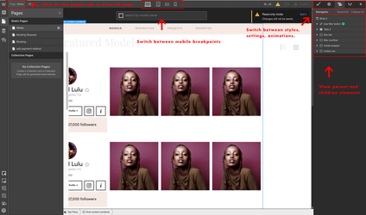

* Webflow Prototype (read-only link): <https://preview.webflow.com/preview/newbookalliance?preview=698658a631d7503c1e23e0f8485ec822>
* Webflow Prototype code: <https://www.dropbox.com/sh/zyfxuonwi7irw3k/AAA9rf0kx_A0kdqwiIQDz4xNa?dl=0>
* Live site prototype: <http://newbookalliance.webflow.io>

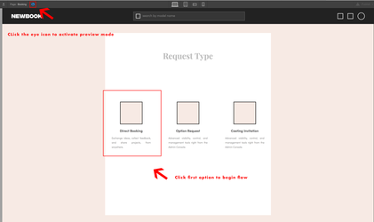

## Booking Flow

To start the the Booking flow simply navigate to the booking page  and click the preview icon which is the eye icon on the top  left corner. Once the page loads you can start the flow by click the first option in the request type.

(To start the flow via <http://newbookalliance.webflow.io> you will need to click on the circle icon in the top right hand of the main page.)

**Success page:**<https://preview.webflow.com/preview/newbookalliance?preview=698658a631d7503c1e23e0f8485ec822>