# Admin Panel Tools/Access

|  |  |
| --- | --- |
| **Target release** |  |
| **Epic** | [PM-385](https://forddigital.atlassian.net/browse/PM-385) - NEW Admin Tools Done |
| **Document status** | REVIEW |
| **Document owner** | Sebastian Flores |
| **Designer** |  |
| **Developers** | Ramiel Galimov, Aleksandr Ishchenko |
| **QA** |  |

**Description:**

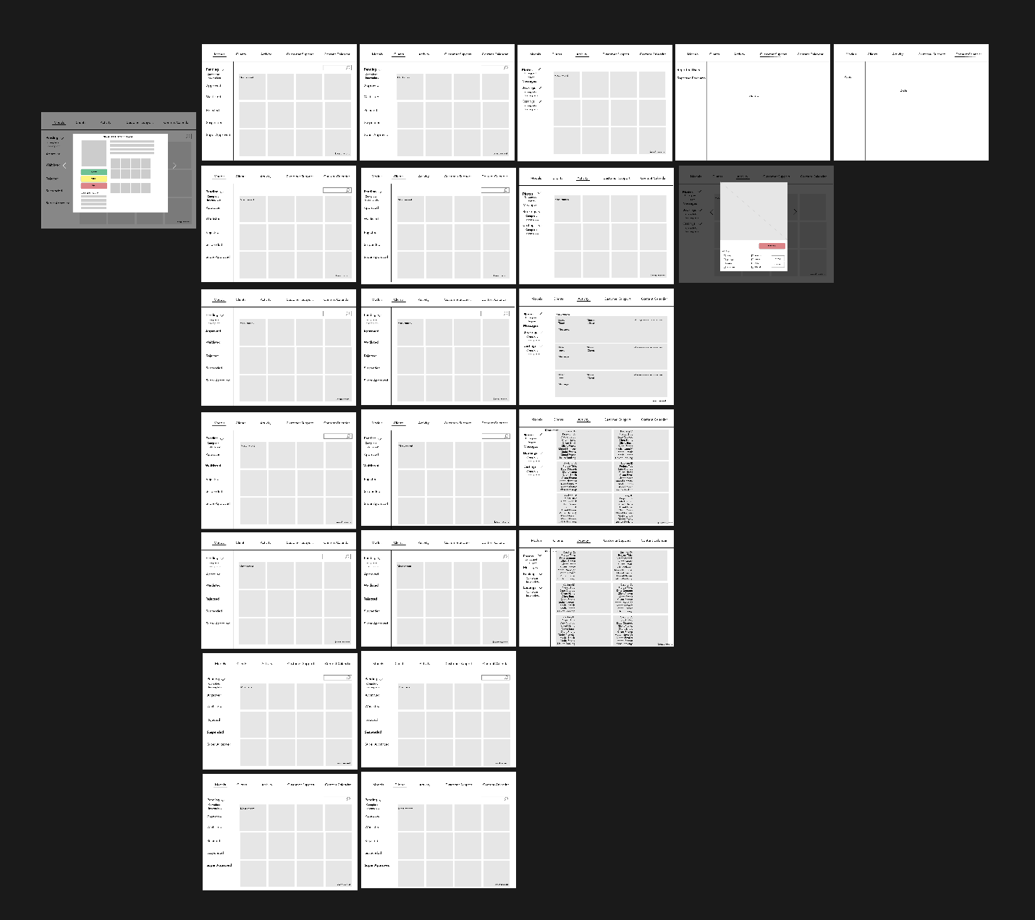

**\*\*UPDATED MODEL AND CLIENT STATUSES FOR MVP:**Pending, Approved, Rejected

**Models**

Pending

* View profile
* Edit profile
* Can’t apply to casting
* Hide from Browse so no client can find them
* Can receive notifications (you’ve been approved & you’ve been rejected)

Unapproved/Rejected

* View profile
* Edit profile
* Can’t apply to casting
* Hide from Browse so no client can find them
* Can receive notifications (you’ve been approved & you’ve been rejected)

Approved

* Can do anything
* Can be rejected

**Clients**

Pending

* Edit profile
* View profile
* Add credit card
* Favorite models
* Cannot message models
* Cannot create castings
* Cannot create projects
* Cannot create requests (option/booking)

Unapproved

* Edit profile
* View profile
* Add credit card
* Favorite models
* Cannot message models
* Cannot create castings
* Cannot create projects
* Cannot create requests (option/booking)

Approved

* Anything
* Can be rejected

## Column Titles in Admin Panel:

**Models**

Pending Status

* Model First name + Last name (is a link to model profile)
* Email Address
* Cell phone number
* Instagram handle (is a link to model instagram account)
* Location
* Date Created
* Date Submitted

Approved/Rejected/Blocked

* Model First name + Last name (is a link to model profile)
* Email Address
* Cell phone number
* Instagram handle (is a link to model instagram account)
* Location
* Date Created

**Clients**

Pending/Approved/Rejected/Blocked

* Company name (is a link to company profile)
* First Name + Last name
* Email
* Company websited (link)
* Instagram handle (link)
* Location
* Date Created

**Models & Clients Status:**   
- Not_yet_submitted: Model has started an application but has not yet submitted for review. User profile not visible to other users. Model can edit/add details.  
  
- Pending: Model has submitted application for review and is waiting for Newbook team review. User profile not visible to other users. Model can edit/add details.  
  
- Approved: Newbook team reviewed submitted application and approved user. User is now visible to other users.  
  
- Waitlisted: Newbook team reviewed submitted application but waitlisted user. User profile not visible to other users. Model can edit/add details.  
  
- Rejected: Newbook team reviewed submitted application and rejected user. User profile is not visible to other users. Model can edit/add details.  
  
- Blocked: At any point, a Newbook team member can block a user which will force-logged out.  
  
Nice to have but not necessary right now: Suspended

## ****First Priorities****

**Model & Client Statuses**

**Activity Tab**

* Photos
  + Tagged
  + Untagged
  + Hide photo

1. Keep:
   1. Incomplete Model / Client applications
   2. Approve / Waitlist / Reject Models
   3. Approve / Reject Clients
   4. Ability to create Daily Featured Models
   5. Content calendar
   6. Suspend Model / Client accounts
   7. Delete Model / Client accounts
   8. Review every recently uploaded photo
   9. Hide photos
   10. Tag photos (categorization)
   11. Review every newly created casting
   12. Ability to suspend castings
   13. Review booking requests and their status
   14. Review every message sent between users
   15. Super approved
   16. Reported
   17. Referral codes
2. No more:
   1. Castings approval before going live