Android Studio Class Instruction for Homework
Android Studio ( Windows and MAC )

JAVA : last stable version is 8u211 . Works without problem with latest ANdroid Studio.
Remove JAVA 9 if you have it installed and download this :
https://java.com/en/download/
ANDROID STUDIO ( only to be installed on your PC/MAC/Laptop, not on your mobile device )
This could go for a few days, as Android Studio installation and setup can take some time. Before we start I want to be sure that all of you have it.
- Download Android Studio for windows 64bit from https://developer.android.com/studio/
- Or select Android studio for MAC in the same place
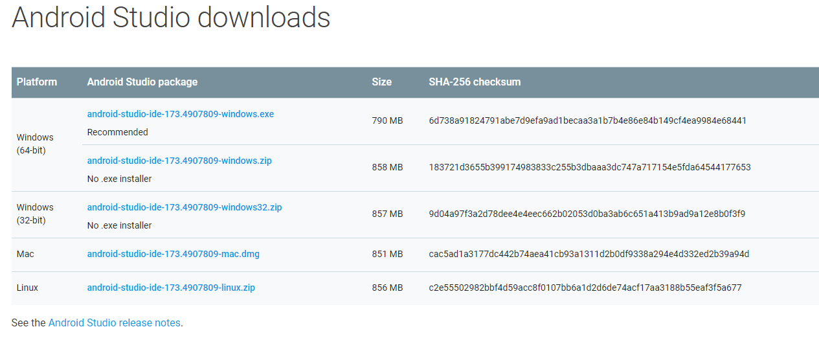
- Scroll down on a same page , download and install SDK Platform-Tools ( Windows and MAC )
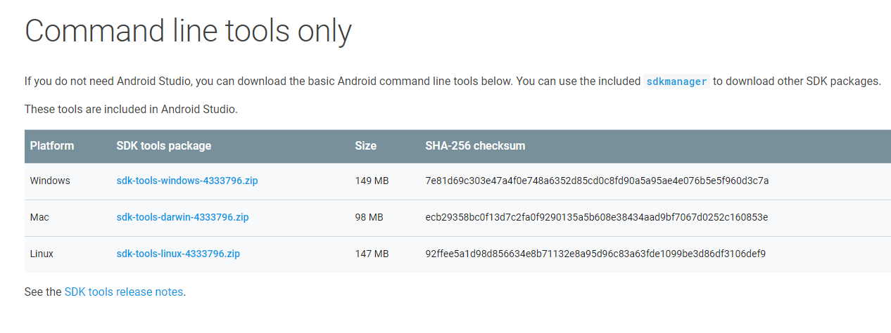

If you have 32bit Windows : Download Android Studio from the same link as #1 . Once installation is complete do not click icon to open it. INSTEAD go to your Explorer ( follow instructions from a document where to find SDK directory , open it and in BIN-->run studio.exe , not studio64.exe

3. In Windows ONLY ( this is Windows 10) → ENABLE ALL HIDDEN FILES AND FOLDERS in FOLDER “VIEW OPTIONS” in WIndows.
You will not find your SDK otherwise ( READ INSTRUCTIONS )
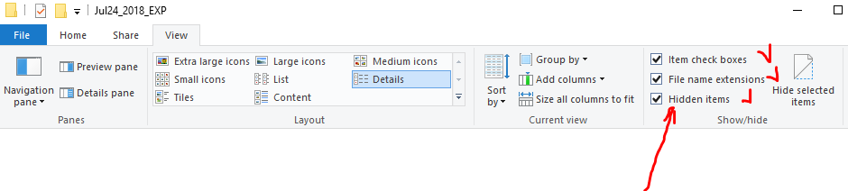
For Windows 7 : Go to Organize-->Folder Options-->View

4. Open Android Studio .
Proceed with Defaults , don’t change any directories while creating a new project.
Just go next, next , next…. Until Android Studio opens up and all processes being loaded.
It may take a few minutes especially the first time .
( at the bottom there is a tab : Terminal )
Install all updates that Android Studio is prompted you to do. Click the suggested links for upgrades inside terminal.

After you are done, ……
5. Click an icon : SDK Manager on a Top Bar ( icon may look different in a newer ANdroid Studio - point a mouse to see icon description )
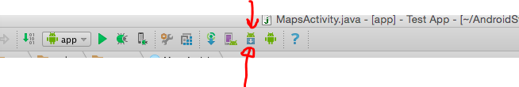
Select the following boxes, check and install ( you will see more options above Android API 28…check and download all that is above Android 5.0 Lollipop.)#1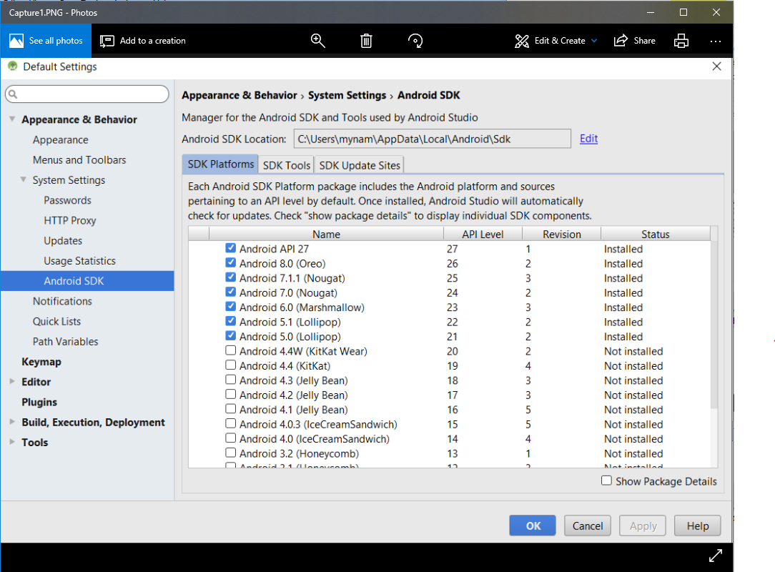

# 2 ( you may see more options or slightly different above CMake….)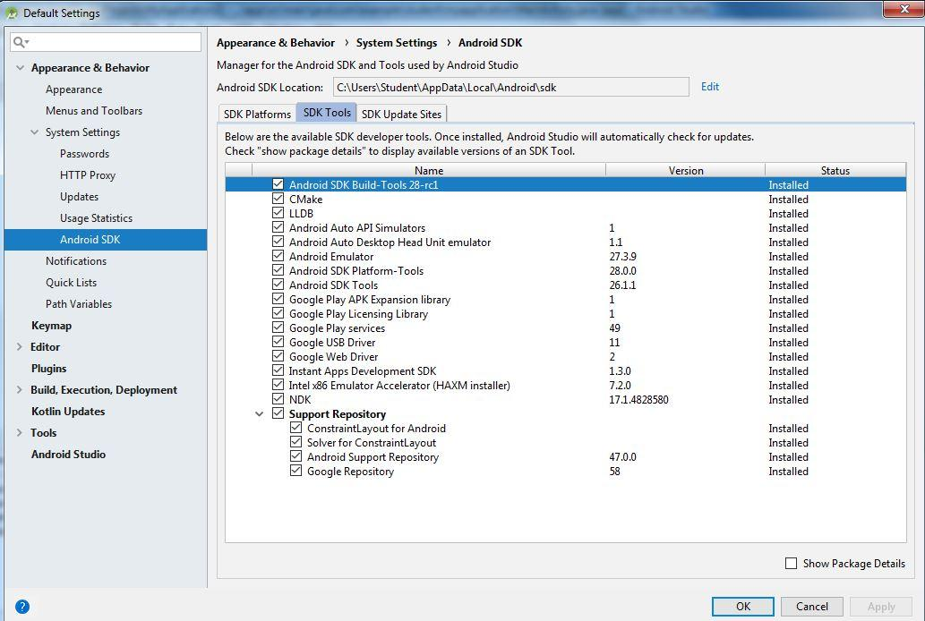

MAC USERS : READ INSTALLATION instructions CAREFULLY.

JUST INSTALL ANDROID STUDIO. No further actions needed at this time.
I will guide you how to connect the device in Class
DO NOT CONTACT ME in case you are jumping ahead and trying to connect your device yourself.

3. Create an Emulator:
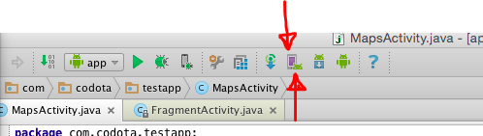
Create Nexus One with 480x800 resolution.
You will be presented with a list of OSs to download .
Select Marshmallow 6.X
Download it .

If you receive a message regarding VTx ( virtualization and Hardware Acceration ) , refer to this document in our Android Studio folder

We will do troubleshooting in class.
I will also help you to connect devices in class.

xxxxxxxxxxxxxxxxxxxxxxxxxxxxxxxxxxxxxxxxxxxxxxxxxxxxxxxxxxxxxxxxxxxxxx

