April 20th, 2017 – ONLINE

5/24/2017
Dear Students,
Please READ Carefully entire instructions before proceeding with testing.
Session 2 Presentation is now posted in https://drive.google.com/drive/folders/0B__Jza6ZnWYYNndOWUwyYTQ3dFU
Please go through Interview Questions for Session1 and Session2 and answer questions.
DO NOT EDIT my original document. Please download your own copy and keep it on your PC/MAC . No need to send or post your document.
https://docs.google.com/document/d/1DghFyVpWy-xsfU7kyJfm0yyTBh2uA_BvoRs4EAfMfEg/edit
Lets ROLL :)
In Homework 1 you have created a Media Files, which we will use now, doing our Homework after Session 2.
USE YOUR DEVICE (Mobile Phone)
1. Open Gallery or Albums where you Files are stored
2. Check Preview (Thumbnail), verify it’s not empty and the picture (frame) is stored.
3. Tap to Playback ( your default Media Player)
4. Playback Media Files that you have recorded. Verify that there are no black screens , video or picture corruption.
What is Lomotif? Please watch this Video to get familiar with our app. You will include it in your resume!
https://www.youtube.com/watch?v=ifOEKai5Gn0&feature=youtu.be
LOMOTIF is a Native APP, used by 5.5 million users all over the world.
Lomotif is the simplest way to add music to your moments. You can create hyper-short, super shareable music videos in 3 simple steps. The app allows users to cherry-pick from over a billion songs to instantly and automatically create visual mash-ups.
It’s developed for both iOS and Android.
It’s a live Project and we have a continuing feedback from the development team, live Bug Tracking Database and Test Suits, which were created by Lomotif QA team.
5. Go to Google Play or App Store. Find LOMOTIF app (do not install) and READ # 6 and further
6. Read carefully the description, reviews, find version number, description of fixes.
7. Observe GUI , does it look good on your Device Screen?
8. Flip your Device to Landscape Mode (if you are in Portrait) and vise versa .
Note: NOT all APPS supporting landscape mode.
9. Install LOMOTIF APP (check your GUI at all times, verify LOGO is not corrupted and Download/Install Buttons are correctly marked)
10. After installation , Open LOMOTIF , tap START at HOME SCREEN.
11. The MEDIA that you have created should be picked by APP and placed in a FOLDER at “ADD PHOTOS AND VIDEOS” (depending on Device this screen with Albums may look a little different. Any way it’s going to be a second screen (page) after HOME PAGE.
12. Playback ALL the Media Files .
(Select , press next ( > on the top) , do not select Music, proceed to next screen.
Please note the Media that is not playable ( or Playback is corrupted ( not normal) , make the following entries in our main table.
PASS – if no problem
Fail – if playback is corrupted
N/A – if you were unable to create an original format on your device.
https://docs.google.com/spreadsheets/d/1VdwP_17ZYg8Ssz_KBurWJSR_VTZfwuJhIQlLo8ChQNI/edit#gid=686398632
See you soon,
-Natalia

5/19/2017
Dear Students,
It’s been a pleasure to begin our Mobile App Testing Sessions with you.
Our Slides Homework as well as Presentations from each session is going to be included in this doc and latest ones are always going to be on top.
https://drive.google.com/drive/folders/0B__Jza6ZnWYYNndOWUwyYTQ3dFU
Our Main Table is here. This document will be showing Project Progress.
https://docs.google.com/spreadsheets/d/1VdwP_17ZYg8Ssz_KBurWJSR_VTZfwuJhIQlLo8ChQNI/edit#gid=686398632

- I would need 6 people to be a Team Leaders : 3 – for Android Devices and 3 – for Apple Devices
- You ( as a group ) should select volunteers that are willing to contribute some extra time to answer questions in a chat room, deliver information from me , know how to manage Google Sheets , supervise data entry , collect problem media and overall have be a nice and helpful people who is patient and courteous.
From our side – volunteer’s activity would be reflected in a resume as extra points.
- Team Leaders: create a separate Group on Skype , name it “Leaders_Apr20” and invite me and Kristina Dzyuba ( your Program Supervisor).
- Copy of incompatible Devices that wouldn’t be able to participate in our project. Please get another device.
https://drive.google.com/drive/folders/0B__Jza6ZnWYYNXJKVVZwRWpGWVU

My message to all : Please READ all instructions CAREFULLY and FOLLOW them.
Our course is very structured and if for some reason you don’t know what to do next, this means you haven’t been guided yet to make a next step or did not proceed with given instructions.
Ask your Team leaders and group members first and “hard” cases will be forwarded to me.
I will not be participating in a Chat Room because of my schedule in a classrooms however I could be reached via Skype ( natalia.stefanioutine ) or email sqamobilemgr@gmail.com
Link to our INFO doc :
https://drive.google.com/drive/folders/0B__Jza6ZnWYYNXJKVVZwRWpGWVU
Let’s ROLL with our first task and prepare a Testing Multimedia Files for our future Project that will be included in your Resume.
No need to send it in or do anything else at this point. Just Record Videos, take pictures and rename it accordingly. (You might want to connect your Device to PC/Laptop to rename files)

NOTE 1: To take upside-down picture/or video you will need just to rotate your phone to the position where camera “window” is down.
NOTE2: some Camera and Video Settings might not be available for your particular Device (Phone). Also, Settings do vary from Device to Device.
NOTE3: Rotating your Phone to the right or left will give you a Landscape Mode (16:9)
Otherwise it’s in 4:3 (Portrait)
If this is a case, please prepare Files that are only applicable for your Device (Phone). Instructions and Screenshots are below.
See you on Monday, May 22nd @6pm .
Natalia S.
Record Video Files :
Rename files ( best to use PC or MAC) . Example : you have recorded a video from front camera, portrait 4:3 layout, in 720p ( from task 1)
Rename a file to : fc_prt_720p.*
(for landscape 16:9 layout the file name is fc_lsp_720p.*)
- FRONT CAMERA – Portrait 4:3 layout : Record 1 ( 1-2 min) videos in 720P mode .
- FRONT CAMERA – Portrait 4:3 layout : Record 1 ( 1-2 min) videos in 1080P mode .
- BACK CAMERA- Portrait 4:3 layout : Record 1 (1-2 min) videos in any mode ( 720p or 1080p)
- BACK CAMERA – Landscape 16:9 layout : Record 2 (1-2 min) videos in any mode ( 720p or 1080p)
- BACK CAMERA – UpsideDown– Portrait 4:3 layout : Record 2 (1-2 min) videos in any mode ( 720p or 1080p)
- BACK CAMERA – UpsideDown– Landscape 16:9 layout: Record 2 (1-2 min) videos in any mode ( 720p or 1080p)
- FRONT CAMERA – any layout- Record 1 ( 1 min) videos in 720P mode .
- FRONT CAMERA – any layout- Record 1 ( 1 min) videos in 1080P mode .
Please take some pictures :
- FRONT CAMERA – Portrait 4:3 layout : 5
- FRONT CAMERA – Landscape 16:9 layout : 5
- BACK CAMERA – Portrait 4:3 layout : 5
- BACK CAMERA – Landscape 16:9 layout : 5
- PANORAMA photo : 2
xxxxxxxxxxxxxxxxxxxxxxxxxxxxxxxxxxxxxxxxxxxxxxxxxxxxxxxxxxxxxxxxxxxxxxxxxxxxxxxxxxxxxxxxxxxx
Android Samsung
- Tap on Camera Icon 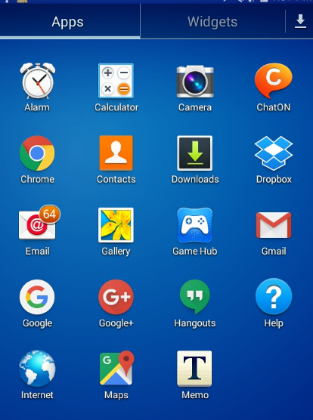

- Tap a Setting Wheel, Select Photo Icon and Select desired option. Complete required task ( below)
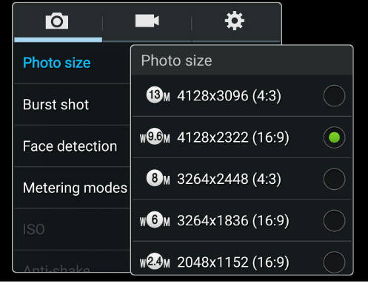
- Repeat #2 for Video.
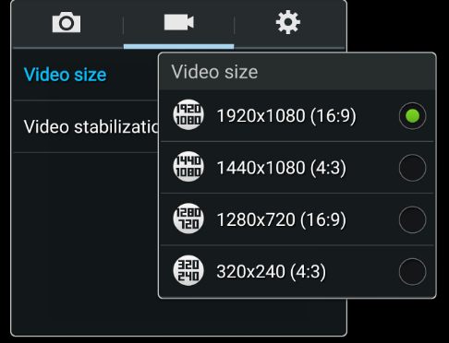

For IPhone : Go to Settings

