Dear Students,
It’s been a pleasure to begin our Mobile App Testing Sessions with you.
Our Homework from each session is going to be included in this doc and latest ones are always going to be on top.
- I would need 6 people to be a Team Leaders : 3 – for Android Devices and 3 – for Apple Devices
- You ( as a group ) should select volunteers that are willing to contribute some extra time to answer questions in a chat room, deliver information from me , know how to manage Google Sheets , supervise data entry , collect problem media and overall have be a nice and helpful people who is patient and courteous.
From our side – volunteer’s activity would be reflected in a resume as extra points.
- Team Leaders: create a separate Group on Skype , name it “Leaders_Jan03” and invite me and Kristina Dzyuba ( your Program Supervisor).
- Copy of incompatible Devices that wouldn’t be able to participate in our project. Please get another device.
https://drive.google.com/drive/folders/0B__Jza6ZnWYYMkhJc05rc1pIdXM

My message to all : Please READ all instructions CAREFULLY and FOLLOW them.
Our course is very structured and if for some reason you don’t know what to do next, this means you haven’t been guided yet to make a next step or did not proceed with given instructions.
Ask your Team leaders and group members first and “hard” cases will be forwarded to me.
I will not be participating in a Chat Room because of my schedule in a classrooms however I could be reached via Skype ( natalia.stefanioutine ) or email sqamobilemgr@gmail.com
Link to our INFO doc https://drive.google.com/drive/folders/0B__Jza6ZnWYYMkhJc05rc1pIdXM

Let’s ROLL with our first task and prepare a Testing Multimedia Files for our future Project that will be included in your Resume.
No need to send it in or do anything else at this point. Just Record Videos, take pictures and rename it accordingly. (You might want to connect your Device to PC/Laptop to rename files)

NOTE 1: To take upside-down picture/or video you will need just to rotate your phone to the position where camera “window” is down.
NOTE2: some Camera and Video Settings might not be available for your particular Device (Phone). Also, Settings do vary from Device to Device.
NOTE3: Rotating your Phone to the right or left will give you a Landscape Mode (16:9)
Otherwise it’s in 4:3 (Portrait)
If this is a case, please prepare Files that are only applicable for your Device (Phone). Instructions and Screenshots are below.
See you on Monday, February 6th @6pm .
Natalia S.
Record Video Files :
Rename files ( best to use PC or MAC) . Example : you have recorded a video from front camera, portrait 4:3 layout, in 720p ( from task 1)
Rename a file to : fc_prt_720p.*
(for landscape 16:9 layout the file name is fc_lsp_720p.*)
- FRONT CAMERA – Portrait 4:3 layout : Record 1 ( 1-2 min) videos in 720P mode .
- FRONT CAMERA – Portrait 4:3 layout : Record 1 ( 1-2 min) videos in 1080P mode .
- BACK CAMERA- Portrait 4:3 layout : Record 1 (1-2 min) videos in any mode ( 720p or 1080p)
- BACK CAMERA – Landscape 16:9 layout : Record 2 (1-2 min) videos in any mode ( 720p or 1080p)
- BACK CAMERA – UpsideDown– Portrait 4:3 layout : Record 2 (1-2 min) videos in any mode ( 720p or 1080p)
- BACK CAMERA – UpsideDown– Landscape 16:9 layout: Record 2 (1-2 min) videos in any mode ( 720p or 1080p)
- FRONT CAMERA – any layout- Record 1 ( 1 min) videos in 720P mode .
- FRONT CAMERA – any layout- Record 1 ( 1 min) videos in 1080P mode .
Please take some pictures :
- FRONT CAMERA – Portrait 4:3 layout : 5
- FRONT CAMERA – Landscape 16:9 layout : 5
- BACK CAMERA – Portrait 4:3 layout : 5
- BACK CAMERA – Landscape 16:9 layout : 5
- PANORAMA photo : 2
xxxxxxxxxxxxxxxxxxxxxxxxxxxxxxxxxxxxxxxxxxxxxxxxxxxxxxxxxxxxxxxxxxxxxxxxxxxxxxxxxxxxxxxxxxxx
Android Samsung
- Tap on Camera Icon
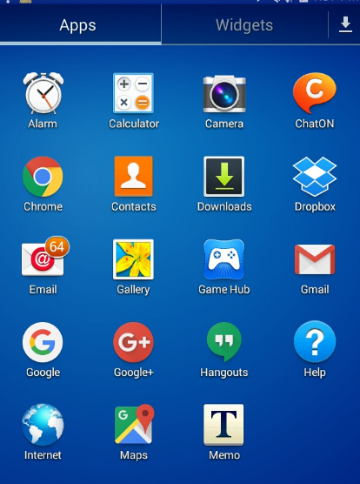

- Tap a Setting Wheel, Select Photo Icon and Select desired option. Complete required task ( below)
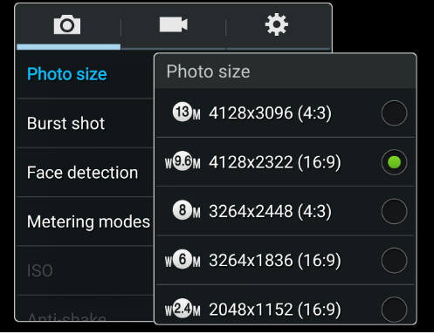
- Repeat #2 for Video.
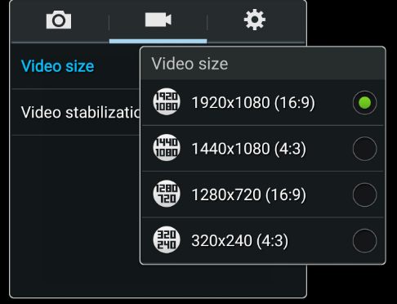

For IPhone : Go to Settings

