Session 11
- Session 11 Slides are now available
https://drive.google.com/drive/folders/0B__Jza6ZnWYYc0Y4Sl9rR3BTbDg
2. Please go through highlighted Interviews questions 1-92 , get yourself being prepared
https://docs.google.com/document/d/1QHc1YDsQvFsLesqIL-fTX0agQy-_Wd_6Dj9igcez6CQ/edit
3. Lomotif Project Summary : create 10 bullets describing Lomotif project and activity that you performed.
Use Complete Guide for Mobile Testing Types, that was posted in a previous ( Session 10 HW).
Use Word Document and upload it to Lomotif_Project Summary Folder ( include your name)
https://drive.google.com/drive/folders/0B__Jza6ZnWYYOTdhWENTbGtYWEE
4. Upload your FULLY COMPLETED Lomotif Testers Checklist for your Device. Make sure all Test Cases have a result for your Device.
Don’t forget to include your name, Device Info on top of a document.
https://drive.google.com/drive/folders/0B__Jza6ZnWYYX0w4ZlpEaHlPc2M
4. Create as many Test Cases for this simple APP ( 1 screen APP, connected to Internet, three buttons A, B and C with Audio 1, Audio 2 and Audio 3 .
Use the Guidance from our Slides Presentation.
Have fun and good luck!
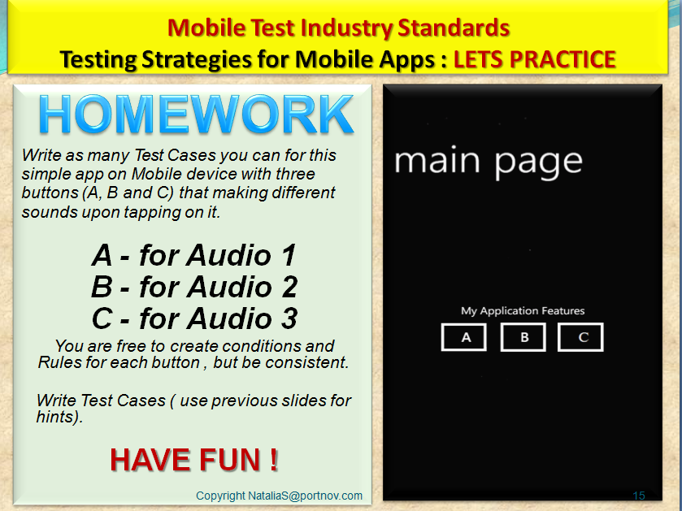

We will start a new Project after Session 12.
Please make sure all Lomotif outstanding tasks are taken care of.
See you tonight , Tuesday ( but you will have plenty of time to complete your Homework)
Regards,
Natalia

