Dear Students,
Please follow the instructions before proceeding with Session5 Homework.
- Below is a link to my shared folder on Google Drive where all documents are going to be posted: ( after c ) read first
- Camera Test Reference Matrix for both Android and iOS users (chose a tab to select). Like I have explained before our Session – please fill out the test results (see instructions inside the document). Please be as neat as possible.
Do not download – work in a Google Drive on this doc ONLY, so all data from each of you is in a same place.
b)Lomotif Test Suits : Separate Docs for Android and iOS Testers – pick the one that applies to you and download to YOUR DEVICE ( Phone, PC or MAC). DO NOT WORK ON IT on Google Drive – have your own copy .
Expand each line to make sure all text is visible.

c) Test Suit ( Scenario # 1) – Test it and fill out the results on your doc.
Link to shared folder on Google Drive : again download your own copy – do not work on this doc in Google Drive.
https://drive.google.com/drive/folders/0B__Jza6ZnWYYa2tMZExQUFpST0k?usp=sharing

- Link to Bugzilla , Lomotif Project ( DO NOT FILE ANY BUGS)
http://bugzilla.portnov.com/
login: lomotif_sep20@portnov.com ( case sensitive)
password: welcome ( case sensitive)
when you logged in , click "browse" then select lomotif_sept20_online

Check my “dummy” bug entry # 5169 how I want bugs to be reported when the time comes.
- Please review these videos from Presentation to get familiar with Monitoring Tools
https://www.youtube.com/user/PerfectoMobile
https://www.youtube.com/watch?v=rtvz9yrw95Y

- Get to know your TEAM LEADS please, and be nice to one another

See you on Thursday, November 10th @6pm

Dear Students ,
Students, that unable to install LOMOTIFF APP, please contact each other and send me 1 list with a devices name, model and os/ios version.
I will try to accommodate you.
For all others :
- Please start your Homework from going to this FAQs about Lomotif, and get familiar with our Project and the way APP behaves.
https://www.lomotif.com/faq_ru.php
- You Lomotif Videos would be cut into to 30 seconds duration, no matter how long an original video was. Exp. You recorded a video that is 3 minutes , but it will be cut to 30 sec max while in a project.
Not a bug, it’s as designed.
- Now, let’s sort out the problem Media Files that you have created. Before reporting a problem go through this list.
- Close Lomotif and go to your Folder where you usually keep Multimedia on your device.
- Double check if files ( from HW 2 ) are playable through default Media Player.
- If OK , proceed to d). (if not, DO NOT ATTEMPT to playback using Lomotif ). STOP HERE
- Playback all Files through Lomotif to double check if there is a problem or no problem with each File
- Grab the Problem Files ( they should be renamed the way I asked you to do in Homework 2)
- Contact your Group Lead and be ready to provide : Device name, model , OS/iOS version .
- Wait for further instructions from your Leader ( he/she will be sending you a folder link where you would be placing your File(s).
To make it clear – ONLY PROBLEM Files are needed, NOT ALL of your Media collection and One File of the same format, no multiples.

Continue working and playing around with Lomotif , get familiar with Filters and editing.
We are going to start an actual testing starting next Tuesday.

Now, we are going to cover Devices that unable to “see” the Media you have created. I need to collect an info from you which of the Devices that have a Lomotif do not see the Media .
- All of the Media that you have created or partial ?
- What are the formats that Lomotif is unable to load into Album Screen?
Stay tuned and wait for further instructions.
You will still be able to proceed with testing, but with a different Media.

Have a good weekend

PREVIOUS HOMEWORK LIST

Dear Students,
Please READ Carefully entire instructions before proceeding with testing.
In Homework 2 you have created a Media Files, that we will use now, doing our Homework after Session 3.
LET’S ROLL , PEOPLE See you on THURSDAY
Natalia S.
USE YOUR DEVICE (Mobile Phone)
- Open Gallery or Albums where you Files are stored
- Check Preview (Thumbnail), verify it’s not empty and the picture (frame) is stored.
- Tap to Playback ( your default Media Player)
- Playback few Files that you have recorded. Verify that there are no black screens instead of Video or Pictures.

What is Lomotif? Please watch this Video to get familiar with our app. You will include it in your resume!
https://www.youtube.com/watch?v=ifOEKai5Gn0&feature=youtu.be
LOMOTIF is a Native APP, used by 5.5 million users all over the world.
Lomotif is the simplest way to add music to your moments. You can create hyper-short, super shareable music videos in 3 simple steps. The app allows users to cherry-pick from over a billion songs to instantly and automatically create visual mash-ups.
It’s developed for both iOS and Android. Current version for iOS is 1.9.6 (released on Oct 17th
) and for OS ver 1.5.0 (released on Oct 23rd)
It’s a live Project and we have a continuing feedback from the development team, live Bug Tracking Database and Test Suits, which were created by Lomotif QA team.

- Go to Google Play or App Store. Find LOMOTIF app (do not install) and READ # 6 and further
- Read carefully the description, reviews, find version number, description of fixes.
- Observe GUI , does it look good on your Device Screen?
8.Flip your Device to Landscape Mode (if you are in Portrait) and vise versa .
- Install LOMOTIF APP (check your GUI at all times, verify LOGO is not corrupted and Download/Install Buttons are correctly marked)
- After installation , Open LOMOTIF , tap START at HOME SCREEN.
- The MEDIA that you have created should be picked by APP and placed in a FOLDER at “ADD PHOTOS AND VIDEOS” ( depending on Device this screen with Albums may look a little different. Any way it’s going to be a second screen(page) after HOME PAGE.
- Playback ALL the Media Files .
(Select , press next ( > on the top) , do not select Music, proceed to next screen.
Please note the Media that is not playable ( or Playback is corrupted ( not normal) , make a note.

\To those who is joining us late. Homework Scope for Session 2 is below.\
Video Recording :
Rename files ( best to use PC or MAC) . Example : you have recorded a video from front camera, portrait 4:3 layout, in 720p ( from task 1)
Rename a file to : fc_prt_720p.*
(for landscape 16:9 layout the file name is fc_lsp_720p.*)
- FRONT CAMERA – Portrait 4:3 layout : Record 5 ( 1-2 min) videos in 720P mode .
- FRONT CAMERA – Portrait 4:3 layout : Record 5 ( 1-2 min) videos in 1080P mode .
- BACK CAMERA- Portrait 4:3 layout : Record 3 (1-2 min) videos in any mode ( 720p or 1080p)
- BACK CAMERA – Landscape 16:9 layout : Record 3 (1-2 min) videos in any mode ( 720p or 1080p)
- BACK CAMERA – UpsideDown– Portrait 4:3 layout : Record 3 (1-2 min) videos in any mode ( 720p or 1080p)
- BACK CAMERA – UpsideDown– Landscape 16:9 layout: Record 3 (1-2 min) videos in any mode ( 720p or 1080p)
- FRONT CAMERA – any layout- Record 2 ( 1 min) videos in 720P mode .
- FRONT CAMERA – any layout- Record 2 ( 1 min) videos in 1080P mode .
Please take some pictures :
- FRONT CAMERA – Portrait 4:3 layout : 10
- FRONT CAMERA – Landscape 16:9 layout : 10
- BACK CAMERA – Portrait 4:3 layout : 10
- BACK CAMERA – Landscape 16:9 layout : 10
- PANORAMA photo : 4

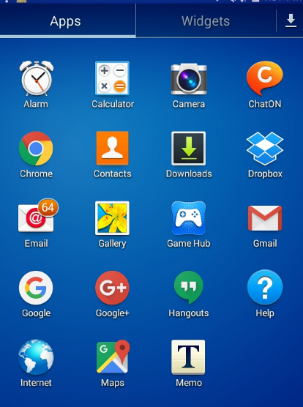

- Tap a Setting Wheel, Select Photo Icon and Select desired option. Complete required task ( below)
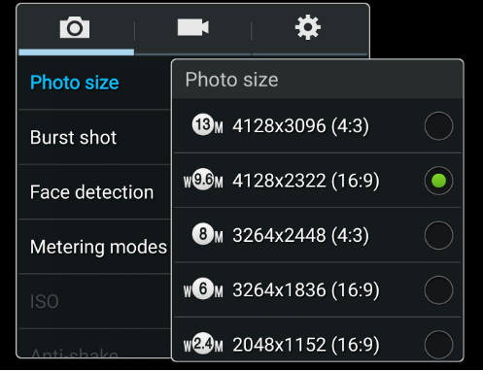
- Repeat #2 for Video.
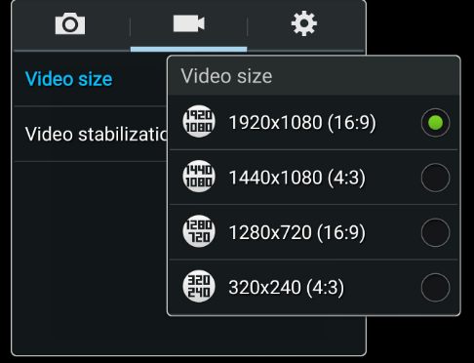

For IPhone : Go to Settings

