Dear Students,
Please READ Carefully entire instructions before proceeding with testing.
In Homework 2 you have created a Media Files, that we will use now, doing our Homework after Session 3.
LET’S ROLL , PEOPLE See you on THURSDAY
Natalia S.
USE YOUR DEVICE (Mobile Phone)
- Open Gallery or Albums where you Files are stored
- Check Preview (Thumbnail), verify it’s not empty and the picture (frame) is stored.
- Tap to Playback ( your default Media Player)
- Playback few Files that you have recorded. Verify that there are no black screens instead of Video or Pictures.

What is Lomotif? Please watch this Video to get familiar with our app. You will include it in your resume!
https://www.youtube.com/watch?v=ifOEKai5Gn0&feature=youtu.be
LOMOTIF is a Native APP, used by 5.5 million users all over the world.
Lomotif is the simplest way to add music to your moments. You can create hyper-short, super shareable music videos in 3 simple steps. The app allows users to cherry-pick from over a billion songs to instantly and automatically create visual mash-ups.
It’s developed for both iOS and Android. Current version for iOS is 1.9.6 (released on Oct 17th
) and for OS ver 1.5.0 (released on Oct 23rd)
It’s a live Project and we have a continuing feedback from the development team, live Bug Tracking Database and Test Suits, which were created by Lomotif QA team.

- Go to Google Play or App Store. Find LOMOTIF app (do not install) and READ # 6 and further
- Read carefully the description, reviews, find version number, description of fixes.
- Observe GUI , does it look good on your Device Screen?
8.Flip your Device to Landscape Mode (if you are in Portrait) and vise versa .
- Install LOMOTIF APP (check your GUI at all times, verify LOGO is not corrupted and Download/Install Buttons are correctly marked)
- After installation , Open LOMOTIF , tap START at HOME SCREEN.
- The MEDIA that you have created should be picked by APP and placed in a FOLDER at “ADD PHOTOS AND VIDEOS” ( depending on Device this screen with Albums may look a little different. Any way it’s going to be a second screen(page) after HOME PAGE.
- Playback ALL the Media Files .
(Select , press next ( > on the top) , do not select Music, proceed to next screen.
Please note the Media that is not playable ( or Playback is corrupted ( not normal) , make a note.

\To those who is joining us late. Homework Scope for Session 2 is below.\
Video Recording :
Rename files ( best to use PC or MAC) . Example : you have recorded a video from front camera, portrait 4:3 layout, in 720p ( from task 1)
Rename a file to : fc_prt_720p.*
(for landscape 16:9 layout the file name is fc_lsp_720p.*)
- FRONT CAMERA – Portrait 4:3 layout : Record 5 ( 1-2 min) videos in 720P mode .
- FRONT CAMERA – Portrait 4:3 layout : Record 5 ( 1-2 min) videos in 1080P mode .
- BACK CAMERA- Portrait 4:3 layout : Record 3 (1-2 min) videos in any mode ( 720p or 1080p)
- BACK CAMERA – Landscape 16:9 layout : Record 3 (1-2 min) videos in any mode ( 720p or 1080p)
- BACK CAMERA – UpsideDown– Portrait 4:3 layout : Record 3 (1-2 min) videos in any mode ( 720p or 1080p)
- BACK CAMERA – UpsideDown– Landscape 16:9 layout: Record 3 (1-2 min) videos in any mode ( 720p or 1080p)
- FRONT CAMERA – any layout- Record 2 ( 1 min) videos in 720P mode .
- FRONT CAMERA – any layout- Record 2 ( 1 min) videos in 1080P mode .
Please take some pictures :
- FRONT CAMERA – Portrait 4:3 layout : 10
- FRONT CAMERA – Landscape 16:9 layout : 10
- BACK CAMERA – Portrait 4:3 layout : 10
- BACK CAMERA – Landscape 16:9 layout : 10
- PANORAMA photo : 4

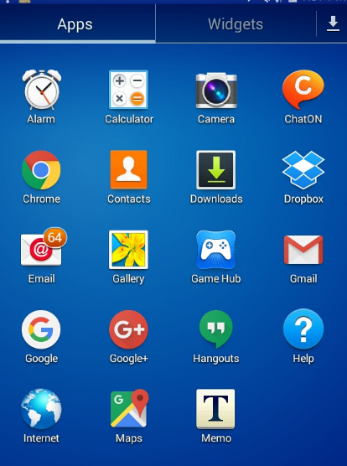

- Tap a Setting Wheel, Select Photo Icon and Select desired option. Complete required task ( below)
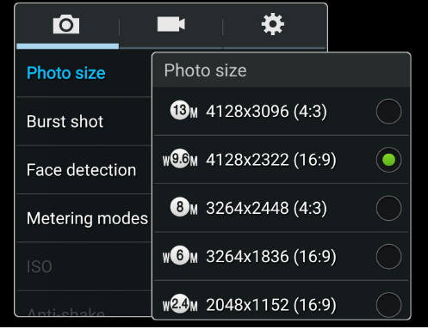
- Repeat #2 for Video.
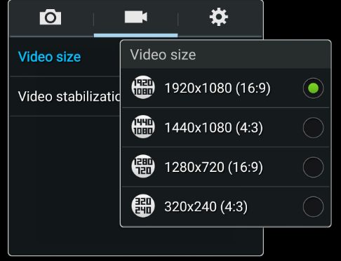

For IPhone : Go to Settings

