Dear Students,
We are heading toward the end of our Mobile App Testing . Three more Sessions and we are done!
Please don’t hesitate to ask questions regarding anything, I will be happy to provide an answer.
In a mean time, continue doing all the assignments as this is an essential part of a learning process.
Your cooperation is greatly appreciated and these new skills might be one of a career changing paths.
- Part of Session11 homework was to write a sample test cases for Mobile Banking App.
I have created a new folder on Google Drive. Please submit your cases in a Word Format , name your doc by skype_name_ba and upload it here
https://drive.google.com/drive/u/0/folders/0B__Jza6ZnWYYaWNNYndjMm1ud0E

- Go through Mobile Simulator slides and read carefully all info.
Session 12 slides Slide 9-12

- Test Scenario ( iOS and Android) – 16 and 17 ( WE ARE DONE!!! )
- GO to Bugzilla ( login info below – see HM 7) and verify bugs #5247 (updated now), #5251, #5252, #5253, #5254, #5255 and #5255,
- Go to the Doc ( Columns added for these entries): https://docs.google.com/spreadsheets/d/1TnjPILE7EnsGpacNn9HrjqquIs_mSYfboi3f_aeG_oI/edit#gid=551318793
- Fill in – PASS (if unable to reproduce), FAIL- if problem confirmed, N/A- if your Device unable to support some of functionality.
- Again select an appropriate Tab for Android and iOS.
See you on Tuesday, Dec 13th, 2016
Regards,
Natalia

Dear Students,
Was pleased to see that you are becoming proficient with Test Cases for Audio App and Banking App.
I posted a checklist to help you to keep your further Test Suits organized and you might find it helpful while testing any mobile App.
Please download your own copy and keep it. Here the link
https://drive.google.com/drive/folders/0B__Jza6ZnWYYa2tMZExQUFpST0k
Due Thursday , Dec 8
- Open your Banking App , Select ONE Module and create at least 10 cases ( consider variables)

We are almost of the end of Lomotif App Testing and checking the Bugzilla entries. By Session 14 we will start filing new issues that you have found on your Devices.
It’s time to create a new test cases for Lomotif, that are not covered by Lomotif Test Suit . Please make it ready by Session 15. I will be posting a new and empty Matrix for you to use soon.
It is a mandatory obligation to go through Bugzilla Bug Verification test PRIOR to filing a new bugs to avoid Bug Duplicates (which is considered as a big no-no in our Industry)
- Test Scenario ( iOS and Android) – 14 and 15
- GO to Bugzilla ( login info below – see HM 7) and verify bugs # 5240, # 5241, # 5242, # 5243, # 5244, # 5245, # 5246, and # 5247,
- Go to the Doc ( Columns added for these entries): https://docs.google.com/spreadsheets/d/1TnjPILE7EnsGpacNn9HrjqquIs_mSYfboi3f_aeG_oI/edit#gid=551318793
- Fill in – PASS (if unable to reproduce), FAIL- if problem confirmed, N/A- if your Device unable to support some of functionality.
- Again select an appropriate Tab for Android and iOS.

See you on Thurday, Dec 8th
-Natalia

Dear Students, we are in a full Test Cycle with our Project.
Please , if you have not done Bug Verifications from Bugzilla, it’s time to start and continue with a process. It’s an essential part of your jobs as a QA Professionals.
I see lots of empty fields in our shared doc that were from previous Homework assignments. Please consider this.
- Due Tuesday , Dec 6.

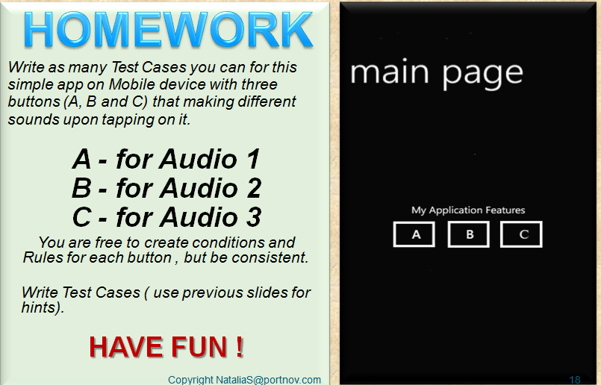
- Be creative : Pretend it’s your own App, you can implement any functionality . The only rule : A( Audio1), B(Audio2), C(Audio3)
- Using all information from Test Types and Industry Standards for Mobile App Testing, write as many test cases as possible. Use slides from this and previous sessions for details.
- Have in mind “expected results” when writing test cases.

FYI : Test Scenario 5 ( iOS) only – Image File “position_me.jpg” is uploaded to Media Folder in our Google Drive ( honestly, I’m surprised that no one , but a single person, was asking for it. And we are at Scenario 11 supposedly C’mon , dear Students!!
- Test Scenario ( iOS and Android) – 12 and 13
- GO to Bugzilla ( login info below – see HM 7) and verify bugs # 5230, # 5231, # 5232, # 5233, # 5234, # 5235, # 5236, and # 5237,
- Go to the Doc ( Columns added for these entries): https://docs.google.com/spreadsheets/d/1TnjPILE7EnsGpacNn9HrjqquIs_mSYfboi3f_aeG_oI/edit#gid=551318793
- Fill in – PASS ( if unable to reproduce), FAIL- if problem confirmed, N/A- if your Device unable to support some of functionality.
- Again select an appropriate Tab for Android and iOS.
Have a nice weekend,
See you on Tuesday, Dec 6

-Natalia

- Due next Tuesday , Dec 6. ( this task ONLY). Other tasks – due this coming Thursday, Dec 1st
- Be creative : Pretend it’s your own App, you can implement any functionality . The only rule : A( Audio1), B(Audio2), C(Audio3)
- Using all information from Test Types and Industry Standards for Mobile App Testing, write as many test cases as possible. Use slides from this and previous sessions for details.
- Have in mind “expected results” when writing test cases.

Due this Thursday , Dec 1st
iOS and Android :
- Test Scenario ( iOS and Android) – 10 and 11
- GO to Bugzilla ( login info below – see HM 7) and verify bugs # 5222, # 5223, # 5224, # 5225, # 5225, # 5226, # 5227 , # 5228 and # 5229
- Go to the Doc ( Columns added for these entries): https://docs.google.com/spreadsheets/d/1TnjPILE7EnsGpacNn9HrjqquIs_mSYfboi3f_aeG_oI/edit#gid=551318793
- Fill in – PASS ( if unable to reproduce), FAIL- if problem confirmed, N/A- if your Device unable to support some of functionality.
- Again select an appropriate Tab for Android and iOS.

Hello Everyone,

iOS and Android :
- Test Scenario ( iOS and Android) – 7,8,9
GO to Bugzilla ( login info below – see HM 7) and verify bugs # 5214, # 5215, # 5216, # 5217, # 5219, # 5220 and # 5221
Go to the Doc ( Columns added for these entries): https://docs.google.com/spreadsheets/d/1TnjPILE7EnsGpacNn9HrjqquIs_mSYfboi3f_aeG_oI/edit#gid=551318793

Fill in – PASS ( if unable to reproduce), FAIL- if problem confirmed, N/A- if your Device unable to support some of functionality.
Again select an appropriate Tab for Android and iOS.
.
https://docs.google.com/spreadsheets/d/1TnjPILE7EnsGpacNn9HrjqquIs_mSYfboi3f_aeG_oI/edit#gid=551318793

xxxxxxxxxxxxxxxxxxxxxxxxxxxxxxxxxxxxxxxxxxxxxxxxxxxxxxxxxxxxxx
- Please learn more about CWE – COMMON WEAKNESS ENUMERATION : https://cwe.mitre.org/about/
- Learn more about Device Accessibility https://www.w3.org/TR/WCAG20/
Have a nice weekend ,
-Natalia

- Complete Guide to Mobile App Testing
Shared on Google Drive https://drive.google.com/drive/folders/0B__Jza6ZnWYYa2tMZExQUFpST0k
- Please include Battery Consumption Results into our Doc ( from Homework #6. I have added a Column – scroll to your right.
- Again select an appropriate Tab for Android and iOS.
I need % of consumption, not the % of Power Left, please.
https://docs.google.com/spreadsheets/d/1TnjPILE7EnsGpacNn9HrjqquIs_mSYfboi3f_aeG_oI/edit#gid=551318793

- Test Scenario 4,5 and 6 ( iOS) and for Android users: 4 and 6 (Scenario 5 – skip)
- THIS TASK IS FOR ALL iOS and ANDROID TESTERS:
GO to Bugzilla ( login info below) and verify bugs # 5202, #5203, #5204 and #5205. These are the real problems (cloned) from my main live Database that is connected to LOMOTIF Team.

- Please report PASS or FAIL (no explanation needed) in a new columns that is added in Camera Test Original Doc. FIND YOUR ORIGINAL ENTRY and Continue in your dedicated field. (I’m keeping track for all the work you are assigned to do.)

Link to Bugzilla , Lomotif Project ( DO NOT FILE ANY BUGS)
http://bugzilla.portnov.com/
login: lomotif_sep20@portnov.com ( case sensitive)
password: welcome ( case sensitive)
when you logged in , click "browse" then select lomotif_sept20_online

Have a good weekend and see you on Tuesday, Nov 22.
-Natalia

Dear Students :
- Please follow this link to learn ADB SHELL commands http://adbshell.com/commands
Review LOGCAT section first.
- What is ANDROID STUDIO and how it works ? Follow this link https://developer.android.com/studio/intro/index.html
- What is Test Flight and how it works? Follow this link http://stacktips.com/reviews/testfairy-android-app-beta-testing-platform
- What is TestFlight and how it works? Follow this link https://developer.apple.com/library/content/documentation/IDEs/Conceptual/AppDistributionGuide/DistributingYourAppUsingTestFlight/DistributingYourAppUsingTestFlight.html
- What is XCode and how it works? Follow this link https://www.raywenderlich.com/110170/mac-os-x-development-tutorial-for-beginners-part-1-intro-to-xcode

- REMOVE ALL THE PROBLEM MEDIA from your Device ( Phone) that we created earlier and save it to a separate Device ( PC or MAC), and wait for Team Leaders to contact you with further instructions.

- Go to my Shared Media Folder on Google Drive and……
please download the following subfolders in Media Folder :
Android Users : Audio Media, Special Media and test_media_5x
iOS Users : Audio Media, Special Media and test_media_6S
here the link to my Google Drive : https://drive.google.com/drive/folders/0B__Jza6ZnWYYV1FnSDJSOXk1Z28?usp=sharing

Note for iOS Users: on some devices it is possible that not ALL test_media_6S files would be downloaded to your device, because of unsupported formats. Please use your own media files and those that were able to download from Media Files Folder.
Should be no issues with Android OS.

- Retest Scenario 1, continue with Scenario 2 and 3. In case there are bugs found please write step by step instructions how to reproduce it.
DO NOT FILE INTO BUGZILLA.

WE are going to test Battery Consumption.
Instructions:
- Uninstall Lomotif APP
- Charge your Phone to 100% , remove the charger
- Install Lomotif APP
- Play around like a regular user, creating projects for 15 min.
- Check your Battery status. How many % Lomotif consumed. Write down the number. (I will be adding a new column in document on Google Drive, where you reported your Camera Testing Results where later you will be filing in your results)
Have a nice day,
See you on Thursday, Nov 17th

Dear Students,
Please follow the instructions before proceeding with Session5 Homework.
- Below is a link to my shared folder on Google Drive where all documents are going to be posted: ( after c ) read first
- Camera Test Reference Matrix for both Android and iOS users (chose a tab to select). Like I have explained before our Session – please fill out the test results (see instructions inside the document). Please be as neat as possible.
Do not download – work in a Google Drive on this doc ONLY, so all data from each of you is in a same place.
b)Lomotif Test Suits : Separate Docs for Android and iOS Testers – pick the one that applies to you and download to YOUR DEVICE ( Phone, PC or MAC). DO NOT WORK ON IT on Google Drive – have your own copy .
Expand each line to make sure all text is visible.

c) Test Suit ( Scenario # 1) – Test it and fill out the results on your doc.
Link to shared folder on Google Drive : again download your own copy – do not work on this doc in Google Drive.
https://drive.google.com/drive/folders/0B__Jza6ZnWYYa2tMZExQUFpST0k?usp=sharing

- Link to Bugzilla , Lomotif Project ( DO NOT FILE ANY BUGS)
http://bugzilla.portnov.com/
login: lomotif_sep20@portnov.com ( case sensitive)
password: welcome ( case sensitive)
when you logged in , click "browse" then select lomotif_sept20_online

Check my “dummy” bug entry # 5169 how I want bugs to be reported when the time comes.
- Please review these videos from Presentation to get familiar with Monitoring Tools
https://www.youtube.com/user/PerfectoMobile
https://www.youtube.com/watch?v=rtvz9yrw95Y

- Get to know your TEAM LEADS please, and be nice to one another

See you on Thursday, November 10th @6pm

Dear Students ,
Students, that unable to install LOMOTIFF APP, please contact each other and send me 1 list with a devices name, model and os/ios version.
I will try to accommodate you.
For all others :
- Please start your Homework from going to this FAQs about Lomotif, and get familiar with our Project and the way APP behaves.
https://www.lomotif.com/faq_ru.php
- You Lomotif Videos would be cut into to 30 seconds duration, no matter how long an original video was. Exp. You recorded a video that is 3 minutes , but it will be cut to 30 sec max while in a project.
Not a bug, it’s as designed.
- Now, let’s sort out the problem Media Files that you have created. Before reporting a problem go through this list.
- Close Lomotif and go to your Folder where you usually keep Multimedia on your device.
- Double check if files ( from HW 2 ) are playable through default Media Player.
- If OK , proceed to d). (if not, DO NOT ATTEMPT to playback using Lomotif ). STOP HERE
- Playback all Files through Lomotif to double check if there is a problem or no problem with each File
- Grab the Problem Files ( they should be renamed the way I asked you to do in Homework 2)
- Contact your Group Lead and be ready to provide : Device name, model , OS/iOS version .
- Wait for further instructions from your Leader ( he/she will be sending you a folder link where you would be placing your File(s).
To make it clear – ONLY PROBLEM Files are needed, NOT ALL of your Media collection and One File of the same format, no multiples.

Continue working and playing around with Lomotif , get familiar with Filters and editing.
We are going to start an actual testing starting next Tuesday.

Now, we are going to cover Devices that unable to “see” the Media you have created. I need to collect an info from you which of the Devices that have a Lomotif do not see the Media .
- All of the Media that you have created or partial ?
- What are the formats that Lomotif is unable to load into Album Screen?
Stay tuned and wait for further instructions.
You will still be able to proceed with testing, but with a different Media.

Have a good weekend

PREVIOUS HOMEWORK LIST

Dear Students,
Please READ Carefully entire instructions before proceeding with testing.
In Homework 2 you have created a Media Files, that we will use now, doing our Homework after Session 3.
LET’S ROLL , PEOPLE See you on THURSDAY
Natalia S.
USE YOUR DEVICE (Mobile Phone)
- Open Gallery or Albums where you Files are stored
- Check Preview (Thumbnail), verify it’s not empty and the picture (frame) is stored.
- Tap to Playback ( your default Media Player)
- Playback few Files that you have recorded. Verify that there are no black screens instead of Video or Pictures.

What is Lomotif? Please watch this Video to get familiar with our app. You will include it in your resume!
https://www.youtube.com/watch?v=ifOEKai5Gn0&feature=youtu.be
LOMOTIF is a Native APP, used by 5.5 million users all over the world.
Lomotif is the simplest way to add music to your moments. You can create hyper-short, super shareable music videos in 3 simple steps. The app allows users to cherry-pick from over a billion songs to instantly and automatically create visual mash-ups.
It’s developed for both iOS and Android. Current version for iOS is 1.9.6 (released on Oct 17th
) and for OS ver 1.5.0 (released on Oct 23rd)
It’s a live Project and we have a continuing feedback from the development team, live Bug Tracking Database and Test Suits, which were created by Lomotif QA team.

- Go to Google Play or App Store. Find LOMOTIF app (do not install) and READ # 6 and further
- Read carefully the description, reviews, find version number, description of fixes.
- Observe GUI , does it look good on your Device Screen?
8.Flip your Device to Landscape Mode (if you are in Portrait) and vise versa .
- Install LOMOTIF APP (check your GUI at all times, verify LOGO is not corrupted and Download/Install Buttons are correctly marked)
- After installation , Open LOMOTIF , tap START at HOME SCREEN.
- The MEDIA that you have created should be picked by APP and placed in a FOLDER at “ADD PHOTOS AND VIDEOS” ( depending on Device this screen with Albums may look a little different. Any way it’s going to be a second screen(page) after HOME PAGE.
- Playback ALL the Media Files .
(Select , press next ( > on the top) , do not select Music, proceed to next screen.
Please note the Media that is not playable ( or Playback is corrupted ( not normal) , make a note.

\To those who is joining us late. Homework Scope for Session 2 is below.\
Video Recording :
Rename files ( best to use PC or MAC) . Example : you have recorded a video from front camera, portrait 4:3 layout, in 720p ( from task 1)
Rename a file to : fc_prt_720p.*
(for landscape 16:9 layout the file name is fc_lsp_720p.*)
- FRONT CAMERA – Portrait 4:3 layout : Record 5 ( 1-2 min) videos in 720P mode .
- FRONT CAMERA – Portrait 4:3 layout : Record 5 ( 1-2 min) videos in 1080P mode .
- BACK CAMERA- Portrait 4:3 layout : Record 3 (1-2 min) videos in any mode ( 720p or 1080p)
- BACK CAMERA – Landscape 16:9 layout : Record 3 (1-2 min) videos in any mode ( 720p or 1080p)
- BACK CAMERA – UpsideDown– Portrait 4:3 layout : Record 3 (1-2 min) videos in any mode ( 720p or 1080p)
- BACK CAMERA – UpsideDown– Landscape 16:9 layout: Record 3 (1-2 min) videos in any mode ( 720p or 1080p)
- FRONT CAMERA – any layout- Record 2 ( 1 min) videos in 720P mode .
- FRONT CAMERA – any layout- Record 2 ( 1 min) videos in 1080P mode .
Please take some pictures :
- FRONT CAMERA – Portrait 4:3 layout : 10
- FRONT CAMERA – Landscape 16:9 layout : 10
- BACK CAMERA – Portrait 4:3 layout : 10
- BACK CAMERA – Landscape 16:9 layout : 10
- PANORAMA photo : 4

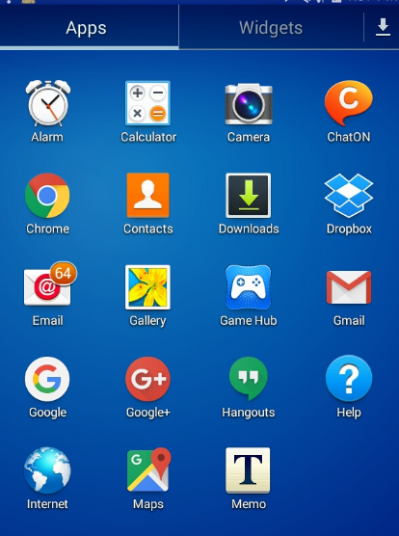

- Tap a Setting Wheel, Select Photo Icon and Select desired option. Complete required task ( below)
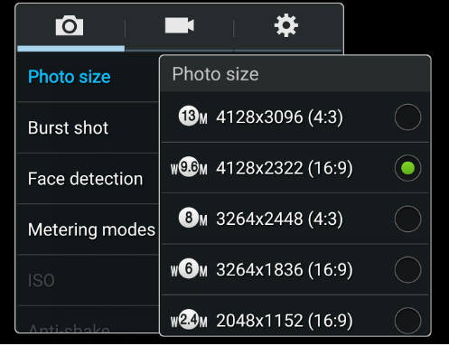
- Repeat #2 for Video.
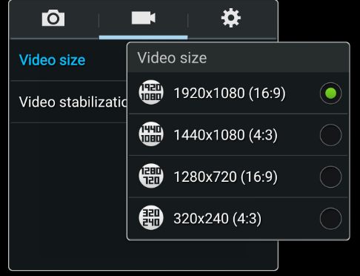

For IPhone : Go to Settings

