Session 3 HOMEWORK
2/13/2018

Session 3 Presentation is now posted in https://drive.google.com/drive/u/1/folders/183DhG115u7O20uSwqNxlg01_hB54bbTI
- Please go through Interview Questions Session 2 and answer questions ## 10-16
https://drive.google.com/drive/u/1/folders/1mnAgnqWC8CmcI-tn-mnOMjcCgTBbCMfv
xxxxxxxxxxxxxxxxxxxxxxxxxxxxxxxxxxxxxxxxxxxxxxxxxxxxxxxxxxxxxxxxxxxxxxxxxxxxxxxxxxxxxxxxxx
DUE THURSDAY ( not tomorrow, next week , FEB 22. We are not going to have a session on Monday, Feb 19 due to a National Holiday )
ANDROID STUDIO ( only to be installed on your PC/MAC/Laptop, not on your mobile device )
This could go for a few days, as Android Studio installation and setup can take some time. Before we start I want to be sure that all of you have it.
- Download Android Studio from https://developer.android.com/studio/index.html
- When downloading , ALSO select SDK TOOLS ( adb , which is Andoid Debugging Bridge resides in these TOOLS )
- Follow instructions a_READ_FIRST*.docs for MAC and WINDOWS in this folder https://drive.google.com/drive/u/1/folders/1Yg1jPjfa4oYstP9FSGekaXaZfU9p7Bb8
- Install Android Studio . Open it. Follow prompts by pressing NEXT without changing anything ( leave in defaults)
You will have to install every update that Android Studio suggests in pop up window.
Go to SDK Manager ( top bar inside Android Studio . Icon .) and make sure you check and install the following
#1
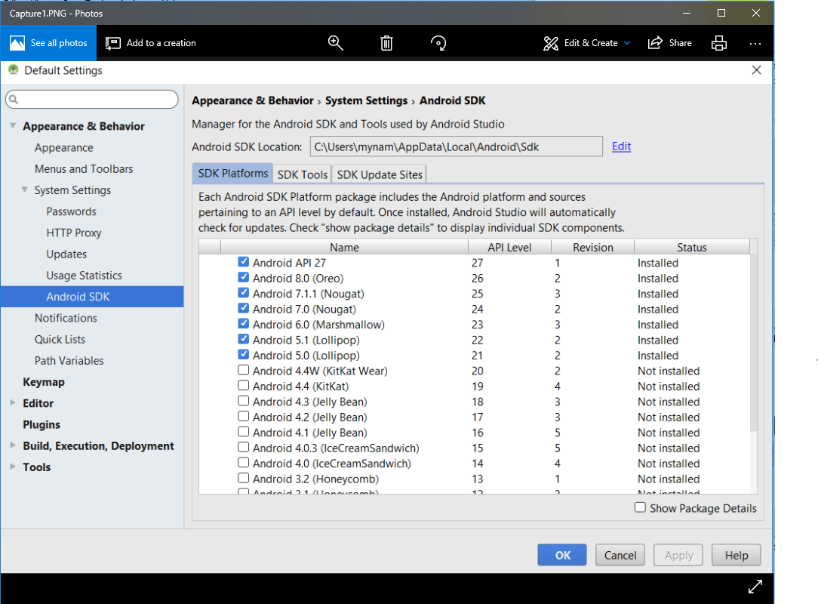
#2

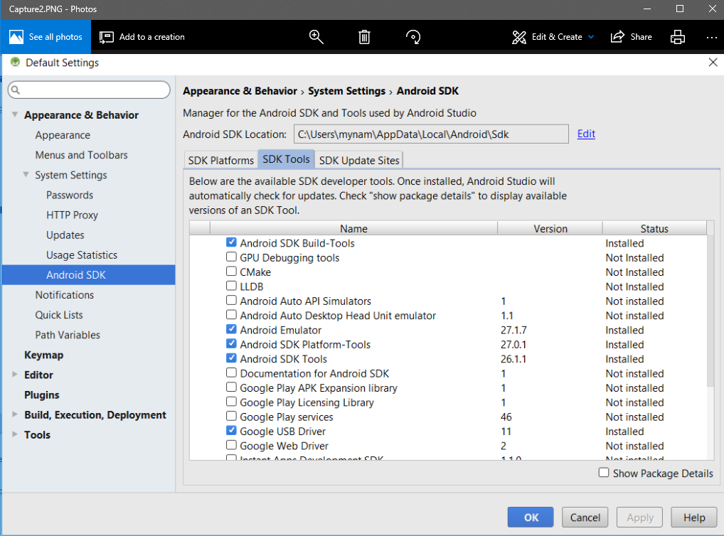

#3
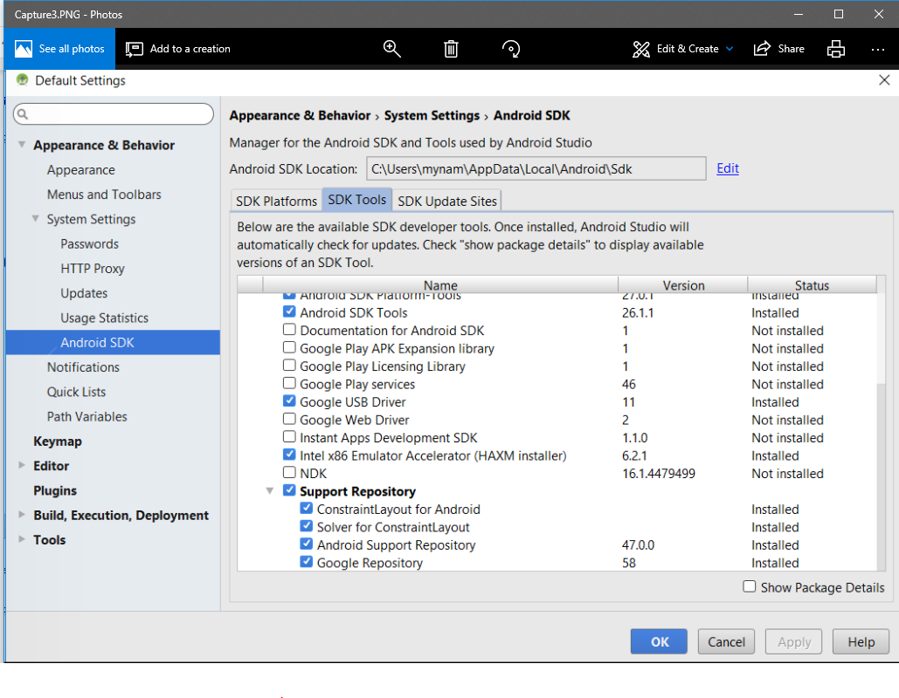

Again, please follow Android Studio instructions for upgrades ( click the blue links if available )
xxxxxxxxxxxxxxxxxxxxxxxxxxxxxxxxxxxxxxxxxxxxxxxxxxxxxxxxxxxxxxxxxxxxxxxxxxxxxxxxxxxxxxxxxxxxxxxx
Due tomorrow , Thursday Feb 14th
Let’s continue to roll with our Mobile APP Testing
Preparing for the Project Testing : Link below ( read first)
https://drive.google.com/drive/u/1/folders/1-BCBmCNA8-Rv1dZeysV2i58KykWoaFei

Please Download a specific Media subfolders to your Devices .
This Media is sent to us by Lomotif).
Get familiar with content. ( no need to report anything yet or test anything)

Android Users : Audio Media, Special Media, Position_me.jpg and test_media_5x
( use iTunes or other tool ) iOS Users : Audio Media, Special Media, Position_me.jpg and test_media_6S
Note for iOS Users: on some devices it is possible that not ALL test_media_6S files would be downloaded to your device, because of unsupported formats. Please use your own media files and those that were able to download from Media Files Folder.
Should be no issues with Android OS.
Our Lomotif Project is very structured and do have Test Plan with Test Cases;
Get familiar ( play around with it, but do not fill out yet ). We would need to go through this document and test with special Media.
This Table is created for iOS devices. If you have an android , please apply logical approach. If you are able to complete the task using a different steps ( like OS doesn’t have an “hamburger” icon ) then it passes.
Download your own copy:
https://drive.google.com/drive/u/1/folders/1_WZAnhV2zDH2brX8AgrbfU3jp1VQnqbF
No further instructions for now. Just create your own copy in the same directory where this matrix is posted.
Your skype name first for renaming document. Make sure you are not renaming my original copy.

Natalia

