06/04/2018
Dear Students,
It’s been a pleasure to begin our Mobile App Testing Sessions with you.
Nice meeting you all and I hope we will have lots of fun learning !
We are going to see each other on Mondays and Thursdays :)

Let’s start ! :)
- I would need 6 people who are willing to spend extra time to answer questions in a chat room, deliver information from me , know how to manage Google Sheets , supervise data entry , collect problem media and overall have be a nice and helpful people who is patient and courteous.
From our side – volunteer’s activity would be reflected in a resume as extra points that is approved by Mikhael and Kristina will be adding it into resumes of those who are involved.
- Team Leaders: create a separate Group on Skype , name it “Leaders_Apr26_2018” and invite me and Kristina Dzyuba ( your Program Supervisor).
- My message to all : Please READ all instructions CAREFULLY and FOLLOW them.
Our course is very structured and if for some reason you don’t know WHAT to do next, this means you haven’t been guided yet to make a next step or did not proceed with given instructions.
- Ask your Team leaders and group members first and “hard” cases will be forwarded to me.
- I will not be participating in a Chat Room because of my schedule in a classrooms however I could be reached via Skype ( nstefanioutine@gmail.com ) or email sqamobilemgr@gmail.com
Please send a personal connection request ONLY if team lEADERS WEREN’T ABLE TO HELP
Thank you for your consideration.
- Link to our INFO doc :
https://docs.google.com/document/d/18ueOi6g_6F783mzCZv5MTfZx8dvRApq-MQ7lHUcPxd4/edit

8. Please get an older Android ( OS 4.4 and higher ) to participate in Android Studio IDE and learn how to use ADB commands when we start . No provider needed , just device itself.

9. IMPORTANT and HIGHLY APPRECIATED :
Please do not modify any of my documents and do not leave yours in my Google Folder unless I ask you.
At all times, students should download and create your own copies on your own PC/Laptop.

We are done with organizational things ! Let’s proceed with a Homework below
xxxxxxxxxxxxxxxxxxxxxxxxxxxxxxxxxxxxxxxxxxxxxxxxxxxxxxxxxxxxxxxxxxxxxxxxxxxxxxxxxxxxxxxxxxxxxxxxxxxxx
Homework
- Please compare Walmart Web APP and Mobile APP
( Hint : Web APP is different from Website . This means Web APP is specifically designed to run on Mobile Device’s screen )
You may access Web version through any browser on your Device, and you will have to install Mobile APP from Market Place ( App Store or Google Play )
Download your own copy and write down comparison points .
Please note : GUI - like menu locations and layouts are not important . Difference in FUNCTIONALITY and ABILITY to perform a certain operations - this is what you will have to find.
https://drive.google.com/drive/u/0/folders/18ZkpUcLgib4TDnIkqxCD-NJIFpYxeN4C
- For this particular task, you are welcome to put your copy in the same directory, so we can compare results ( don’t peek into other people work ) LOL

Xxxxxxxxxxxxxxxxxxxxxxxxxxxxxxxxxxxxxxxxxxxxxxxxxxxxxxxxxxxxxxxxxxxxxxxxxxxxxxxxxxxxxxxxxxxxxxxxxxxxxxxxxxxxxxxxxxxxxxxxxx
2. Our Slides Homework as well as Presentations from each session is going to be included in this doc and latest ones are always going to be on top.
https://docs.google.com/document/d/1BAmqDJGk5nV-NH5Ca7mRJgJEkG_p9xixErkD8RL0pYE/edit

3. I will be asking you to answer Interview Questions after each Session. By doing so, your chances to pass an interview is increasing dramatically.
https://drive.google.com/drive/u/0/folders/1KRjt0oE7IfypwwTjbEtpYZr44yQLgZ8l
Your task for Thursday : PLEASE ANSWER QUESTION # 1-12
xxxxxxxxxxxxxxxxxxxxxxxxxxxxxxxxxxxxxxxxxxxxxxxxxxxxxxxxxxxxxxxxxxxxxxxxxxxxxxxxxxxxxxxxxxxxxxxxxxxxxxxxx
4. Our Main Table is here. This document will be showing Project Progress.
https://drive.google.com/drive/u/0/folders/1REbMizsgcDwutgXidh6wot_7zpOyiIOf
Please add your device name and info here : PLEASE NOTE there is a separate TABS for iOS ( APPLE) devices and Android Devices

Let’s ROLL with our first task and prepare a Testing Multimedia Files for our future Project that will be included in your Resume.
No need to send it in or do anything else at this point. Just Record Videos, take pictures and rename it accordingly. (You might want to connect your Device to PC/Laptop to rename files).
When asked to create upside pictures and videos all I care is that your camera is down. The picture would rotate, but it’s not important .

NOTE 1: To take upside-down picture/or video you will need just to rotate your phone to the position where camera “window” is down.
NOTE2: some Camera and Video Settings might not be available for your particular Device (Phone). Also, Settings do vary from Device to Device.
If this is a case, please prepare Files that are only applicable for your Device (Phone). Instructions and Screenshots are below.

NOTE3: Rotating your Phone to the right or left will give you a Landscape Mode (16:9)
=Otherwise it’s in 4:3 (Portrait)

Record Video Files :
Rename files ( best to use PC or MAC) . Example : you have recorded a video from front camera, portrait 4:3 layout, in 720p ( from task 1)
Rename a file to : fc_prt_720p.*
(for landscape 16:9 layout the file name is fc_lsp_720p.*
- PANORAMA photo : 2
xxxxxxxxxxxxxxxxxxxxxxxxxxxxxxxxxxxxxxxxxxxxxxxxxxxxxxxxxxxxxxxxxxxxxxxxxxxxxxxxxxxxxxxxxxxx

Android SamsungTap on Camera Icon 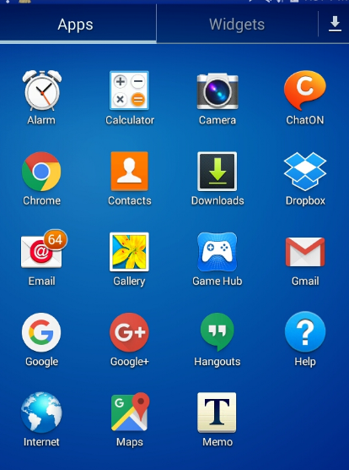

- Tap a Setting Wheel, Select Photo Icon and Select desired option. Complete required task ( below)
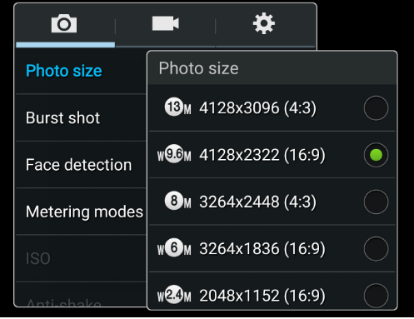
- Repeat #2 for Video.
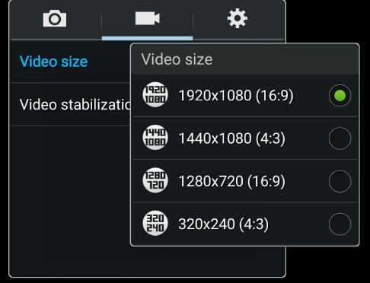

For IPhone : Go to Settings

